WELSH SCHOOLS’ FOOTBALL ASSOCIATION

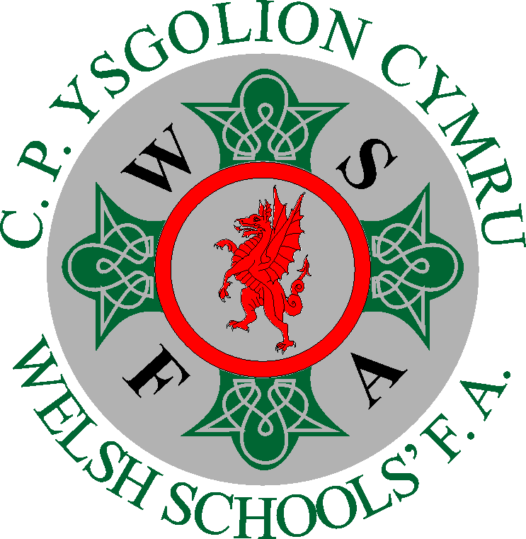 WELSH CWMDEITHAS
SCHOOLS’ PELDROED
FOOTBALL YSGOLION
ASSOCIATION CYMRU

AIMS and OBJECTIVES.

The Welsh Schools FA (WSFA) aims to encourage the mental, moral, and physical development of pupils through association football through Individual School Competitions and Inter-Association Competitions
Our objectives include providing competitions for primary and secondary school students and colleges across Wales.
WSFA also aim to provide national football opportunities for players aged u14 and u16, for both BOYS and GIRLS and International football for u18 boys.
Collaborate and develop partnerships with other organizations, such as the FAW; assisting with player development and identification.
Our aims and objectives:
Aims:
- Development of Pupils:
To foster the holistic development of young people through football, encompassing their mental, moral, and physical well-being.
Develop self-discipline, tolerance, resilience, commitment, loyalty and respect for others.
- Promote Football in Schools:
To make football a prominent sport within Welsh schools, both primary and secondary. A healthy life style choice and accessible to all.

- Education and Inspiration:
To use football as a tool for education, inspiring and educating pupils through the love of the game, enjoyment and achievement.
Promote healthy life styles, teamwork, leadership, decision making and communication skills.
- High-Quality Provision:
To ensure that school football is well-supported and of high quality, focusing on participation, enjoyment, and development.
- Equality and Inclusion:
To promote positive equality and inclusivity in football, ensuring that all children have access to the game, regardless of their gender, background or abilities.
Strive to eliminate discrimination and create fairness and respect for all.

Objectives:

- Competitions:
To organize and run competitions for students at all levels of school football, from primary to secondary.
- National and International Representation:
To provide opportunities for students to represent Wales at national level, particularly at Under 14, Under 16, and international level at Under 18 age groups for boys.
- Player Development:
To work in collaboration with the FAW to identify and develop promising young players.
To provide a developmental opportunities pathway from school, to district or county, to national and international level.
- Collaboration:
To foster strong relationships with schools, local authorities, clubs and other organizations involved in football in Wales, such as the FAW and Sport Wales.
- Support and Resources:
To provide the necessary support and resources for schools, coaches, and clubs to deliver high-quality football programmes.
- Advocate for Change:
To advocate for positive change in Welsh football, particularly in areas related to increased participation and accessibility, equality, inclusion, diversity and development.

In essence, the WSFA seeks to be a driving force in the growth and development of football within Wales, with a focus on ensuring that all young people have access to the game and the opportunity to reach their full potential.

