WELSH SCHOOLS’ FOOTBALL ASSOCIATION
CODE OF CONDUCT- PARENTS/CARERS & SPECTATORS
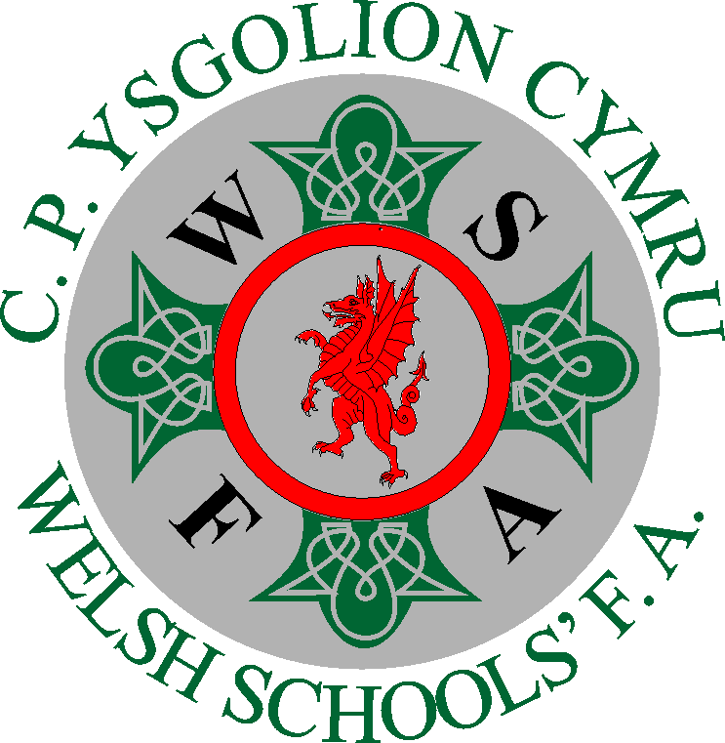

We all have a responsibility to promote high standards of conduct and behaviour in the game.

Parents have a great influence on children’s enjoyment and success in football.

Children play football because they first and foremost love the game – it’s FUN.

Remember children’s football is a time for them to develop and learn.

We want them to win but not at all costs.
We want them to learn to win and lose in the appropriate way.

Play your part by supporting your child and observe the Code of Conduct at all times.
Be positive and be a good example, showing respect for all.
PARENT/CARER, SPECTATOR
- Always encourage your child to play by the rules.
- Teach your child that losing must be accepted without undue disappointment.
- Applaud effort and good play from both sides
- Always respect the match officials’ decisions and encourage your child to do the same.
- Remain outside the field of play or within the Designated Spectators’ Areas
- Let the coach do their job and not confuse the players by telling them what to do
- Encourage your child, and others, or be quiet. Praise effort and performance, not results
- Encourage the players to respect the opposition, referee and officials
- Avoid criticising a player for making a mistake – mistakes are part of learning
- Be positive, discourage and do not tolerate, offensive, insulting, abusive or racist language or behavior.
- Parents must develop an appropriate supportive relationship with both the coach and their child, based on mutual trust and respect.
- Support the coach’s decisions and discuss any concerns directly with the coach in private.

I understand that if I need to follow the Code of conduct :Date_____________________

Parent:_______________________________ Name of player_______________________.

