PRE-K SUPPLY LIST
2026 - 2027

- 2 packs Crayola crayons (24 pack)
- 1 hard plastic folders with pockets (preferably Mead brand with additional
Clear inside pockets)
- 1 package of Crayola washable markers
- 1 pack of basket coffee filters
- 2 rolls of paper towels
- 2 boxes of Kleenex
- 3 Elmer’s glue sticks- purple
12. 2 containers of baby wipes
13. 2 bottle of clear hand soap
14. 1 full size school bag (big enough to hold a folder and towel-no rolling bags)
15. 12 Ticonderoga pencils.
16. 1 container of Disinfectant Wipes
17. 3 reams of copy paper
18. 1 pack of white 12” paper plates
19. 1 Crayola brand watercolor paint.
20. 2 cans of Lysol disinfectant spray
19. 2 individual 3 oz. containers of playdoh.
20. 1 large pack of heavy white cardstock
21. 1 box of Gallon size zip lock bags
23. 1 box of quart size zip lock bags
24. 1 small beach towel to cover with (no blankets or pillows)
25. 1 Mead (brand) Primary composition notebook (blank space at the top of
page, lines at the bottom of the page – see below)
26. 3 pack of 3 oz. plastic/paper cups
27. 1 pack of colored index cards
28 1 box of Band-Aids

PRIMARY JOURNAL:
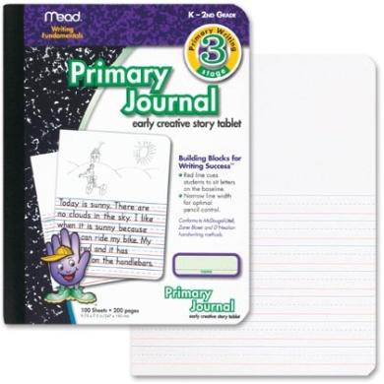
***EACH STUDENT MUST BRING A CHANGE OF CLEAN UNIFORM CLOTHES IN A ZIPLOC BAG LABELED WITH THEIR NAME. PLEASE INCLUDE UNDERWEAR AND SOCKS.

**PLEASE WRITE YOUR CHILD’S NAME ON SCHOOL BAGS, TOWELS, BLACK AND WHITE NOTEBOOKS AND FOLDERS. NAMES ARE NOT NEEDED ON THE OTHER ITEMS.

PLEASE PUT ALL SUPPLIES IN ONE LARGE BOX WITH YOUR CHILD’S NAME ON THE OUTSIDE OF THE BOX.

