

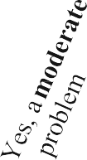

Tinnitus and Hearing Survey


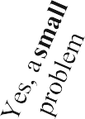
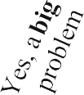
Name: Date:

Tinnitus
0 | 1 | 2 | 3 | 4
0 | 1 | 2 | 3 | 4
0 | 1 | 2 | 3 | 4
0 | 1 | 2 | 3 | 4
Total of each column
0 | 1 | 2 | 3 | 4
0 | 1 | 2 | 3 | 4
0 | 1 | 2 | 3 | 4
0 | 1 | 2 | 3 | 4
Total of each column

Over the last week, tinnitus kept me from sleeping.
Over the last week, tinnitus kept me from concentrating on reading.
Over the last week, tinnitus kept me from relaxing.
Over the last week, I couldn’t get my mind off of my tinnitus.

Hearing
Over the last week, I couldn’t understand what others were saying in noisy or crowded places.
Over the last week, I couldn’t understand what people were saying on TV or in movies.

Over the last week, I couldn’t understand people with soft voices.
Owvaserbtehienglassatiwd einekg,rIoucopuclodnnv’teursnadtieornstsa.nd what

Sound Tolerance
Over the last week, sounds were too loud or 0 1 2 3 4
uncomfortable for me when they seemed normal to others around me.*
If you responded 1, 2, 3, or 4 to the statement above:
Please list two examples of sounds that are too loud or uncomfortable for you, but seem normal to others.

*If sounds are too loud for you while wearing hearing aids, please tell your audiologist.

