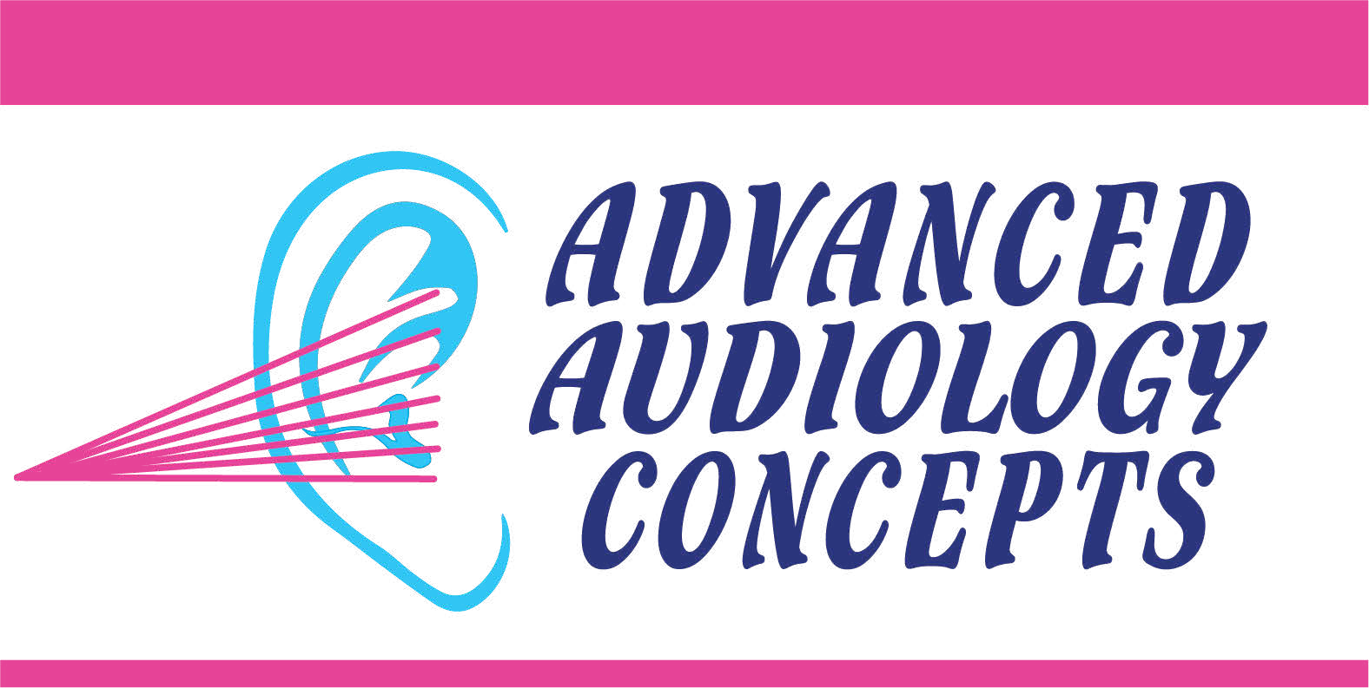
Notice of Privacy Practices

Who Follows the Privacy Practices in this Notice?
All employees, trainees, students, volunteers, and agents of Advanced Audiology Concepts, Inc (“AAC”) must follow these practices.

Our Commitment to Your Privacy
AAC is committed to maintaining the privacy of your health information in all formats (electronic, paper or verbally). We keep your health information in a secure health record. We will only use or disclose (share) your health information as described in this notice.

How We May Use and Share Your Health Information with Others?
We may use and share your health information for treatment, payment, and health care operation purposes.
-We may use and share your health information with other health care providers who are treating you or with a pharmacy that is filling your prescription;
-We may use and share your health information with your health insurance plan to get pre-approval for your treatment or to collect payment for health care services; or
-We may use and share your health information to run our business, to evaluate practitioner or provider performance, or to educate health care professionals.
We may share your health information with business associates such hearing aid manufactures and those who help us collect payment for services. All of our business associates are required to protect the privacy and security of your health information.
We may use and share your health information to contact you about health-related benefits, services, newsletters and new product information. You must opt in to receive newsletters, new product information and other materials such as birthday cards.
We may also use and disclose your health information for the following reasons:
-For public health activities (for example, to report injuries, diseases, births and deaths to a public health official authorized to receive such information);
-For workers’ compensation or similar programs that provide benefits for work-related injuries;
-To alert appropriate authorities about victims of abuse, neglect, or domestic violence; if we reasonably believe that you have been a victim of such abuse, neglect, or domestic violence, we will make every effort to get your permission before sharing this information. However, in some cases we may be required or authorized to act without your permission;
-For oversight by government or private agencies that review health care organization’s practices to ensure safety and quality activities;
-For monitoring products which may need repair or are being recalled (for example, to satisfy FDA requirements);
-To create and disclose de-identified (does not have your name, SS#, etc.) health information or limited data sets that do not have direct identifiers about you;
-For judicial and administrative proceedings (for example, a court order);
-For law enforcement purposes (for example, to identify or find a suspect or missing person, or to report a crime that occurred on or off our property);
-To coroners, medical examiners, or funeral directors as necessary to do their jobs;
-To organizations that handle organ, ear or tissue donation;
-To avoid a serious threat to health or public safety; For specialized government functions;
-Incidental uses and disclosures (for example, if a patient or staff member overhears a discussion at the front desk even when reasonable steps were taken to keep your information confidential); and
-As otherwise required or allowed by local, state or federal law.
If you give us permission, we may use or share your health information for:
-Payment for your care such as a family member assisting in payment Uses and disclosures of your health information that involve marketing, payments from a third party, or any other use or disclosure not described in this notice or required by law will only be made with your written authorization (permission). You have the right to withdraw (take back) your authorization, except when we have already relied on it, by contacting our privacy official provided below.

SMS Messages Privacy Policy:
No mobile information will be shared with third parties/affiliates for marketing/promotional purposes. All the above categories exclude text messaging originator opt-in data and consent; this information will not be shared with any third parties.

What Rights do you have About Your Health Information?
Although your health record is the property of AAC, you have the right to:
Request restrictions on how we use or share your information for treatment, payment, and health care operations, and how we may share it with your family and friends. We are not required to agree to your request, except when you pay for services out-of-pocket, in full and request us not to share the health information with your health insurance plan.
-Request confidential communications of your health information.
-Review and copy health information in your medical and billing records upon written request. If you request an electronic or paper copy of your health information, one will be provided to you within 3 to 10 days of your request. You may be charged no more than .75¢ per page for paper copies. For electronic copies, we may also charge you a reasonable fee for using electronic media.
-Request amendment (changes) to information in your medical and billing records. You must make your request to change, in writing and provide a reason for the request. We are not required to agree to your request, but will let you know in writing, and state a reason, when we do not agree. If we agree, your suggested amendment will be added to your record.
-Receive an accounting of disclosures. An “accounting of disclosures” is a report that identifies certain other people or organizations to which we have disclosed your health information without your authorization. (See the section on “We may also use and disclose your health information for the following reasons” for an explanation of who might be included.) You have a right to receive one accounting of disclosures every 12 months without charge; however, we may charge you for the cost of providing any additional accounting in the same 12-month period.
-Name a personal representative who may act on your behalf to control the privacy of your health information. Parents and guardians will generally have the right to control the privacy of health information of minors (children under 18 years old) unless the minors are permitted by law to act on their own behalf. There may also be exceptions to this per individual state law.
-Ask for and be given a paper copy of this notice.
-Request additional privacy protections with respect to your electronic medical record.
Requests must be made in writing to the privacy official or appropriate doctor’s office or hospital department. For more information or to get a designated request form, please contact the privacy official provided below.

What are Our Duties about Your Health Information and this Notice?
We are required by federal and state law to keep the privacy and security of health information that may tell your identity. If there is a breach of privacy that compromises your identifiable health information, we will notify you in writing or by email.
We are required to provide you with a copy of this notice and agree to the terms of this notice. We reserve the right to change the terms of this notice; the revised notice will be effective for all health information that we keep. We will post any revised notices on our public website at www.aacHEAR.org and in admitting or waiting room areas. You may also request a paper copy of the revised notice at the time of your next visit.
If you have any questions about this notice or believe your privacy rights have been violated, please contact us at:

Advanced Audiology Concepts, Inc 8897 Mentor Ave.
Mentor, Ohio 44060 440-205-8848
You may also contact the Secretary of the United States Department of Health and Human Services. We will not retaliate or take action against you for filing a complaint.

REQUEST FOR ACKNOWLEDGMENT
An acknowledgement form will be printed for you to sign during your registration process. By signing the Notice of Privacy Practices Acknowledgment Form, you are confirming that you have received a copy of this notice.
This notice is effective as of 02-03-14.

