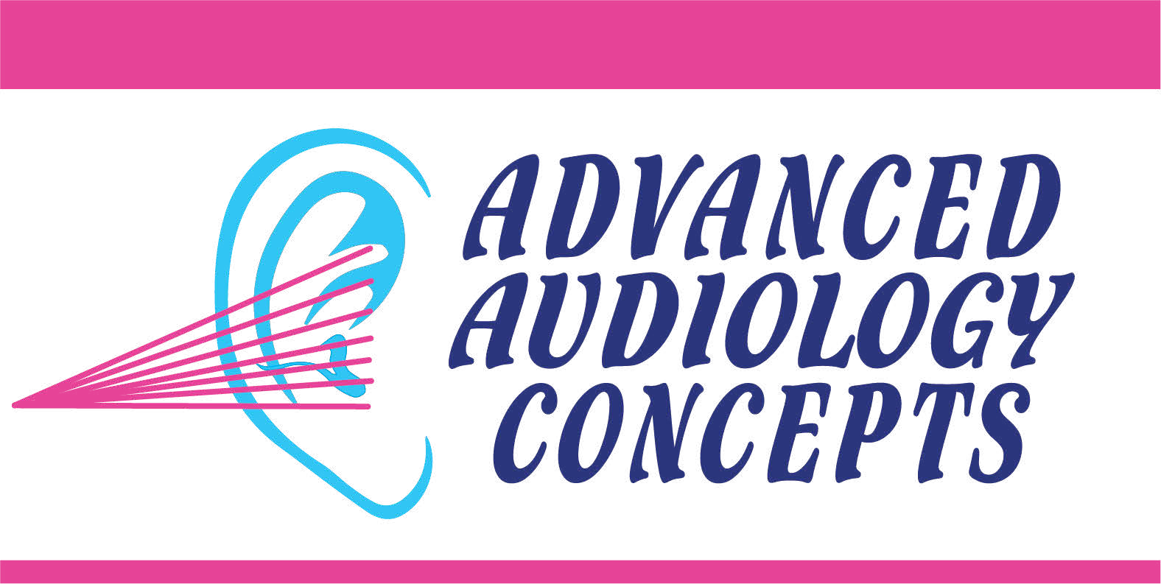
8897 Mentor Ave., Mentor, Ohio 44060
1-440-205-8848

Lyric Consent Form

Name: Date:
I have been given information about my hearing condition and consent is hereby voluntarily given for a Lyric Extended Wear Fitting and Sizing.
I confirm the Lyric extended wear fitting and sizing procedure, alternatives to the Lyric and potential gains and risks of wearing a Lyric device have been explained to my satisfaction by the audiology staff. I have also been provided and have reviewed, the Lyric user manual, and my questions about the Lyric device have been answered by the audiology staff.
Risks and warning associated with the fitting, sizing, and use of the Lyric:
- Lyric extended wear fitting and sizing risks are rare and include abrasion, discomfort, soreness, bleeding, infection and pain.
- Do not submerge your head in water while wearing Lyric. Water submersion may cause damage to early failure to the device.
- Do not scuba dive or dive under water. Diving while wearing the Lyric may cause injury to your ear or damage the device.
- Do not put cotton swabs or anything else in your ear canal. You should not attempt to remove earwax from your ear canal while Lyric is in place. It may injure your ear or damage the device.
- Lyric must be removed before you have an MRI because it contains metal parts.
- If Lyric stops working for any reason, it must be removed within 24 hours, and you should return to your audiologist for an examination of your ear canal and Lyric refitting.
- Lyric does not restore normal hearing and it will not prevent or improve a hearing impairment resulting from organic conditions. In most cases, infrequent use of hearing device does not permit a user to attain full benefit from it. The use of a hearing device is only part of hearing rehabilitation and may need to be supplemented by auditory training and instruction in lip reading.
- Call 440-205-8848 immediately, if the device malfunctions, you experience pain beyond the initial general discomfort, or if you experience a sudden or significant change in your hearing. If you experience pain or discomfort beyond the initial general discomfort remove the device/s from your ear/s.
In addition to procedural consent, I give approval during the procedure to utilize the service of an assistant and/or allow observation of the procedure.
Signature: X Date:

Witness signature: Date:

