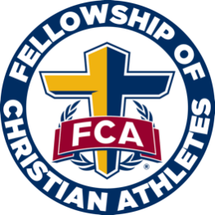
Coweta FCA Elementary Lesson Plans
Morning of Worship
Memory Verse
“A gossip betrays a confidence, but a trustworthy person keeps a secret” (Proverbs 11:13)

Definition
Biblical definition of worship:
1. Acknowledging God's Worth:
- Worship is fundamentally about recognizing God's supreme value and giving Him the honor He deserves.
- It involves understanding His holiness, power, and love, and responding with reverence and awe.
2. More Than Just Ritual:
- While worship can include singing, prayer, and other expressions of praise, it is not limited to these.
- Biblical worship encompasses a lifestyle of obedience, love, and service to God and others.
- It involves aligning one's thoughts, words, and actions with God's will, reflecting His character in daily life.
3. Spirit and Truth:
- Jesus emphasized that true worship is offered "in spirit and in truth" (John 4:24).
- This means worship should be genuine, coming from the heart, and based on a true understanding of God's Word.
- It is not merely a rote performance but a heartfelt response to God's revelation.
4. Holistic Response:
- Worship is not just an individual activity but also a corporate expression.
- It can be expressed through acts of praise, prayer, service, and even suffering for one's faith.
- Ultimately, worship is a reflection of a transformed life, acknowledging God's Lordship in all aspects of existence.

Worship Music
Worship Leader provided by Pastor Josh or a worship leader from your church.

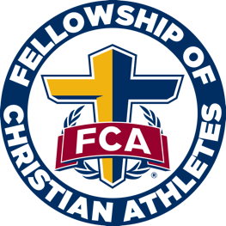
Campus Huddle Checklist
□ Speaker confirmed?
□ Do you have a printed list of who is registered to attend your campus huddle? All students who attend must be registered. If someone shows up and is not registered, please have a form ready to send home or contact the parent to register for the next meeting.
□ Music selected and equipment/supplies ready?
□ Are you having breakfast? If so, has it been ordered?
□ Do you need paper goods for breakfast?
□ Are you doing any type of take away item?

Prepare for Campus Huddle
- Print out definitions and memory verse as well as any take home papers.

Campus Huddle Suggested Itinerary

Suggested Template and Time Frame
Depending on your time constraints, this may be changed to fit the needs of your school.

7:00-7:05 – Check-in
Please have a checklist of all registered students available. Students must register before they can attend.

7:05-7:15 – Large group worship, no more than 3 songs when combined with a game.
Songs can be led from You Tube or can be presented by a worship leader.

7:15-7:30 – Speaker
This should be a coach, children’s pastor, student pastor, church staff, or school staff. Please keep in mind that whoever the speaker is, they MUST be preapproved by FCA staff. We will have some contacts of speakers on the Coweta FCA Elementary resources page on our website at CowetaFCA.org.

7:30 – Dismissal
- Always close in prayer prior to dismissing the students, you could have the speaker, a student (who was asked beforehand), or Coweta FCA staff pray.
- You could have the students do prayer requests on index cards as they leave.
- Many schools like to dismiss to music.
- Some schools prefer to hand breakfast out as the students leave.

