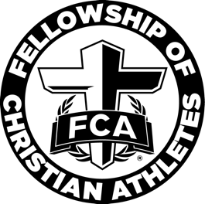

Coweta FCA Elementary Lesson Plans
Competition

Game Time

Cup Stacking Game
Materials: 36 plastic cups or however many you want to make a triangle (like a pyramid)

How to Play:
Divide into teams. Stack 36 plastic cups into a triangle. The team who can stack their pyramid without falling, wins. If it falls, they start over. You can make this harder by blindfolding the person who is stacking.

Big Idea
We compete not for ourselves, but to glorify Jesus.

Memory Verse
“Whatever you do, work heartily, as for the Lord and not for men.” Colossians 3:23

Definitions
Biblical definition of competition: Doing what is necessary to earn “the prize” for its own sake, not for the sake of beating others

Bible Story
Matthew 4:1-11, Luke 4:1-13

Our Bible story teaches us about competition and temptation. God led Jesus into the wilderness. It was a time of temptation for Jesus and competition with the devil. The devil wanted Jesus to sin or do things God would not want Him to do. God was with Jesus and helped him to do what was right. Jesus was in the wilderness for 40 days. He did not eat (or fasted) for 40 days. He was very hungry. When we are hungry, it can be hard to make good choices.

The devil used this time to tempt Jesus into doing the wrong thing or sinning. (A sin is when we go against God’s laws or rules). The devil told Jesus, “If you are God’s son, turn these stones in to bread.” Jesus said, “Man needs God’s words more than bread!”.

The devil took Jesus to the top of the temple and said, “If you are God’s Son, jump down. God’s Word says He will not let You get hurt.” Jesus said, God’s word tells us ‘Do not test God!’

The devil then took Jesus to a high mountain and showed Him the earth. The devil said, “I will give You all of this if You worship me.” Jesus said, “Go away! God’s Word says to only worship God!” The devil went away, and God sent angels to take care of Jesus.

Jesus will always win. He is the only perfect person who never sinned. The devil will always be present and trying to compete with us to have us do something wrong. Jesus will help us to win and to resist temptation.

Devotion
Is competing with a friend or another team bad? Not always, but one sure way to be unhappy in life and displeasing God is to compete with others. The world often follows Satan and not God. Satan tried to compete with God. Do you think he won? No way! Jesus will always win against evil. It is better to keep our mind on Jesus. He will help us in any situation.

We should not live our lives how others do. We have God on our side, and we should live our lives for Him and not others. We should find joy not by competing with others but by living for Jesus.

Discussion Questions
- Who led Jesus into the wilderness? (The devil)
- What did Jesus say God’s Word said (He will not let You get hurt)
- Who is the only person we can worship? (God/Jesus)
- Did Jesus turn the stones into bread? (No, He said people need God’s words more than bread)
- Will God always take care of us? (Yes. God will always take care of us. He has a plan for our lives and His plan is always good)

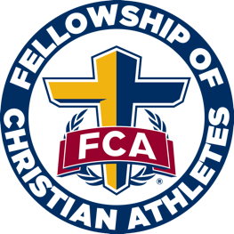
Campus Huddle Checklist
□ Speaker confirmed?
□ Do you have a printed list of who is registered to attend your campus huddle? All students who attend must be registered. If someone shows up and is not registered, please have a form ready to send home or contact the parent to register for the next meeting.
□ Music selected and equipment/supplies ready?
□ Are you having breakfast? If so, has it been ordered?
□ Do you need paper goods for breakfast?
□ Are you doing any type of take away item?

Prepare for Campus Huddle
- Print out definitions and memory verse as well as any take home papers.

Campus Huddle Suggested Itinerary

Suggested Template and Time Frame
Depending on your time constraints, this may be changed to fit the needs of your school.

7:00-7:05 – Check-in
Please have a checklist of all registered students available. Students must register before they can attend.

7:05-7:15 – Large group worship, no more than 3 songs when combined with a game.
Songs can be led from You Tube or can be presented by a worship leader.

7:15-7:30 – Speaker
This should be a coach, children’s pastor, student pastor, church staff, or school staff. Please keep in mind that whoever the speaker is, they MUST be preapproved by FCA staff. We will have some contacts of speakers on the Coweta FCA Elementary resources page on our website at CowetaFCA.org.

7:30 – Dismissal
- Always close in prayer prior to dismissing the students, you could have the speaker, a student (who was asked beforehand), or Coweta FCA staff pray.
- You could have the students do prayer requests on index cards as they leave.
- Many schools like to dismiss to music.
- Some schools prefer to hand breakfast out as the students leave.

