**QI Initiative Worksheet**

**QI Intervention Expectations**

Starting your QI Initiative

* Establish an inter-professional improvement team (ideally including a patient or family member.)
* Meet weekly or at least bi-weekly (every two weeks) during the initiative.
* Follow the steps in the QI Initiative process workbook.

**Step 1- Form Inter-professional Team**

The first step of any improvement effort is the formation of an interprofessional team. The team should have representation from each component of the care team that cares for these patients. This includes clinical and non-clinical staff. The team members will be responsible for sharing information and getting feedback from their peers. It is also recommended that you consider adding a patient partner to the team. The patient partner can provide insight into the QI work.

|  |  |  |  |
| --- | --- | --- | --- |
| **Team Members Name** | **Role** | **Team Members Name** | **Role** |
|  |  |  |  |
|  |  |  |  |
|  |  |  |  |
|  |  |  |  |
|  |  |  |  |
|  |  |  |  |

**Step 2- Determine Time and Location for Weekly QI Meeting**

Establishing a consistent date, time, and location to meet is important to establish a rhythm of improvement. It also makes it easier for busy staff to have a consistent meeting that can be worked into their routine schedule. To ensure that those who are not able to join in person can still participate, it is important to identity a conference line or a virtual meeting platform (Teams, Zoom, etc.) so, those who are not present can still be an active member of the improvement team.

|  |  |  |  |
| --- | --- | --- | --- |
| Day/Frequency | Location | Time | Platform |
|  |  |  |  |

**Step 3 Baseline Data- What matters to you and the people you care for?**

Before starting any improvement effort, you need to first understand the current environment in which you are going to do the work and where the problem was identified. This process can also help to identify potential areas in need of improvement and provide a baseline for your work. The chart below breaks the data down into three categories: Clinical, Operational and Financial. The Clinical bucket includes any patient clinical/biological or functional measures relevant to the system and or patient population of interest. Operational examples could include patient mix and demographics, staff and patient satisfaction, staffing levels, patient wait times, process cycle times, referral patterns, etc. Financial data could include insurance mix, medication/supply cost, hospitalization rates, length of stay, staff cost, emergency, and urgent care visits, etc.

The first step is to identify the location of the data and its availability. Some data will be available through your EMR, a registry, organizational data warehouse, and state or federal databases. You may need to collect some data yourself to ensure that you have all the information you need to proceed with your improvement. This short cycle sampling can be very helpful to verify data from other sources, engage others in the work and to put the data in context.

|  |  |  |  |  |  |
| --- | --- | --- | --- | --- | --- |
| Clinical | | Operational | | Financial | |
| Topic | Data | Topic | Data | Topic | Data |
|  |  |  |  |  |  |
|  |  |  |  |  |  |
|  |  |  |  |  |  |
|  |  |  |  |  |  |
|  |  |  |  |  |  |

Insert Charts/Graphs

Graphical representation of the data makes it easier to identify data trends and relationships that may be lost in a data table. It also allows you to post the data so that other staff, providers, leaders, and patients can follow the work and provide input for the team. Consider creating a dashboard of metrics that are important to you and your clinic for monitoring the systems of care that are in place to support your patients and staff.

**Step 4- Assess Current Process flows (insert here)**

Part of understanding the current system context is to have a clear understanding of the various processes and systems of care. You can do this by creating processes flows. When creating the process flows you may find confusion on steps in the processes or find that there is no standard process at all. The list below is noted as examples only. You should choose processes that are relevant to your area.

**Clinic/Unit Flow**

**Phone and Triage Flow**

**Patient Electronic Communication Flow**

**Patient Notification (lab, radiology, referrals,)**

**Falls Monitoring**

**Discharge planning**

**Unit scheduling**

**Other Process flows that matter to you and your patients.**

**Step 5- Assess Staff/Patient/Organization Ideas for Improvement**

At this time, an area of focus or problem may already be identified, or the team may be reviewing data looking for needed improvements. The team needs to assess the ideas of the other staff, providers, and patients on what they feel are areas of opportunity for improvement. The team can review current survey data or develop brief short cycle surveys to gain a better understanding from those who work in and those who receive care in the clinic. There are many QI tools available to help with this assessment.

|  |
| --- |
| Top 5 Ideas for Improvement Focus |
| 1. |
| 2. |
| 3. |
| 4. |
| 5. |

**Step 6- Determine Area(s) of Focus**

Once you have reviewed all the data, clinic identified top 5 ideas on areas of opportunity and your process flows, you can brainstorm potential areas to focus your improvement efforts. You can identify more than one potential area and then determine which improvement you will start with before proceeding with the others.

|  |
| --- |
| 1. |
| 2. |
| 3. |
| 4. |

**Step 7 - Determine Global Aim**

Now that you have narrowed down the possible areas to improve, you can take the next step to focus your improvement on a specific process (Global Aim). You will then narrow that down to a specific area within that process (Specific Aim). It is important to do a process flow that encompasses the process outlined by the Global Aim. (Process begins with and ends with statement.)

|  |
| --- |
| We aim to improve: _____________________________________________________________ |
| In/at: _________________________________________________________________________ |
| The process begins with: _________________________________________________________ |
| The process ends with: ___________________________________________________________  By working on this process, we expect: _______________________________________________  It’s important to work on this now because: __________________________________________ |

**Step 8- Determine Specific Aim**

|  |
| --- |
| We will: p improve p increase p decrease |
| The: p quality of p number/amount of p percentage of ________________________ |
| By or From: ____________________________________________________________ |
| To or By: _________________________________________________________________ |
| By: ____________________________________________________________ |
| (date) |

**Step 9 - Determine Cause and Effect- What do you think is affecting (causing) the current outcomes? (This will help you in determining change ideas.)**

People

Equipment

Put Desired Outcome or Current Outcome Here

Process

Environment

**Step 10- Brainstorm Change Ideas- Choose 1 to Test**

Select change ideas that you feel would address the issues outlined by the fishbone diagram and are linked to your Global and Specific Aims.

|  |
| --- |
| List Possible Change Ideas |
|  |
|  |
|  |
|  |
|  |
|  |
|  |
|  |

**Step 11- Determine Plan/Do/Study/Act Cycle to Test Your Change**

**Plan**

|  |  |  |  |  |
| --- | --- | --- | --- | --- |
| **Task** | **Who** | **When** | **Tools Needed** | **Measures** |
|  |  |  |  |  |
|  |  |  |  |  |
|  |  |  |  |  |
|  |  |  |  |  |
|  |  |  |  |  |
|  |  |  |  |  |
|  |  |  |  |  |
|  |  |  |  |  |
|  |  |  |  |  |

**Step 12- Determine Measures to monitor if the change idea had the desired effect.**

|  |
| --- |
| Change Idea: |
| Measurement Conceptual Definition (what will you measure): |
| Operational Definition (how will it be measured): |

**Data Collection Plan**

|  |  |  |  |
| --- | --- | --- | --- |
| Who  (Who will collect the data?) | What  (What data will be collected?) | How  (How will it be collected?) | When  (When will it be collected?) |
|  |  |  |  |
|  |  |  |  |
|  |  |  |  |
|  |  |  |  |
|  |  |  |  |
|  |  |  |  |
|  |  |  |  |
|  |  |  |  |
|  |  |  |  |
|  |  |  |  |

Do- Test Your Change- Repeat until you reach your goal.

|  |
| --- |
| Cycle 1 |
| What (will be done) | Who (will do it) | How (will it be done) | When |
|  |  |  |  |
|  |  |  |  |
|  |  |  |  |
|  |  |  |  |

|  |
| --- |
| Study- What was learned? |
|  |
|  |
| Act- What will be changed or standardized? |
|  |
|  |

|  |
| --- |
| Do- Cycle 2- Apply changes |
| **What** | **Who** | **How** | **When** |
|  |  |  |  |
|  |  |  |  |
|  |  |  |  |
|  |  |  |  |

|  |
| --- |
| Study- What was learned? |
|  |
|  |
| Act- What will be changed? |
|  |
|  |

**Step 13- Standardize- Once You Meet Your Goals**

1. What will you need to “stop doing” in order to make this the “new normal”?
2. Is training required?
3. Need to create a new Policy and Procedure?
4. How will you monitor and ensure your new process continues to meet its goals?
5. How frequently will you review to ensure new process is being sustained?
6. Create a new standard operating procedure to reflect the new process as well as how it will be monitored and sustained.

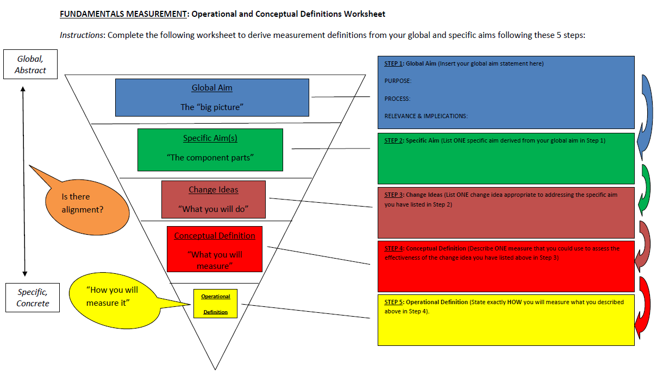

(Used by permission Dr. Brant Oliver)

References:

1. Godfrey. (2013). *Improvement Capability at the Front Lines of Healthcare: Helping through Leading and Coaching*. Retrieved from <http://hj.diva-portal.org/smash/record.jsf?pid=diva2%3A640804&dswid=-944>

2. Lipmanowicz. (n.d.). *Buy-In v. Ownership*. Retrieved from<http://static1.1.sqspcdn.com/static/f/1272828/17864115/1335380597587/Buy-In+v.+Ownership.pdf?token=svxyxzaPu2z9PBaWD7KcITtr7rA%3D>

3. Godfrey MM, Oliver BJ (2014). Accelerating the rate of improvement in Cystic Fibrosis care: Contributions and insights of the Learning and Leadership Collaborative. BMJ Quality &amp; Safety; 23:i23-i32.

4. Donabedian, A (1988). "The quality of care: How can it be assessed?" JAMA. 260 (12): 1743–8. doi:10.1001/jama.1988.03410120089033

5. Nelson, E. C., Batalden, P. B., & Godfrey, M. M. (2011). *Quality By Design*. John Wiley & Sons.

‌6. Godfrey, Foster, Johnson (2024). *Quality by Design: A Clinical Microsystems Approach 2nd Edition.* Jossey-Bass.

7. Oliver, B. J., & Ogrinc, G. S. (2022). *Practical Measurement for Health Care Improvement*.

‌8. Clinicalmicrosystem.org. https://clinicalmicrosystem.org/