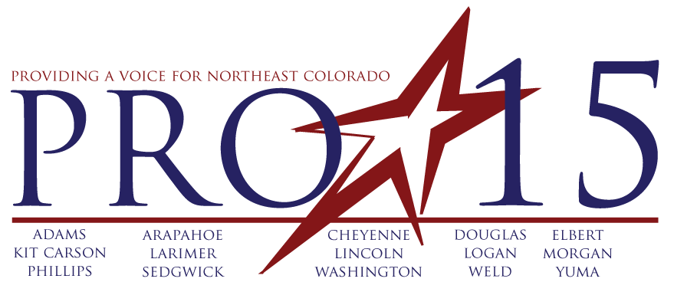

RESOLUTION TE 2014-2

REGARDING EPA’S PROPOSAL TO REGULATE CARBON DIOXIDE EMISSIONS FROM EXISTING FOSSIL FUEL-FIRED POWER PLANTS

WHEREAS, Colorado has abundant natural resources that has been instrumental in growth and development throughout the region; and

WHEREAS, Colorado benefits from a diverse mix of energy sources that include coal, natural gas, and hydro and renewables; and

WHEREAS, maintaining a diverse, reliable, and affordable energy supply is vital to economic growth in the Western region; and

WHEREAS, on June 2, 2014, the U.S. Environmental Protection Agency (EPA) issued proposed guidelines under Section 111(d) of the federal Clean Air Act to reduce carbon dioxide (CO₂) emissions from fossil fuel-fired power plants in 49 states; and

WHEREAS, EPA’s proposal requires Colorado to significantly reduce the CO₂ emissions rate of its electric generating fleets;

WHEREAS, EPA projects that its proposal will increase electricity and natural gas prices for consumers and cause the retirement of 49,000 megawatts of coal-fueled electric generating capacity; and
WHEREAS, EPA’s proposal is based on emission reduction measures that directly involve the regulation of electricity by the states; and

WHEREAS, EPA’s proposal will have a major impact on energy resources, electric ratepayers, jobs, and the economy of the Western region.

NOW, THEREFORE, BE IT RESOLVED, that Progressive 15 finds that EPA’s proposed guidelines for reducing CO₂ emissions from fossil fuel-fired power plants under Section 111(d) of the federal Clean Air Act interfere with the sovereign power of Colorado to regulate electricity within its borders; and

NOW, THEREFORE, BE IT RESOLVED, that Progressive 15 finds that EPA’s proposed guidelines interfere with the prerogative and responsibility of Colorado to ensure a reliable and affordable supply of electricity for its citizens; and

BE IT FINALLY RESOLVED, that Progressive 15 urges EPA to withdraw the proposed guidelines and issue new guidelines that respect the primacy of the various states to establish policies that are in the best interest of the Western region and each of its states.

Adopted this __________day of July, 2014

