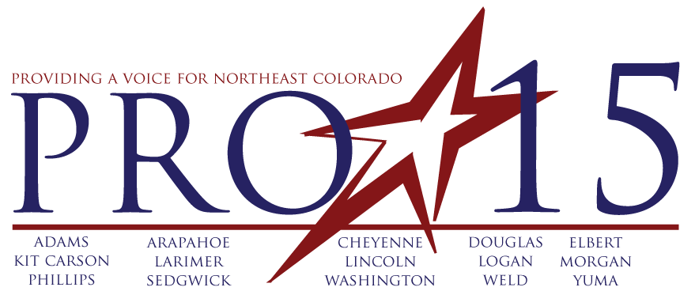
Progressive 15 Resolution
TE 2014 – 1

A RESOLUTION ENCOURAGING CONGRESS TO ADDRESS THE SHORTFALLS IN FEDERAL HIGHWAY TRUST FUND AND COMPLETE A LONG-TERM TRANSPORTATION REAUTHORIZATION BILL PRIOR TO ITS EXPIRATION ON SEPTEMBER 30, 2014.

WHEREAS, transportation is a critical factor in our economy. This is true locally, statewide and nationally. The United States has been nearing a crossroads in surface transportation for many years but this year the crossroads could result in a roadblock; and

WHEREAS, the Ports-to-Plains Alliance has provided Ports-to-Plains’ Congressional delegation with its Federal Priorities of the Ports-to-Plains Alliance for MAP-21 Implementation and Reauthorization and these Federal Priorities describe a short term and a longer term funding issue; and

WHEREAS, the Ports-to-Plains Alliance and Progressive 15 supports a user fee increase and indexing required to meet current funding levels and to expand transportation funding lost due to inflation in the past twenty years since the user fees were last changed; and

WHEREAS, the Ports-to-Plains Alliance and Progressive 15 supports a five or six year reauthorization bill, which is consistent with previous surface transportation bills and necessary for proper long-term planning. Operating under a series of short-term extensions is problematic and difficult on federal and state transportation agencies; and

WHEREAS, Progressive 15 endorses two priorities to ensure projects like the Ports-to-Plains Corridor, North America’s Energy Corridor, and other critical transportation projects can continue.

NOW THEREFORE, BE IT RESOLVED BY THE BOARD OF DIRECTORS OF PROGRESSIVE 15 THAT:

Section 1. We urge you, as Members of Congress representing the 15 County Progressive 15 Region in (Northeast Colorado) to work to ensure that Congress--

- Passes a short-term fix immediately so that the Trust Fund does not run out of money in August, 2014; and

- Passes a long-term fix by September 30, 2014, or as soon thereafter as possible, that accomplishes the following:
  - Reauthorizes Federal transportation programs (MAP-21) for five or six years in accordance with Ports-to-Plains Alliance priorities; and
  - Provides the user-fee-based, sustainable revenues for the Highway Trust Fund necessary to support the higher levels of investment needed to modernize the America’s national transportation network, including rural freight corridors are critical to energy development and agricultural production in Colorado.
Section 2. This resolution to be in full force and effect from and after its passage and approval.
Adopted this _______ of ____________, 2014.

