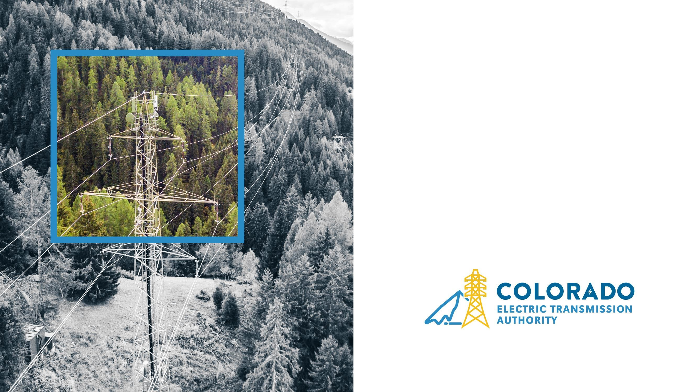
PRO 15 FALL
CONFERENCE
Oct. 17, 2024
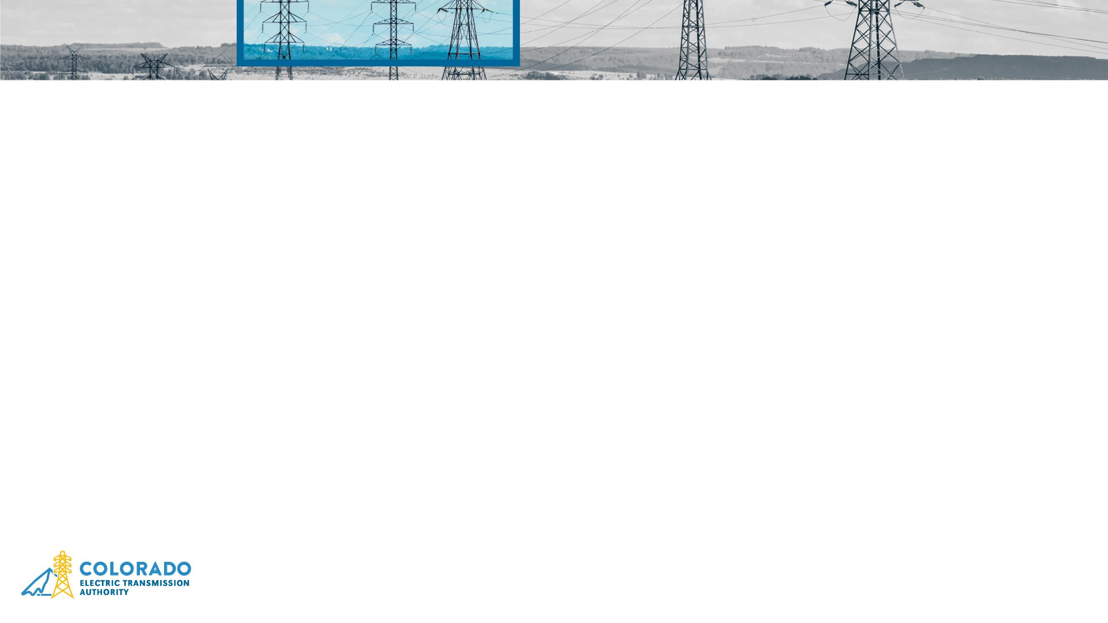
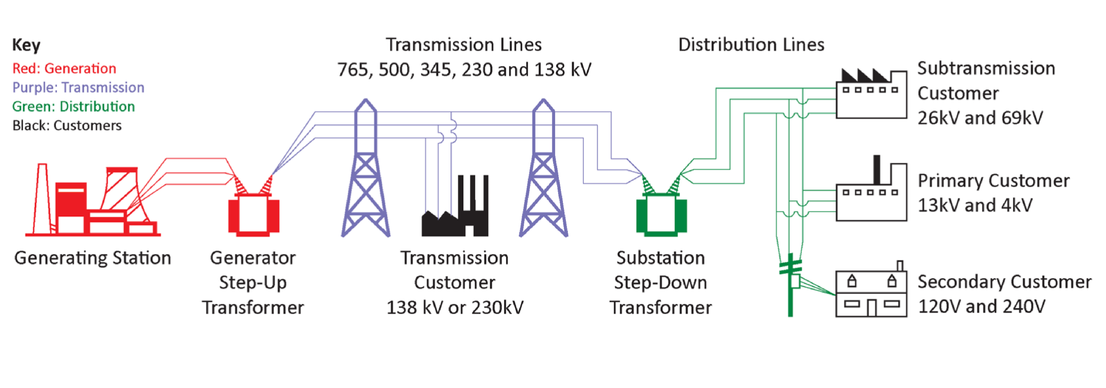
The Electric Grid
Source: NERC,
Understanding the Gri
d
,
March 2023.
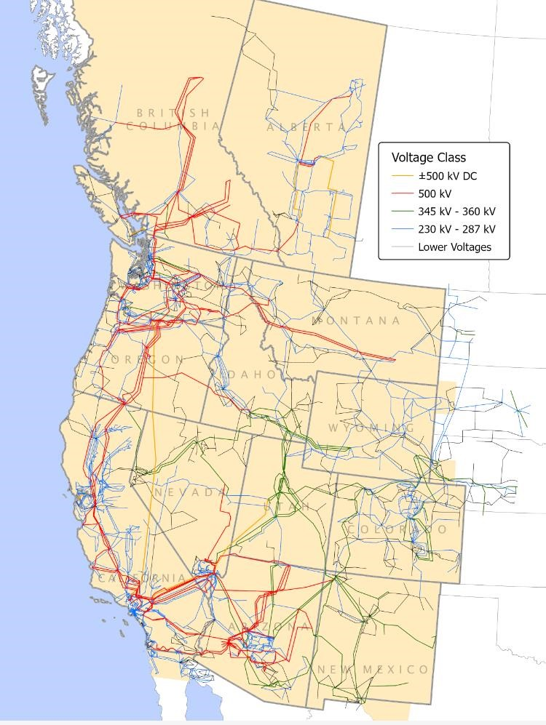
The Western Interconnection
- One big synchronous grid
- Better interconnections support reliability
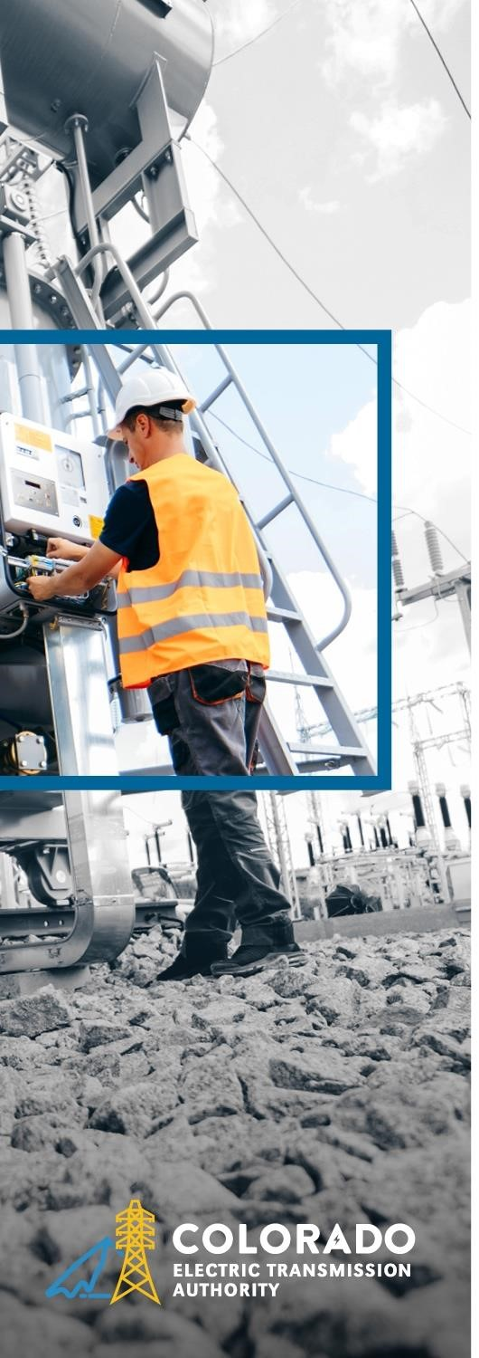
- Organic growth may not have been the most efficient
Source: WECC, Western Interconnection, accessed July 2024.
How Does Colorado’s Grid Compare?
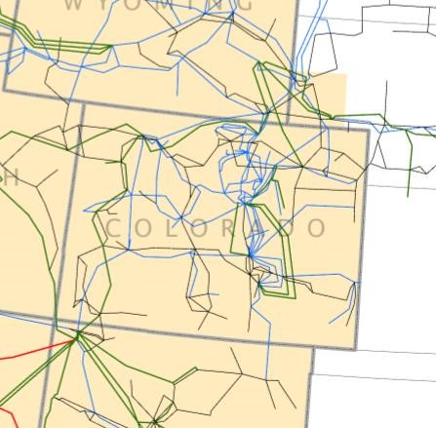
Electrically isolated:
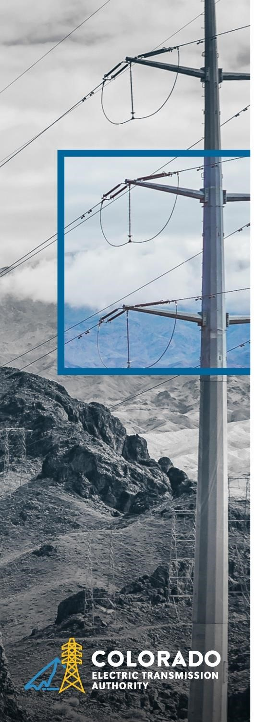
- East-west interconnection boundary on CO’s eastern border
- Limited lines to the west
- North-south lines are few and do not span weather patterns or time zones
Powers:
•
Enter into

public
-
private partnerships for
transmission expansion
•
Identify and establish transmission corridors in
the state, subject to local use permits
•
Issue revenue bonds
•
Use eminent domain for right
-
of
-
way
acquisition
Who is CETA?
Mission
:
engage in transmission planning activities to 1) increase grid reliability, 2)
help CO meet its clean energy goals, and 3) aid in economic and community
development
Organizational Structure:
•
Independent special purpose authority and
subdivision of the state
•
Not subject to direction by a state agency
or commission
•
9
-
member appointed board
Source:
Sect. 4
0
-
4
2
-
10
4
,

CRS

Economic
development
Reliability and
Security
Lower Energy
Cost
State Policy
Planning Gaps
Increasing electric
demand: data
centers,
electrification,
EVs,
manufacturing
Increase the
optionality of the
system: resource
and time zone
diversity
Market access:
avoid
overbuilding
locally and ability
to seek lower cost
generation
State clean energy
goals: changing
generation mix
CETA as the
provider of last
resort: where
existing utilities
don’t want to
build
Why do we need transmission and CETA?
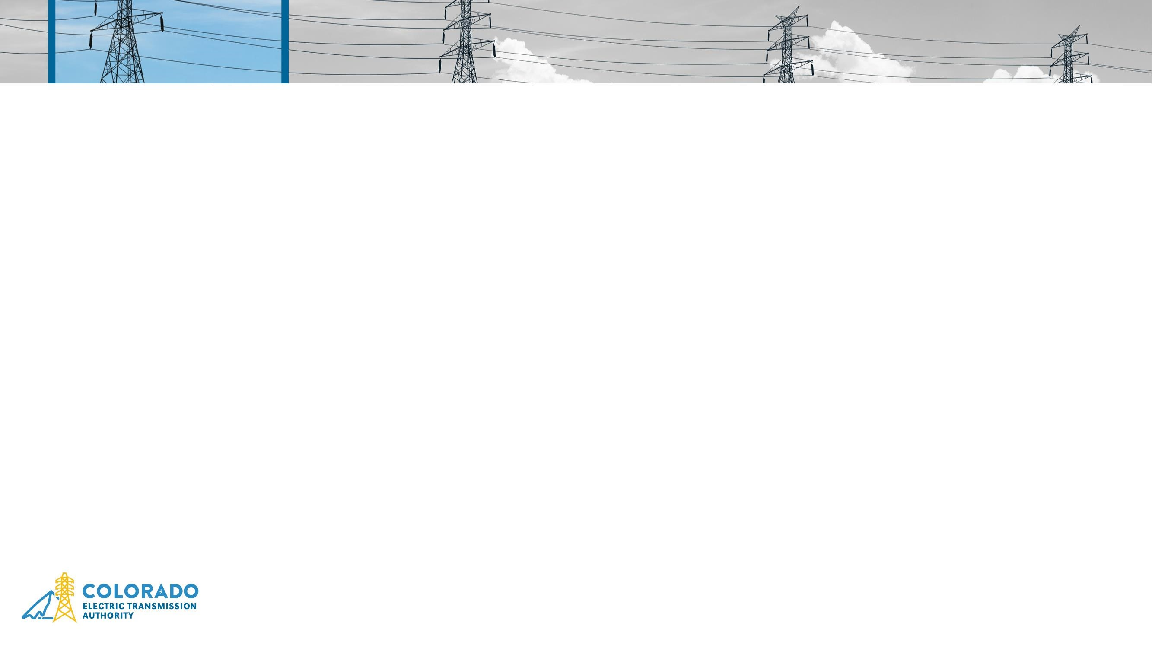
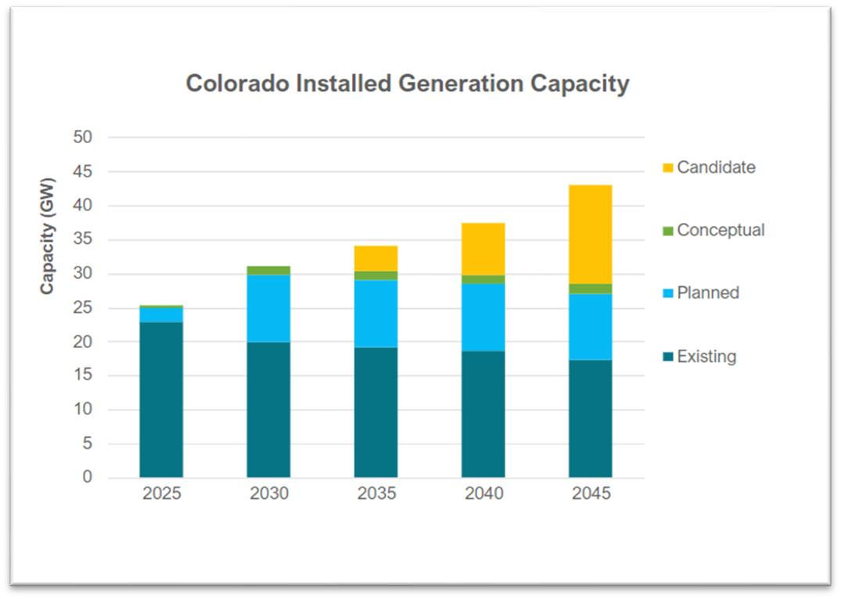
What does Colorado's electric future look
like?
2023
Legislation
:

to study the need for expanded transmission capacity in the state
•
Least cost resource portfolio to meet long
term planning and policy constraints
•
Extrapolations from utility Electric
Resource Plans, demand forecasts
Source:
Sect. 4
0
-
4
2
-
10
9
, CRS and
CETA Study May 2024 presentatio
n
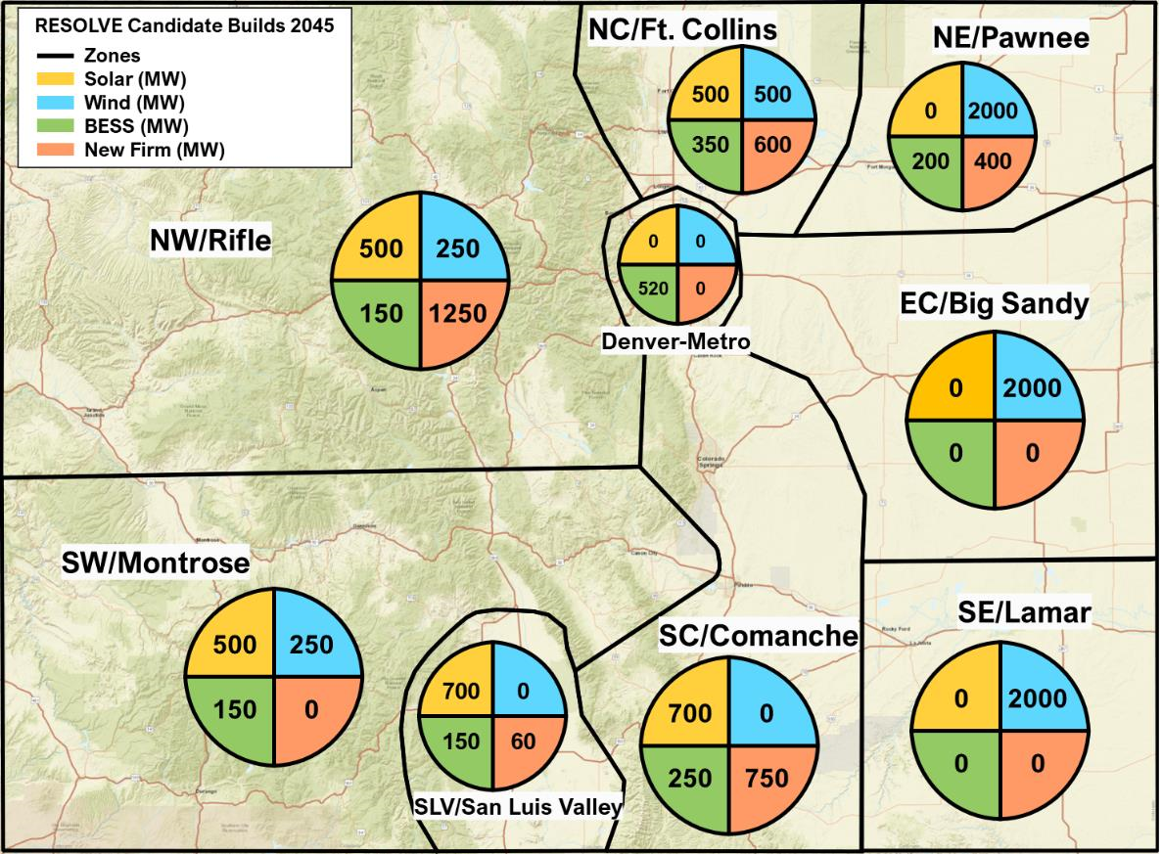
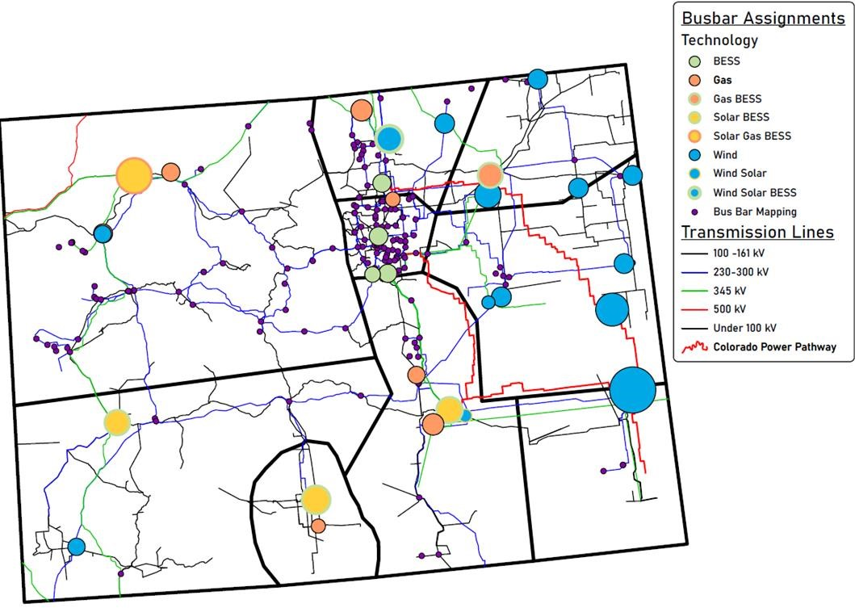
Where is development expected to happen?
Source:
CETA Study July 2024 presentatio
n
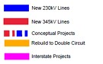
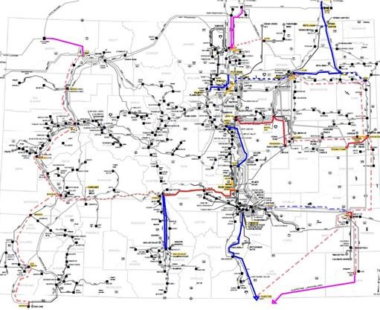
•
Reference Case Projects:

$4.2 B in needed
investment.

Roughly 30% is reconductoring
projects.

Remaining 70% is new build.
•
Interstate Projects:

Roughly $752 M to enhance
Colorado’s connections to Wyoming, Utah, and New
Mexico.

•
Conceptual Projects:

Additional $4.6 B in investment
opportunities.
•
Scenario Projects:
Additional $4.2 B in investment
under High Demand scenario. Additional $160 M to
$396 M to deliver SPP wind generation to Colorado (not
including cost of expanding DC ties).
What does this mean for transmission needs?
Source:
CETA Study July 2024 presentatio
n
How are we going to do this?
Purpose:

to develop a principled, inclusive approach to community engagement
to guide CETA’s partnership terms
Introduced
Project
Research
Study
Session I
Draft
Study
Session II
Revisions
Final
Feb. 8
Mar.
-
Apr.
April 30
June 13
July 15
Jul.
-
Aug.
Oct.
n
Workpla

Literature
revie
w
Presentations

and
n
discussio

Draft Board
principle
s
Board and

t
public inpu
Written

s
comment
Approved

principle
s
INFORMATION SHARING
Principle 1: Require a transparent, credible, and open process
What principles will guide us?
Approved by the CETA Board Oct. 10, 2024
COMMUNICATION
Principle 2: Require meaningful engagement with local communities
COMMUNITY BENEFITS
Principle 3: Advocate for public resources and both financial and non
-
financial benefits that support local communities
ACCOUNTABILITY
Principle 4: Require long
-
term commitments to host communities

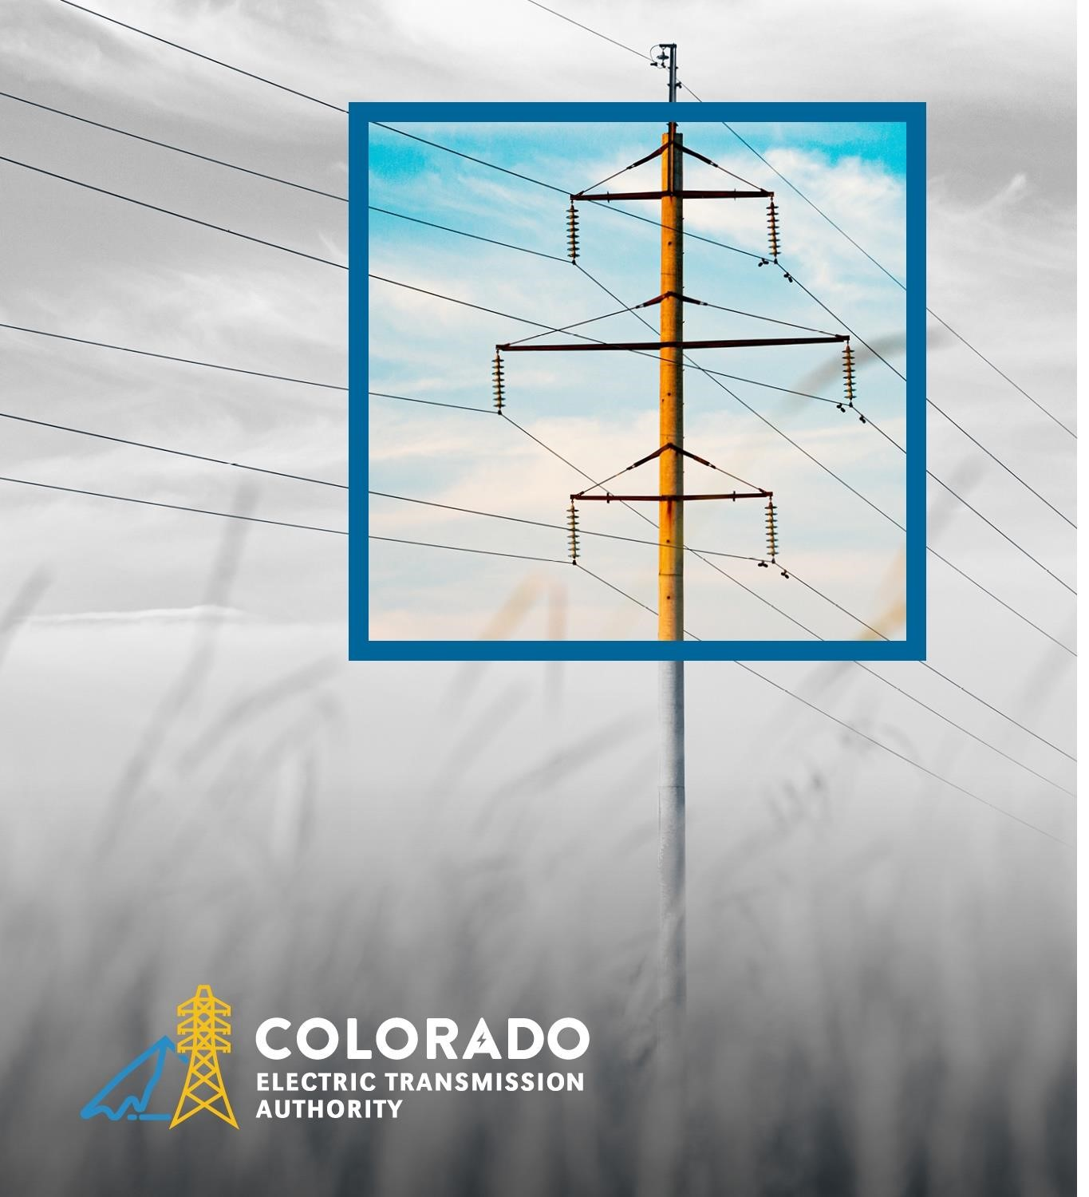
THANK YOU
Questions?
Maury Galbraith, Executive Director
Mgalbraith@cotransmissionauthority.com

Appendix
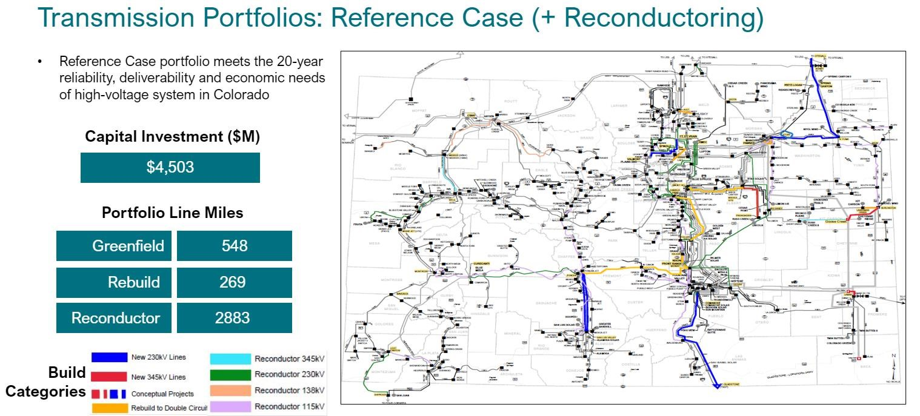
What does this mean for transmission needs?
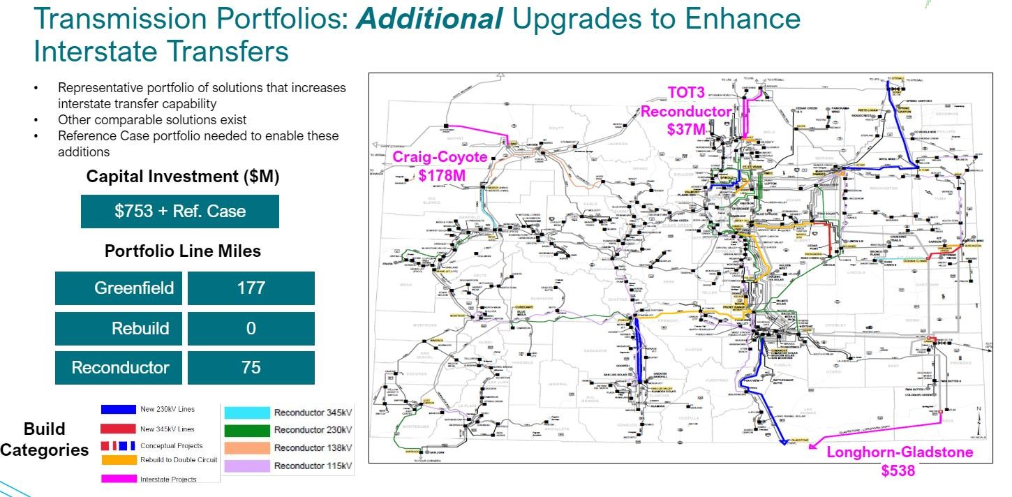
Interstate Options
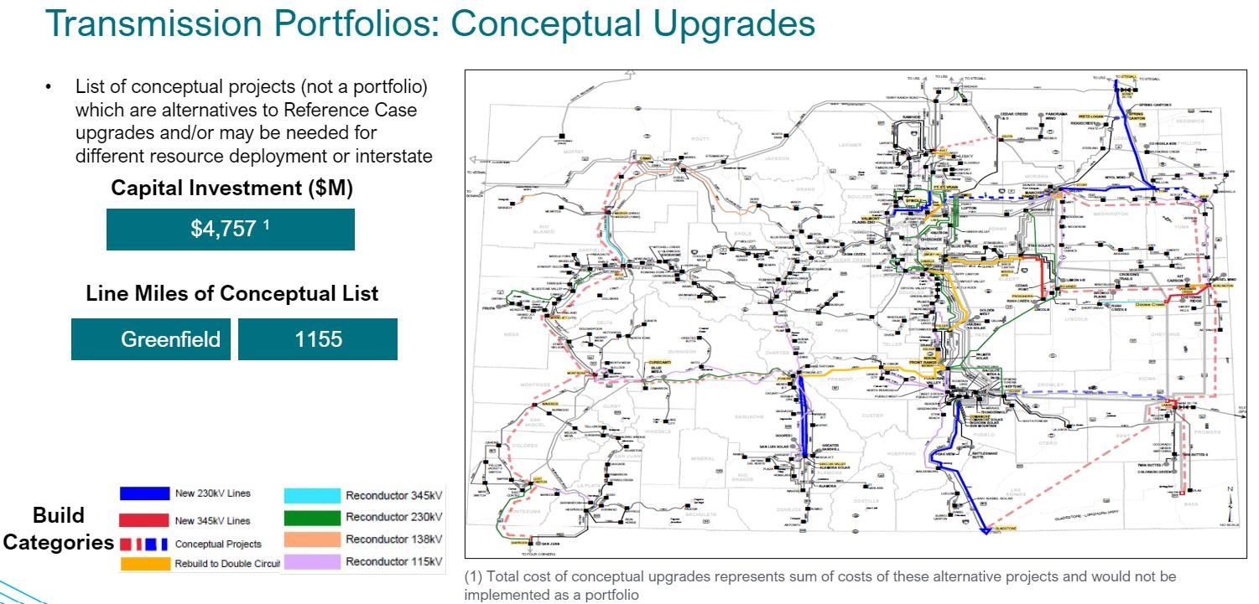
Conceptual Alternatives
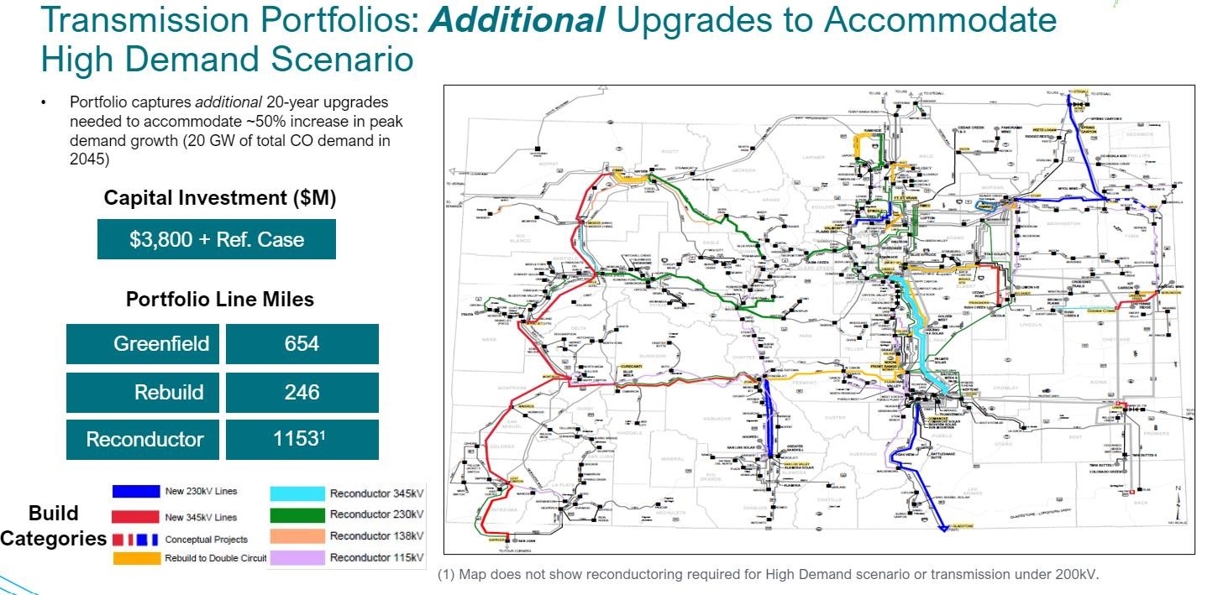
High Demand Option
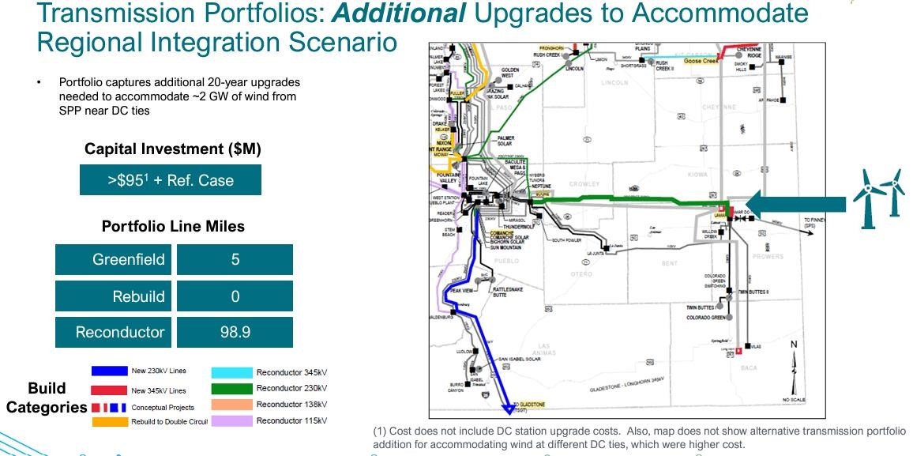
Regional Integration Option

