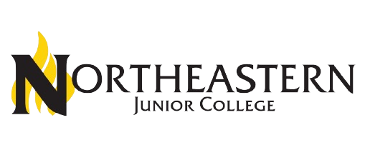
The Power of 13
Colorado
Community
College
System
•
Arapahoe Community
College
•
Community College of
Aurora
•
Community College of
Denver
•
Colorado Northwestern
Community College
•
Front Range
Community College
•
Lamar Community
College
•
Morgan Community
College
•
Northeastern Junior
College
•
Otero College
•
Pueblo Community
College
•
Pikes Peak State
College
•
Red Rocks
Community College
•
Trinidad State
College

Community Colleges Outside CCCS
- Aims Community College • Have local funding
- Colorado Mountain supported by property
College taxes and gas






- 12+ months of collaborative work around the state
CCCS Strategic
Plan 2025
-
2030
- Replaces a complex 10-year plan
- Feedback from community
stakeholders, students, faculty, and staff
- New draft plan creates more focus
- Five key themes emerging:
- Education For All
- Economic Mobility
- Partner of Choice
- Empowered Talent
- Power of 13

Power of 13
The whole is greater than
the sum of its parts.
Aristotle
Increase shared opportunities to
grow enrollment, improve quality,
and achieve cost efficiencies
through
consortial

models and
collaboration while leveraging
each college’s unique strengths.

Power of 13
Shared Services
Shared Programs
Shared Key Functional Positions
Statewide Service Areas
Shared Technology
Shared Legal
- Institutional Research• Shared Programs
- Front Range -> • Community Otero College and College of
Lamar Community Aurora and
CollegeNortheastern
- Registrar CollaborationJunior College
- Morgan on Paramedicine
Power of 13 in Action
Community
College, Pueblo • Morgan CC
Community Bachelor of
CollegeScience in
- Administrative PlanningNursing with
NJC, LCC, OC,
- Northeastern to CNCC
Rural College
Consortium

Colorado
Community
College
Online
Becomes
Colorado
Online
CCCOnline
- Sat as a separate instructional division operated by the CCCS
- All courses are taught “asynchronous online” allowing students anytime-anywhere education
- CCCS is not the accredited organization
- Did not meet Higher Learning Commission requirements for college oversight of instructional programs
Colorado Online
- Redistributes CCCOnline to the colleges, operated under the HLC accreditation of the
13 colleges
- Continues “asynchronous online” instruction
- Uses the Power of 13 to meet a broad demand for online learning across the region

Colorado Northwestern Community College
Lamar Community College





Morgan Community College Northeastern Junior College
Rural
College
Consortium
(
RCC
)
Otero College
Pueblo Community College
Trinidad State College
- Same great sharing as the Power of 13
Rural College
Consortium
- Sharing instructional programs through live Zoom classes, referred to as “synchronous remote.”
- Focused on the sustainability of the smaller rural colleges
- Pools enrollment
- Close partnerships to deal with unique challenges of a small college


Power of 13 Strategic Plan

- Expected approval in December 2024
- Implementation January 2025
- Many of the 13 colleges are redeveloping institutional strategic plans that will align with the new CCCS plan

