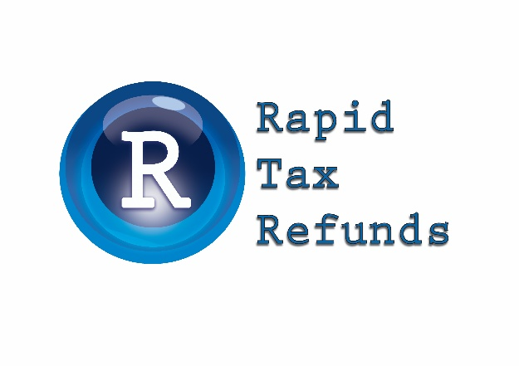

**2024/25 Year-end Checklist for Business**

*Many business clients like to review their tax position before the end of the income year and evaluate any strategies that may be available to legitimately reduce their tax. Traditionally, year-end tax planning for profitable small businesses is based around accelerating deductions and deferring income.*

*Small Business Entities ('SBEs') – i.e., those with an aggregated turnover of less than $10 million – often have greater tax planning opportunities compared to other businesses, due to certain concessions generally only applying to them. SBEs usually also have the flexibility to pick concessions that suit their circumstances. For 2024/25, many of these concessions may also be available to medium-sized businesses ('MSBs'), i.e., businesses with an aggregated turnover of less than $50 million.*

The following are common strategies that may be considered for **all** business taxpayers.

# Maximising deductions for non-SBE business taxpayers

Deductions can be maximised for non-SBE business taxpayers by **prepaying expenses**, **accelerating expenditure** and/or **accruing expenses** that have been incurred.

## Prepayment strategies

Any part of an expense prepayment relating to the period up to 30 June is generally deductible.

In addition, non-SBE taxpayers may generally claim prepayments in full for expenditure that is:

* under $1,000;
* made under a 'contract of service' (e.g., salary and wages); or
* required to be incurred under law.

*Note: Medium-sized businesses ('MSBs') may be able to fully deduct certain prepayments made before 1 July 2025 (refer below).*

## Accelerating expenditure (including depreciation deductions)

Accelerating expenditure involves bringing forward expenditure on regular, on-going deductible items.

In fact, this is a useful strategy for any business taxpayer (i.e., including SBEs) because businesses can generally claim deductions for expenses they 'incurred' during 2024/25, even if the expenses have not actually been paid by 30 June 2025.

Examples of accelerated expenditure that may be incurred and claimed as a tax deduction in 2024/25 by a business taxpayer include the following:

* **Repairs.**
* **Maintenance.**
* **Consumables/spare parts.**
* **Advertising.**
* **Fringe benefits.** Any employee benefits to be provided, such as property benefits, could be purchased and provided prior to 1 July 2025.
* **Superannuation contributions** made to a complying fund, to the extent the contributions are actually made (i.e., they cannot be accrued but must be *paid* by 30 June 2025).

In addition to accelerating expenditure on business items such as those listed above, for 2024/25, non-SBE businesses may claim the following depreciation deductions for **depreciating assets** first used (or installed ready for business use) by **30 June 2025**:

* Depreciating assets costing $100 or less (including any GST) can be written off in the year of purchase.
* Assets costing less than $1,000 may be allocated to a Low Value Pool and depreciated at a rate of 18.75% (in 2025) and 37.5% thereafter.
* In most other cases, the asset's cost is depreciated over its effective life (as determined by the taxpayer or the ATO).

*Note: While the instant asset write-off threshold of*

*$20,000 for SBEs has been retained for 2024/25, it has* ***not*** *been extended to non-SBEs with an aggregated turnover of between $10 million and*

*$50 million, as was previously proposed.*

## Accrued expenditure

Business taxpayers (including SBEs) are entitled to a deduction for expenses incurred as at 30 June 2025, even if they have not yet been paid.

Examples of expenses that may be accrued and claimed as a tax deduction in 2024/25 include:

* **salary or wages and bonuses** accrued for the number of days that employees have worked but have not been paid as at 30 June 2025;
* accrued **interest** outstanding on a business loan that has not been paid;
* **commission** payments owing to employees or other external parties;
* the **fringe benefits tax ('FBT') instalment** for the June 2025 quarter, if it is due but not payable until July 2025; and
* **directors’ fees payable** as at 30 June 2025, where the company is definitively committed to the payment.

# Maximising deductions for SBE taxpayers

Deductions can be maximised for SBE taxpayers by **accelerating expenditure** and/or **prepaying** deductible business expenses (and also by **accruing expenditure** – as discussed above).

# Accelerating depreciation expenditure

In addition to accelerating expenditure on various business items (as discussed above), for 2024/25, SBE taxpayers that use the simplified SBE depreciation rules may claim the following deductions in relation to **depreciating assets**:

* The instant asset write-off threshold for SBEs has been increased from (less than) $1,000 to (less than) **$20,000** as from 1 July 2023. This was recently extended by 12 months **until 30 June 2025**.

This allows small businesses (with an aggregated annual turnover of less than $10 million) to immediately deduct the full cost of eligible depreciating assets costing less than

$20,000 that are first used or installed ready for use on or before 30 June 2025.

* The SBE closing pool balance (before current year deductions), if any, will be fully claimed in the 2025 income year, if it is below the increased threshold.

*Note: Eligible SBE taxpayers using the simplified SBE depreciation rules* ***cannot*** *opt out of fully expensing their SBE general pool.*

If appropriate, SBE taxpayers should consider purchasing and using (or installing ready for use) these items by 30 June 2025.

**Prepayment strategies (SBEs and MSBs)** SBEs and medium-sized businesses ('MSBs') that make prepayments before 1 July 2025 can choose

to claim a full deduction in the year of payment

(i.e., in 2024/25), if the payment covers a period of no more than 12 months (ending before 1 July 2026).

Otherwise, the prepayment rules are the same as for non-SBE taxpayers.

The kinds of expenses that may be prepaid include:

* **Rent** on business premises or equipment.
* **Lease payments** on business items such as cars and office equipment.
* **Interest** – check with your financier whether it is possible to prepay up to 12 months interest in advance.
* **Business trips.**
* **Training courses** that run from 1 July 2025.
* **Business subscriptions.**

# Information Required

This is some of the information we will need you to bring to help us prepare your income tax return:

* Stock-take details as at 30 June 2025.
* Debtors listing (including a list of bad debts written off) as at 30 June 2025.

*Note: To claim a tax deduction, the debt must be written off on or before 30 June.*

* Creditors listing as at 30 June 2025.