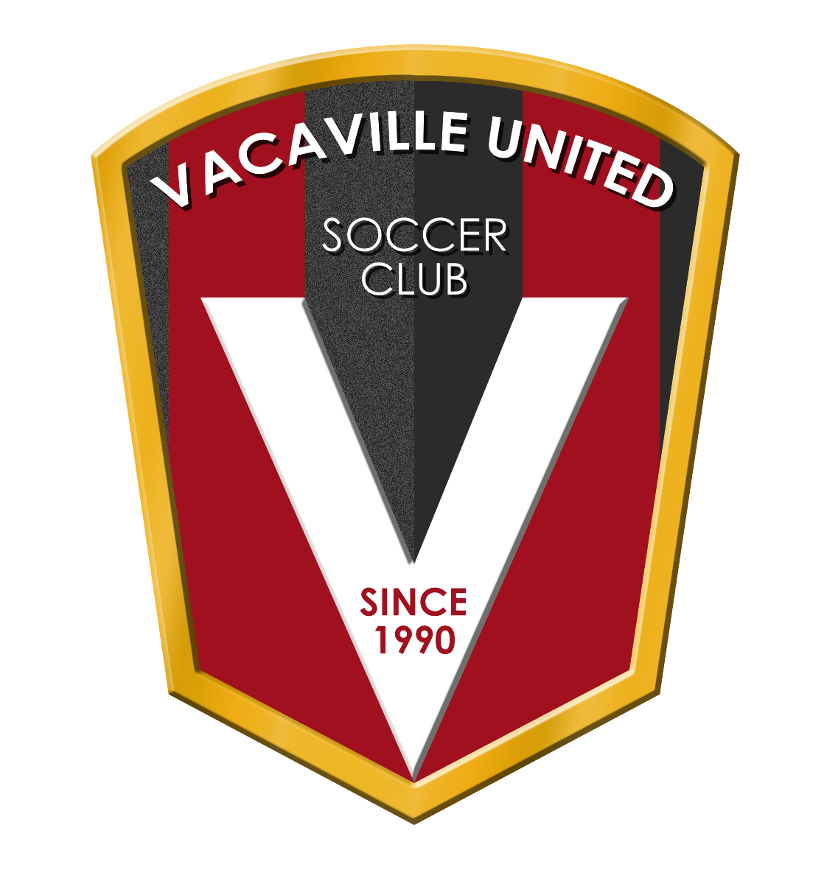Vacaville United Soccer Club - PO Box 73 - Vacaville, CA 95696 - 501.3 Tax ID 94-2594172
Vacaville United Soccer Club
Sponsorship Options

Platinum Field sponsor $1,800
You name the field instead of being called field ‘A’!
Includes a sign at the field with the name you choose, 1 banner displayed at front gates, social media shout-out and logo on the website.

Pop-Up Tents SPONSOR $1,500
Your Company logo is on a VUSC Pop-up tent.
A tent will be placed on each field for the players and coach of one team.

GOLD BANNER SPONSOR $600
A large individual logo banner displayed out on the fences around soccer fields.

REC team SPONSOR $350
Your company sponsors a team!
Company logo on team banner displayed prominently at the field for the rec season during their game. (Aug-Nov)

Recreational Tournament Title Sponsor $3,500
We are looking to host a recreational tournament in October. Your logo and name will be included in the title, displayed on the website, and on all social media advertisements.

Have other sponsorship ideas?! We would love to hear them!
Sponsorship/Fundraising Committee
Vuscfundraising24.25@gmail.com

