Ten Tips to Raise Your Visibility
Synthesized from a conversation with Krista Crawford, Vistage

1. Start Socializing Your Story Now
Even if you're not aiming for your aspirational role yet, visibility starts early.
What to do:
- Share your resume, bio, and professional narrative with people you trust — mentors, peers, sponsors, and colleagues who know your work.
- Ask them:
  - “Does this reflect the way you see me?”
  - “What strengths am I missing?”
  - “Where do you see my leadership potential growing?”
This gives you real-world clarity and strengthens your brand before you take the next career step.

2. Build Simple Habits to Stay Industry-Smart
You don't need to know everything — you just need to stay current.
Choose 2–3 resources and subscribe:
- Industry newsletters
- Leadership digests
- Governance or management insight sources
- Podcasts or webinars relevant to your field
Create a “Career Growth” email folder:
- Auto-filter your subscriptions.
- Block one hour weekly to read or skim.
This keeps you sharp, gives you language that senior leaders use, and arms you with topics to discuss with mentors and sponsors.

3. Treat LinkedIn Like Your Professional Front Door
Your profile is often your first impression — make it intentional.
Use LinkedIn Makeover Tips to elevate your profile.

4. Shift Your Experience Toward Leadership Language
Even if you're mid-level now, you can frame your work in leadership terms.
Use verbs that signal growth and ownership:
- “Led,” “guided,” “shaped,” “oversaw,” “advised,” “partnered,” “drove”
instead of
- “Executed,” “handled,” “processed,” “managed tasks”
Focus on outcomes:
- What changed because of your work?
- Did you streamline something?
- Improve morale?
- Save time?
- Reduce risk?
- Support a strategic initiative?
Results communicate impact — and impact raises visibility.

5. Use LinkedIn Posts to Demonstrate Your Thinking
You don’t have to be an influencer — but you do want to be visible.
Simple posting ideas:
- A leadership lesson you learned
- Something interesting you read + why it resonated
- A key takeaway from an Executive Alliance session
- Kudos to a colleague (lifting others lifts you too)
- A reflection on a project or challenge
Aim for consistency, not frequency:
- Start with 1 post every 6 weeks
- Comment meaningfully (10+ words) on others’ posts 1–2 times per week
- Reply when people engage with you
This shows you’re active, thoughtful, and building a leadership mindset.
6. Expand Your Network Intentionally — Not Randomly
At mid-career, your network becomes one of your strongest assets.
How to grow it the right way:
- Connect with everyone in the Executive Alliance mentoring community.
- Connect with people in roles you aspire to.
- Follow leaders whose careers inspire you.
- Accept connection requests from people who add value, not noise.
Pro tip:
Ask mentors for warm introductions — it’s the fastest visibility booster there is.

7. Start Capturing “Career Stories” Before You Need Them
These stories help you shine in performance reviews, promotions, interviews, leadership programs and sponsorship conversations
Write down 5–7 moments that show:
- How you solved a problem
- How you led through uncertainty
- How you improved a process
- How you influenced people without authority
- How you learned from a challenge or setback
These become your go-to examples when opportunities arise.

8. Share Your Wins — With Confidence and Humility
Self-promotion is a leadership skill.
How to do it gracefully:
- Show gratitude (“I’m honored…”)
- Share credit (“This team made it possible…”)
- Add insight (“What I learned was…”)
- Keep the tone warm and collaborative
This builds trust and visibility without coming across as boastful.

9. Use AI as a Helper, Not Your Voice
AI can help you, draft a LinkedIn post, summarize an article, tighten your About section
But always edit it so it sounds like you — authentic, thoughtful, and aligned with the leader you’re becoming.

10. Show Up as the Leader You Want to Be
Even at mid-career, you can project leadership presence.
Practice:
- Asking good questions
- Sharing your point of view
- Being curious
- Being visible in meetings
- Lifting others up publicly
- Following through
These habits build a reputation that reaches beyond your current role.

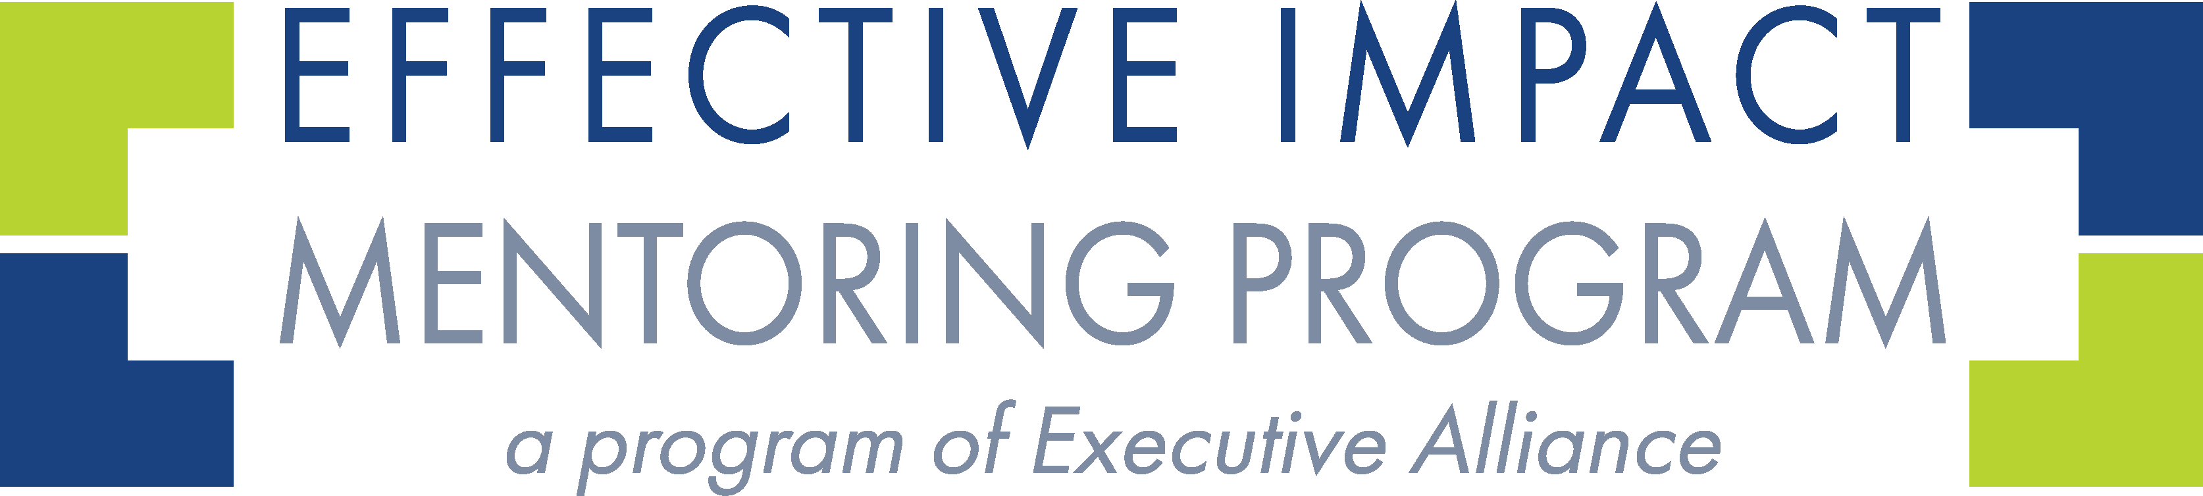
LinkedIn Makeover Checklist
1. Profile Photo
☐ Use a professional headshot (clean background, good lighting).
☐ Wear something that reflects your leadership presence.
☐ Expression: confident, warm, approachable.
2. Banner Image
☐ Replace the default blue background. Choose something that signals your industry, values, or leadership style, such as city skyline, abstract professional design, Industry-relevant image or a photo from a speaking or leadership moment
3. Name + Pronouns (Optional)
☐ Make sure your name matches how you introduce yourself professionally.
☐ Add pronouns if you prefer or if it aligns with your workplace culture.
4. Headline (Your 1-Sentence “Brand”)
Write something that reflects who you are and where you are going.
☐ Include your job function or title
☐ Add 2–3 strengths or specialties
☐ Consider adding your leadership focus
Examples:
- Operations Manager | Process Optimization | People-First Problem Solver
- Marketing Strategist | Customer Growth | Storytelling & Brand Building
5. About Section (Your Professional Narrative)
Write in first person, in a warm but polished tone. Include:
☐ What you do well
☐ What drives you
☐ What kind of leader you’re becoming
☐ What you value in your work
☐ The impact you want to make next
Aim for 1–3 short paragraphs, not a full autobiography.
6. Experience Section (Leadership Framing)
For each role:
☐ Use leadership verbs: “led,” “guided,” “improved,” “influenced,” “developed,” “streamlined.”
☐ Add 3–5 bullet points focused on outcomes and results.
☐ Include cross-functional work or influence without authority.
☐ Highlight any mentoring, team-building, or cultural leadership you’ve done.
☐ Add metrics when possible (time saved, process improved, engagement increased).
7. Skills Section
☐ Pin your top 3 skills (these show up first). Pick skills that support your leadership direction, such as Project Management, Communication, Team Leadership, Strategic Thinking, Data Analysis (if relevant)
☐ Remove skills you no longer want to be known for.
8. Recommendations
☐ Ask for 2–3 recommendations from colleagues, supervisors, mentees you’ve supported and Executive Alliance mentors
Ask them to highlight your leadership qualities, not just tasks.
9. Featured Section (Optional but Powerful)
Pin items that show your growth:
☐ A post you’re proud of
☐ An article you wrote
☐ A project you contributed to
☐ A speaking moment or award
☐ Something from Executive Alliance (if appropriate)
10. Activity: Show You’re Engaged
Start with small, sustainable steps:
☐ Comment meaningfully on posts (1–2 times per week).
☐ Share a post or create your own every 4–6 weeks.
☐ Celebrate wins with gratitude and humility.
☐ Engage with Executive Alliance members intentionally.
11. Connections
☐ Connect with your Executive Alliance mentor + mentee group.
☐ Add colleagues, supervisors, and past collaborators.
☐ Follow leaders, companies, and organizations aligned with your career goals.
☐ Keep your network relevant and high-quality (not random).
12. Optional Power-Ups
If you want to go further:
☐ Turn on “Open to Work (privately to recruiters).”
☐ Add volunteer roles, special projects, or community leadership.
☐ Add certifications, courses, or professional programs.
☐ Customize your URL (e.g., linkedin.com/in/yourname).

