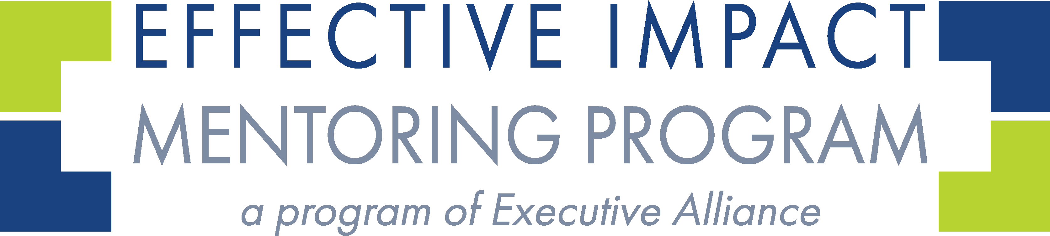
Gap & Growth Analysis Worksheet
Use this link https://forms.gle/w7oWU5sa5guWws3HA to answer the questions online and create a custom Gap Analysis Report.

SECTION 1: ABOUT YOU
1. Full Name:
2. Email Address:
3. Current Role / Title:
4. Organization(s):
5. LinkedIn Profile URL:

6. Brief Work History (2–3 sentences):

SECTION 2: STRENGTHS & VALUES
7. Top 5 CliftonStrengths:

8. Which strengths do you use most often?
9. Which strengths do you underutilize?
10. Top 5 Personal Values:
On a scale of 1-5 (with 5 being the strongest) how well does your current role support those values?

SECTION 3: GOALS
11. What is your aspirational leadership role (5–10 years)?

12. Top 3 professional goals for the next 1–3 years:

SECTION 4: ACCOMPLISHMENTS
13. List 1–3 accomplishments from the past year that demonstrate leadership or strategy:
14. What motivates you most in your work?

SECTION 5: GAPS & BLIND SPOTS
15. Thinking about your aspirational goal, what is missing between now and then?

16. Where do you feel underrecognized or underutilized?

17. What tends to hold you back from progress?

SECTION 6: VISIBILITY & GROWTH
18. On a scale of 1–5, how visible are you within your organization or industry?

19. What is your current “personal brand” in the workplace and industry?

20. What kind of leader do you want to be known as?

Personal Brand Audit Checklist

As you review your partner’s online presence, consider the following:
☐ Can you easily find them on Google and LinkedIn?
☐ Does their LinkedIn headline clearly communicate their role or value?
☐ Is their profile photo professional and recent?
☐ Do they share accomplishments, values, or thought leadership online?
☐ Is their experience section complete and aligned with their current goals?
☐ What do you assume about their leadership style or priorities from their profile?
☐ Are they visible in your shared industry or network?
☐ Do they appear active and engaged in their profession?
☐ What’s one word you’d use to describe their online presence?

