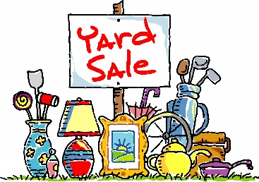
Redeemer’s Haiti Yard Sale

Friday, Sept 18th 2PM-6PM
Saturday Sept 19th 8AM-12PM
Set Aside Items to Donate:
- Please consider donating clean, useful, salable items you no longer want.
- Furniture, rugs, kitchenware, small appliances, decorations
- Craft Items, picture frames, garden decorations, outdoor furniture, tools
- Toys, games, sporting equipment, bicycles, crafts, musical instruments, books
- Linens, luggage, religious goods, medical equipment, jewelry, electronics
- Children’s clothing - clean, free of stains, in good repair. (No adult clothing please)
Items we cannot accept:
- Baby cribs, car seats, rubber bath toys, plastic books, baby equipment with suction cups Baby walkers with a base less than 36”
- TV's other than flat screen Desktop
- Computer equipment & monitors
- Bed Frames & Mattresses
- Adult Clothing
- Children’s clothing that is faded, stained, or worn out
- Items that are broken
Please save paper grocery bags with handles - Leave them in the Commons in the box marked “Team Haiti Yard Sale”

Donation Drop Off: Monday Sept 14th 12PM-8PM
Tuesday – Wednesday, Sept 15th -16th between 10AM - 7:30PM

- Pickup of larger items, such as furniture will be available. (Must be on the first floor with easy access) Call the church office at 804-746-4911 to request a pickup no later than Wednesday, Sept 9th. Pickups will be scheduled for Monday Sept 14th & Tuesday Sept 15th. Note: donated items must be in good enough condition to sell. If items requested for pickup are not saleable, the pickup team may ask for a $25 donation to transport items to the dump.
- Volunteer:
  - Please consider donating your time. Many Hands make light work!
  - Morning & evening shifts are available Monday Sept 14th - Friday Sept 18th and Saturday Sept 19th
  - We need help with set-up, pick-up, sorting, displaying, pricing, baking for the bake sale, greeting customers, cashier sales, and break down/clean up.
  - Sign up on-line with the Sign-Up Genius https://www.signupgenius.com/go/10C0448ADAA23A75-64275327-2026 or on paper with the Redeemer Haiti Yard Sale Commitment Form.
Thank you for supporting our Haiti Ministry. Redeemer is twinned with the Women of AFAL, Lascahobas, Haiti. AFAL is a women’s empowerment group that works to improve the lives of their community by providing education and improving housing. Your help also gives the Mechanicsville community an affordable shopping opportunity! May your many treasures you no longer need, bless someone else’s home!
