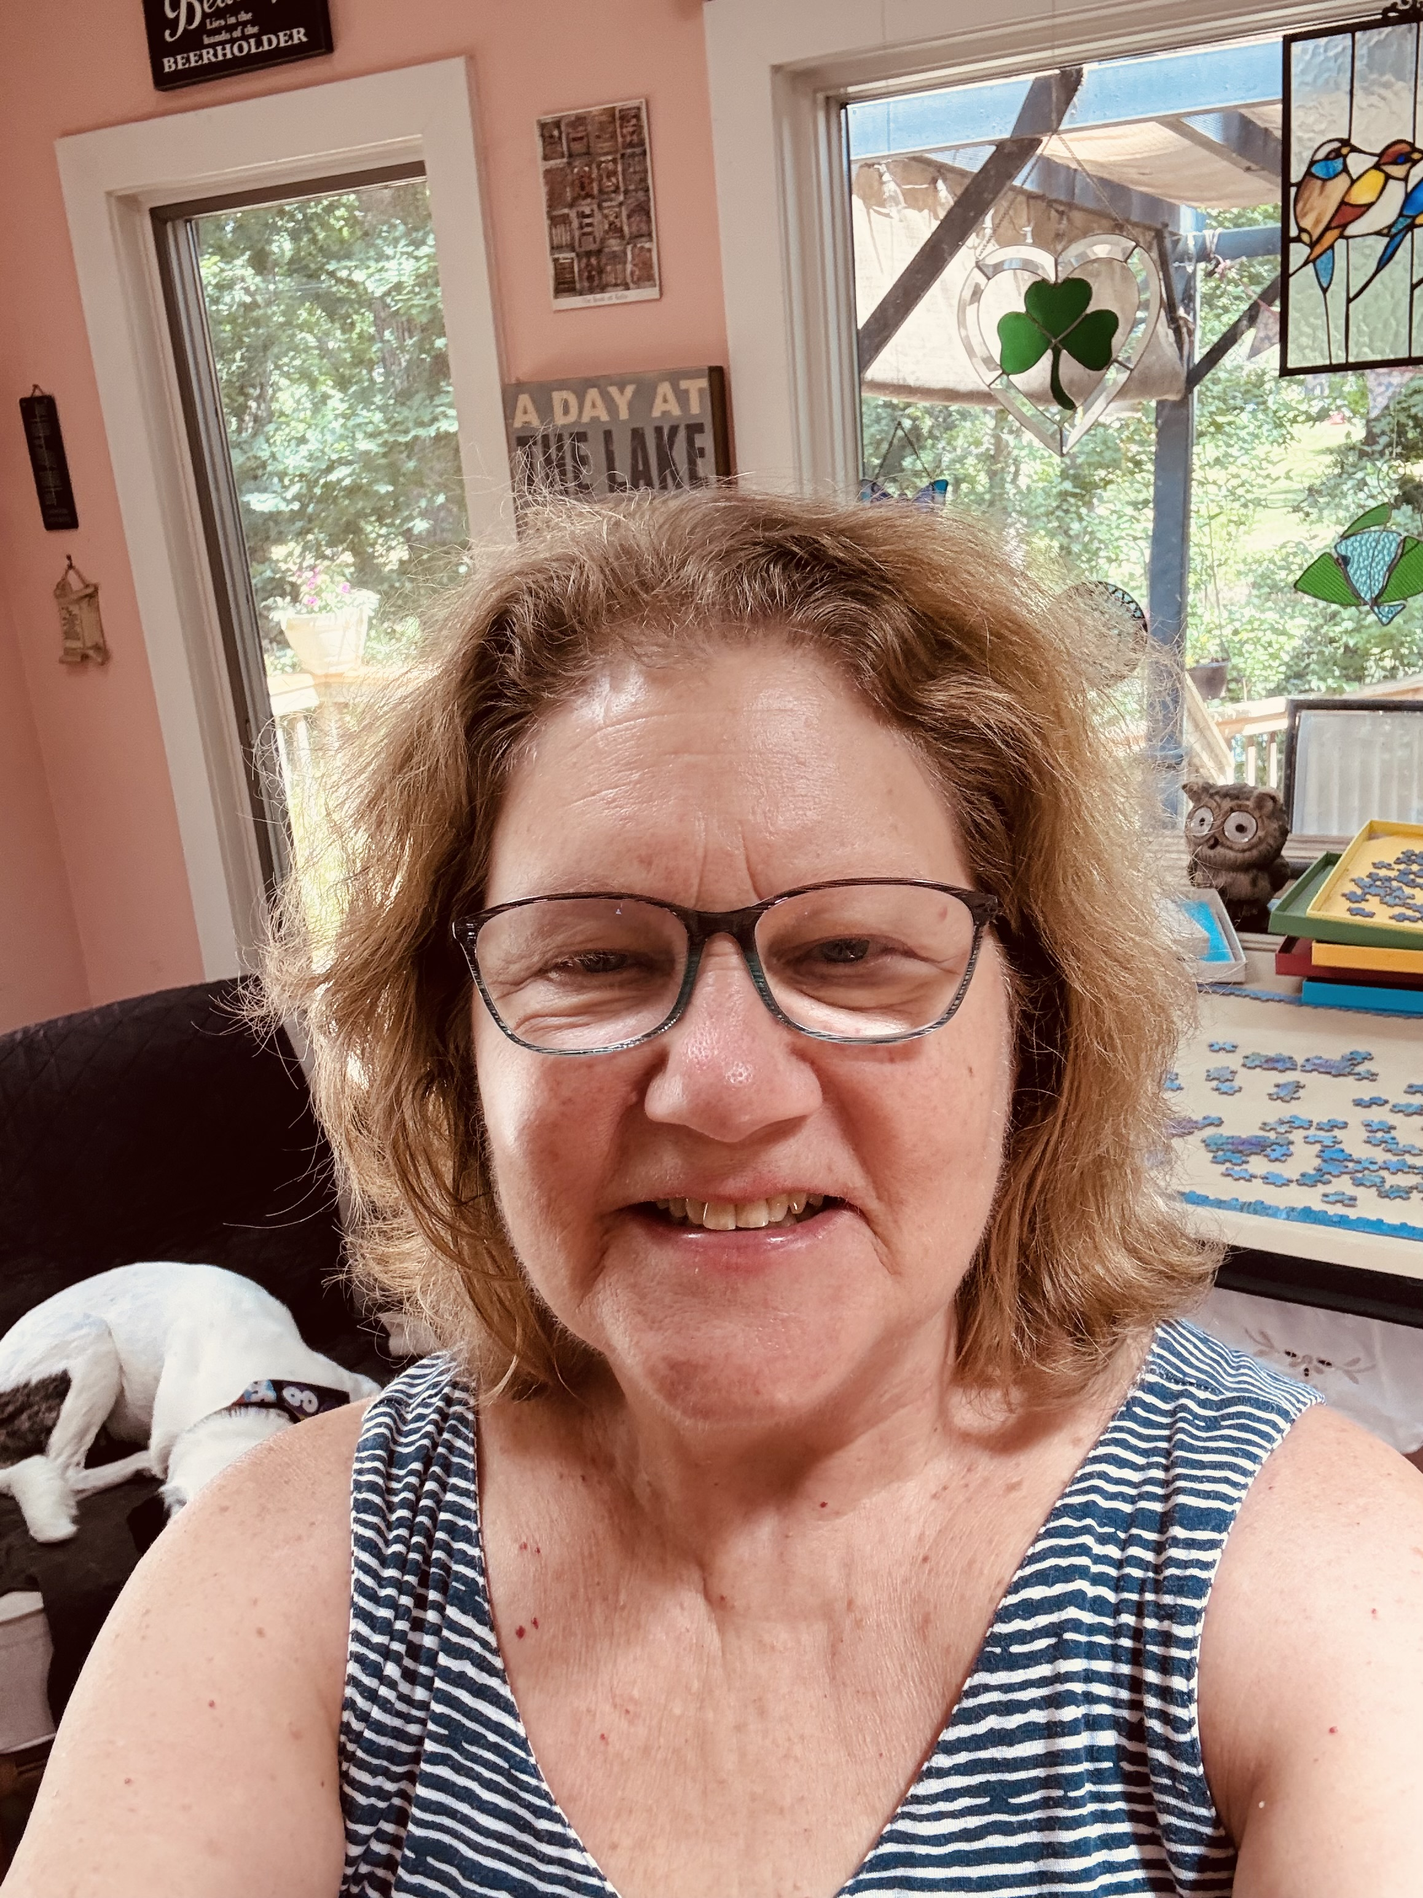

- Terry Crowl has been a member of the parish from 1982 to 1985 and again from 1998 to 2026.
- A wife, mother of two grown sons, grandmother of seven, and now retired,
- Terry has remained deeply connected to parish life through active service in the Music Ministry, on the Liturgy Committee, and in leading a prayer ministry.
- She most often plays the flute with the choir at the Sunday 10 a.m. liturgy and has also helped facilitate the parish’s recent Conversations in the Spirit, sharing her gifts in worship and community life.
- Terry cherishes the deep sense of community within the parish and, with a deep love for its mission, hopes to serve on the Parish Council by bringing thoughtful, positive ideas for growth while helping strengthen the faith, unity, and future of the parish.

