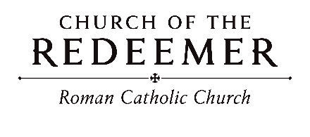
Pentecost
May 23/24, 2026

PRELUDE: “My Country ‘Tis of Thee”
My country, ‘tis of thee, sweet land of liberty, of thee I sing; land where my fathers died, land of the pilgrim’s pride, from ev’ry mountainside let freedom ring!
Text by Samuel F. Smith, Tune AMERICA, 66 4 666 4; Thesaurus Musicus, 1744
GATHERING SONG: “Ye Sons and Daughters”
Refrain: Alleluia, Alle-luia, Alleluia!
1. That night apostles met in fear; Amidst them came their Lord most dear, And
said, “My peace be on all here.” Alleluia!

2. How blest are they who have not seen, and yet whose faith has constant been, for they eternal life shall win.

3. On this most holy day of days, To God your hearts and voices raise, in laud and jubilee and praise. Alleluia!
Text: O fillie et filiae. Jean Tisserand, tr. By John M. Neale. Mode II acc. Richard Proulx, Copyright 1975 by GIA Publications, Inc. All rights reserved. OneLicense.net License #A-701559

GLORIA
Glory to God, glory to God, glory to God in the highest and on earth peace, on earth peace to people of good will.

1. We praise you, we bless you, we adore you, we glorify you, we give you thanks for your great glory, Lord God, heavenly King, O God, almighty Father.

2. Lord, Jesus Christ, Only Begotten Son, Lord God, Lamb of God, Son of the Father, you take away the sins of the world, have mercy on us; you take away the sins of the world, receive our prayer; you are seated at the right hand of the Father, have mercy on us.

3. For you alone are the Holy One, you alone are the Lord, you alone are the Most High, Jesus Christ, with the Holy Spirit, in the glory of God the Father.
Text: ICEL, Copright 2010,. Music: Mass of Joy and Peace, Tony E. Alonso. Copyright 2010 GIA Publications, Inc.

FIRST READING: Acts 2:1-11

PSALM 104: “Send Out Your Spirit”
Cantor: Lord, send out your Spirit; renew the face of the earth.
All: Lord, send out your Spirit; renew the face of the earth. (sing both lines after verses)
By Tim Schoenbachler. Copyright 1979 by New Dawn Music. All rights reserved. Reproduced with permission under License #A-701559, OneLicense.net

SECOND READING: 1 Corinthians 12:3b-7, 12-13

SEQUENCE for PENTECOST: “By the Waking of Our Hearts”
Please remain seated.
By the waking of our hearts, by the stirring of our souls, may the Spirit of
God abide and bring us together in Christ.
Verses based on the Pentecost Sequence, Veni Sancte Spiritus. By Ricky Manalo. Copyright 1997 Ricky Manalo, CSP. Published by OCP Publications. All rights reserved under OneLicense.net #A-701559.

GOSPEL ACCLAMATION: “Celtic Alleluia”
Please sing with the cantor: Alleluia, alleluia! Alleluia, alleluia!
By Fintan O'Carroll and Christopher Walker of the St. Thomas More Center. Copyright 1985 by New Dawn Music. All rights reserved.
GOSPEL: John 20:19-23

HOMILY

CREED
I believe in one God, the Father Almighty, maker of heaven and earth, of all things visible and invisible.
I believe in one Lord, Jesus Christ, the only Begotten Son of God, born of the Father before all ages. God from God, Light from Light, true God from true God, begotten, not made, consubstantial with the Father; through him all things were made. For us men and for our salvation he came down from heaven: (bow) And by the Holy Spirit was incarnate of the Virgin Mary, and became man. For our sake he was crucified under Pontius Pilate; he suffered death and was buried, and rose again on the third day in accordance with the Scriptures. He ascended into heaven and is seated at the right hand of the Father. He will come again in glory to judge the living and the dead and his kingdom will have no end.

I believe in the Holy Spirit, the Lord, the giver of life, who proceeds from the Father and the Son, who with the Father and the Son is adored and glorified, who has spoken through the prophets. I believe in one holy catholic and apostolic Church. I confess one Baptism for the forgiveness of sins and I look forward to the resurrection of the dead and the life of the world to come. Amen

LITURGY OF THE EUCHARIST: “Prayer to the Holy Spirit”
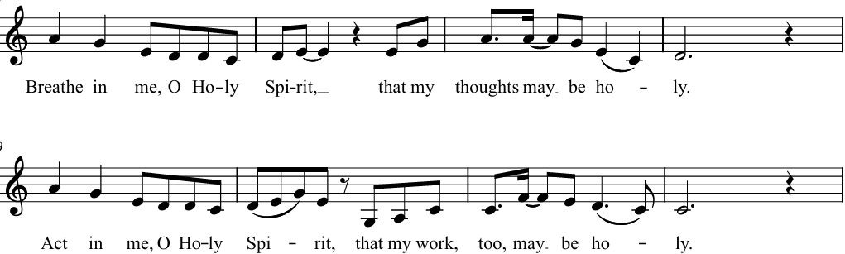
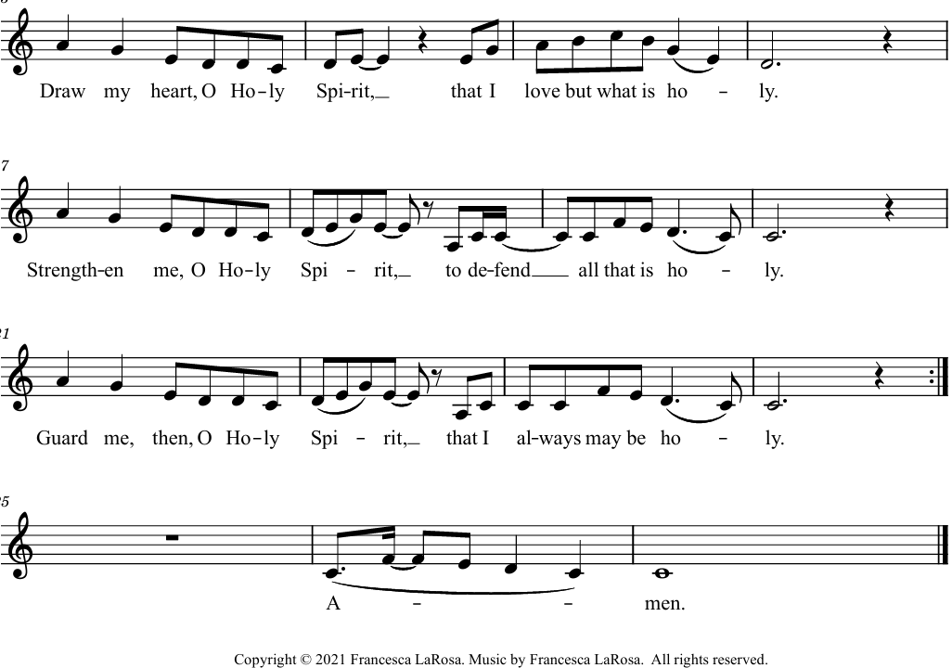

Holy, Holy

Holy, holy, holy Lord God of hosts. Heaven and earth are full of your glory. Hosanna in the highest. Blessed is he who comes in the name of the Lord. Hosanna in the highest. Hosanna in the highest.

Memorial Acclamation

When we eat this bread and drink this Cup, we proclaim your Death, O Lord, until you come again.

Amen

A - men, A - men, A - men, A - men. A - men, A - men, A - men, A - men.
Text: ICEL, copyright 2010. Music: Mass of Creation, Marty Haugen. Copyright 2010 GIA Publications, Inc.

The Lord’s Prayer

Sign of Peace

Lamb of God
Lamb of God: you take away the sins of the world: have mercy on us.
Lamb of God: you take away the sins of the world: have mercy on us.
Lamb of God: you take away the sins of the world: grant us peace, grant us peace.

COMMUNION: “Spirit and Grace”
1. Spirit and grace, here in this meal; you are the wind that breathes through the field. Gather the wheat and form us in Christ. Come, be our source and breath of life.

Refrain: In the bread, blessed, broken and shared, Christ is our life, whose presence we bear. Come, O Spirit, make your grace revealed in this holy meal. (Last time repeat: Come, O Spirit, make your grace revealed in this holy meal. )

2. Spirit and grace, here in this meal; you are the life that flows through the vine. Gather this drink and form us in Christ. Come, be our source and blood of life.

3. Spirit and grace, here in this place; you are the light that shines in this space. Gather your people and form us in Christ. Come, be the heartbeat of our lives.

4. Spirit of God, sending us forth; we spread your wisdom throughout all the earth. Gather the nations and form us in Christ. Come, be the presence in our lives.
By Ricky Manalo, CSP. Copyright 2006, Ricky Manalo, CSP. Published by OCP. All rights reserved. Reproduced with permission under OneLicense.net

COMMUNION: “We Are Many Parts”
We are many parts, we are all one body; and the gifts we have, we are given to share. May the Spirit of love make us one indeed; one, the love that we share, one, our hope in despair, one, the cross that we bear.

1. God of all, we look to you, we would be your servants true, let us be your love to all the world.

2. So my pain is pain for you, in your joy is my joy, too; all is brought together in the Lord.

3. All you seekers, great and small, seek the greatest gift of all; if you love, then you will know the Lord.
By Marty Haugen. Copyright 1980, 1986 by G.I.A. Publications, Inc. All rights reserved. OneLicense.net License #A-701559

SENDING FORTH: “Alive in One Spirit”
Alive in one Spirit, we go forth in mission, alive in one Spirit, anointed we serve, called to be sacrament of the Lord’s presence, light to the nations and salt of the earth.
1. Send us, O Spirit now poured out among us; burn in our hearts with the fire of your love. Make us anew in the image of Jesus, that we may mirror the goodness of God.
By Bob Hurd. Copyright by Bob Hurd. Published by spiritandsong.com/OCP Publications. All rights reserved. Reproduced with permission under License #A-701559, OneLicense.net.

