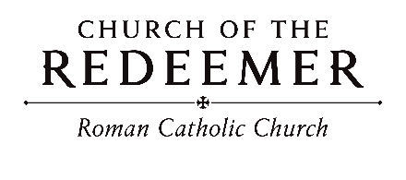
Palm Sunday of the Passion of the Lord March 28/29, 2026

GREETING
BLESSING OF THE PALMS: “Jerusalem, My Destiny”
I have fixed my eyes on your hills, Jerusalem, my destiny! Tho' I cannot see the end for me, I cannot turn away. We have set our hearts for the way; this journey is our destiny. Let no one walk alone. The journey makes us one.
By Rory Cooney. Copyright 1990 by G.I.A. Publications, Inc. All rights reserved. OneLicense.net License #A-701559
GOSPEL: Matthew 21:1-11
“Palm Sunday Processional”
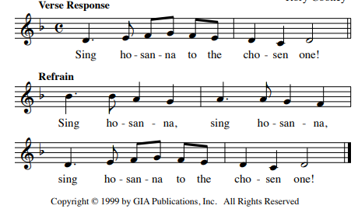
FIRST READING: Isaiah 50:4-7
PSALM 22: “My God, My God”
My God, My God, why have you abandoned me? Why have you forsaken me?
By John Michael Talbot. Copyright 1981 Birdwing Music/Cherry Lane Publishing Co. All rights reserved.

SECOND READING: Philippians 2:6-11

GOSPEL ACCLAMATION/RESPONSE DURING GOSPEL:
“Jesus, Remember Me”
Jesus, remember me when you come into your Kingdom.
Jesus, remember me when you come into your Kingdom.
Text: Luke 23:42, tune by Jacques Berthier. Copyright 1981 Les Presses de Taize (France). All rights reserved. Used with permission of GIA Publications, Inc.
OneLicense.net License #A-701559
GOSPEL: Matthew 27:11-54
HOMILY

CREED
I believe in one God, the Father Almighty, maker of heaven and earth, of all things visible and invisible.
I believe in one Lord, Jesus Christ, the only Begotten Son of God, born of the Father before all ages. God from God, Light from Light, true God from true God, begotten, not made, consubstantial with the Father; through him all things were made. For us men and for our salvation he came down from heaven: (bow) And by the Holy Spirit was incarnate of the Virgin Mary, and became man. For our sake he was crucified under Pontius Pilate; he suffered death and was buried, and rose again on the third day in accordance with the Scriptures. He ascended into heaven and is seated at the right hand of the Father. He will come again in glory to judge the living and the dead and his kingdom will have no end.
I believe in the Holy Spirit, the Lord, the giver of life, who proceeds from the Father and the Son, who with the Father and the Son is adored and glorified, who has spoken through the prophets. I believe in one holy catholic and apostolic Church. I confess one Baptism for the forgiveness of sins and I look forward to the resurrection of the dead and the life of the world to come. Amen.

LITURGY OF THE EUCHARIST: “In Christ Alone”
1. In Christ alone my hope is found, he is my light, my strength, my song; this cornerstone, this solid ground, firm through the fiercest drought and storm. What heights of love, what depths of peace, when fears are stilled, when strivings cease. My comforter, my all in all, here in the love of Christ I stand.
2. In Christ alone, who took on flesh, fullness of God in helpless babe! This gift of love and righteousness, scorned by the ones he came to save. Till on that cross as Jesus died, the path of God was satisfied. For every sin on him was laid; here in the death of Christ I live.
3. No guilt in life, no fear in death, this is the pow’r of Christ in me; from life’s first cry to final breath, Jesus commands my destiny. No pow’r of hell, no scheme of man, can ever pluck me from his hand; till he returns or calls me home, here in the pow’r of Christ I’ll stand!
By Keith Getty and Stuart Townend. Arr.Rick Modlin. Copyright 2001, 2009 Thankyou Music (PRS). All rights reserved. Administered at EMICMGPublishing.com. Used with permission.
INVITATION TO PRAYER
Priest: Pray, brothers and sisters, that my sacrifice and yours may be
acceptable to God, the almighty Father.
People: May the Lord accept the sacrifice at your hands for the praise
and glory of his name, for our good and the good of all his holy church.

Preface Dialogue
Priest: The Lord be with you. People: And with your spirit.
Priest: Lift up your hearts. People: We lift them up to the Lord.
Priest: Let us give thanks to the Lord our God. People: It is right and just.

HOLY, HOLY
Holy, Holy, Holy Lord God of hosts. Heaven and earth are full of your glory. Hosanna in the highest, hosanna in the highest. Blessed is he, blessed is he who comes in the name of the Lord. Hosanna in the highest, hosanna in the highest. Hosanna in the highest, hosanna in the highest

MEMORIAL ACCLAMATION
We proclaim your Death, O Lord, and profess your Resurrection until you come again.

AMEN
A - men, A - men, A - men, A - men. A - men, A - men, A - men, A - men.

THE LORD’S PRAYER

SIGN OF PEACE

LAMB OF GOD:

Lamb of God: you take away the sins of the world: have mercy on us.
Lamb of God: you take away the sins of the world: have mercy on us.
Lamb of God: you take away the sins of the world: grant us peace, grant us peace.
Text: ICEL, copyright 2010. Music: Mass of Joy and Peace, Tony E. Alonso. Copyright 2010 GIA Publications, Inc.

COMMUNION: “Jesus Christ is Lord” 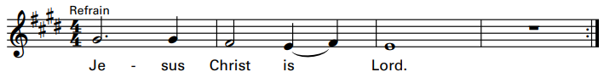
1. He did not hold to his equality with God, for he did empty himself to be as one of us, to be as one of us.

2. He chose the will of God through death upon a cross, and God did raise him up, exalting him on high, exalting him on high.

3. And so God gave to him a name above all names. May all in heaven and earth proclaim him now as Lord, proclaim him now as Lord.

COMMUNION: “Only This I Want”

Only this I want: but to know the Lord, and to bear the cross so to wear the crown he wore.

1. All but this is loss, worthless refuse to me, for to gain the Lord is to gain all I need.

2. I will run the race; I will fight the good fight, so to win the prize of the Kingdom of my Lord.

3. Let your heart be glad, always glad in the Lord, so to shine like stars in the darkness of the night.
By Dan Schutte. Copyright 1981 by Dan Schutte and New Dawn Music. All rights reserved. Reproduced with permission under License #A-701559, OneLicense.net.

COMMUNION: “Your Only Son (Lamb of God)”
1. Your only Son, no sin to hide, but you have sent him from your side to walk upon this guilty sod, and to become the Lamb of God.
Refrain: O Lamb of God, sweet Lamb of God; I love the holy Lamb of God. O wash me in his precious blood. My Jesus Christ, the Lamb of God.
2. Your gift of love they crucified, they laughed and scorned him as he died; the
humble King they named a fraud, and sacrificed the Lamb of God.

3. I was so lost I should have died, but you have brought me to your side to be led
by your staff and rod, and to be called a lamb of God.
Copyright 1985, Straightway Music (ASCAP) Mountain Spring Music (ASCAP). All rights reserved. Administered by EMI Christian Music
Group. Used with permission
.

SENDING FORTH: “How Great Thou Art”
1. O Lord, my God! When I in awesome wonder consider all the worlds thy hands have made, I see the stars, I hear the rolling thunder, thy pow'r throughout the universe displayed.

Refrain: Then sings my soul, my Savior God to thee; how great thou art! how great thou art! Then sings my soul, my Savior God to thee; how great thou art! How great thou art!

2. And when I think that God, his Son not sparing, sent him to die, I
scarce can take it in; That on the cross, my burden gladly bearing, he
bled and died to take away my sin.
By Stuart K. Hine. Copyright 1955, renewed 1981, Manna Music, Inc. All rights reserved. Used with permission.

