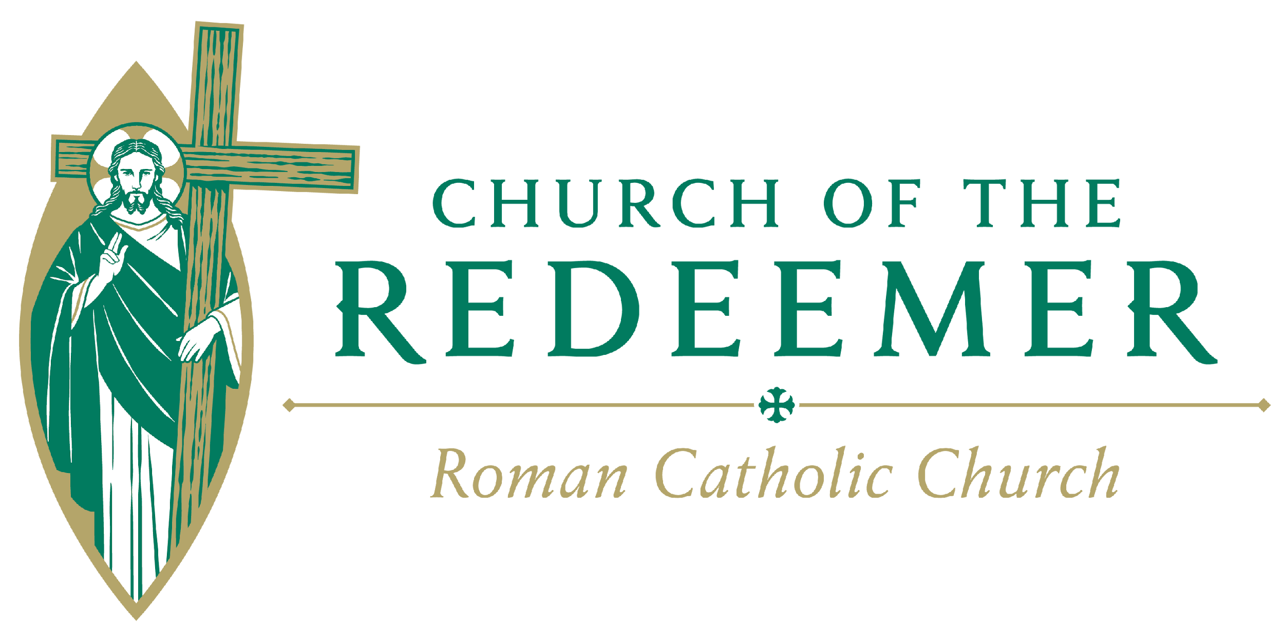
Pastoral Council Nominations
2026 - 2027

Please complete this form to nominate yourself or someone else for Pastoral Council. If possible, contact the person you are nominating to see if they are interested in running for the Council. Also, please provide you or their contact information if available. You have until Sunday, May 17 to submit your nomination. Place your nomination in the special basket when leaving the worship area, or complete online.
Thank you, Redeemer Pastoral Council

1. Name, Email & Phone#___________________________________________________________

2. Name, Email & Phone#___________________________________________________________

Current members of the Council should not be nominated. The following are not eligible for nomination this year:

Pastoral Council: Alex Kulinowski, LuAnn Orie, Dennis Beeman, Kathryn Massino, Jeff Decker, Julia Crowder, Dick Letter, Paulette Beaseley, Linda Kastelberg, Lola Edwards, Mark Remick, Tad Stillwell, Fr. Jim Cowles
Staff: Diane Atkins, Kate Chittum, Renee Reisenweaver, Laurie Richman, Regina Watson-Fields, and Erin Woods.

