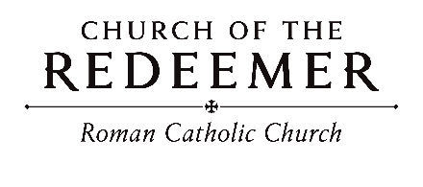
Mary, the Holy Mother of God
January 1, 2026

GATHERING SONG: “Angels We Have Heard On High”
1. Angels we have heard on high, sweetly singing o'er the plains, and the mountains in reply, echoing their joyous strains.

Refrain: Glo-ria in excelsis Deo! Glo-ria in excelsis Deo!

2. See him in a manger laid, whom the choirs of angels praise; Mary, Joseph, lend your aid, while our hearts in love we raise. French traditional carol.

GREETING
GLORIA: “Mass of Renewal”
Glory to God in the highest, and on earth peace to people of good will.

1. We praise you, we bless you, we adore you, we glorify you, we give you thanks for your great glory, Lord God, heavenly King, O God, almighty Father.

2. Lord, Jesus Christ, Only Begotten Son, Lord God, Lamb of God, Son of the Father, you take away the sins of the world, have mercy on us; you take away the sins of the world, receive our prayer; you are seated at the right hand of the Father, have mercy, have mercy on us.

3. For you alone are the Holy One, you alone are the Lord, you alone are the Most High, Jesus Christ, with the Holy Spirit, in the glory of God the Father. Amen. Amen.
Text Copyright 2010, ICEL. Music Mass of Renewal by Curtis Stephan. Published by OCP. All rights reserved under OneLicense.net.

FIRST READING: Numbers 6:22-27

PSALM 67: “O, God, Let All the Nations”
O God, let all the nations praise your name, let all the nations praise your name.
Refrain text copyright 1969, 1981, ICEL. Verses text copyright 1995, ICEL. All rights reserved. Used with permission. Music copyright 1996, Timothy R. Smith. Published by OCP Publications. All rights reserved. Reproduced with permission under License #A-701559, OneLIcense.net

SECOND READING: Galatians 4:4-7
GOSPEL ACCLAMATION: “Mass of Renewal”
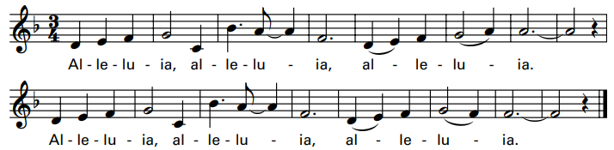
Verses text copyright 1969, 1981, 1997. Copyright 2009 by Curtis Stephan. Published by OCP Publications. All rights reserved. Used with permission.
GOSPEL: Luke 2:16-21
HOMILY

CREED
I believe in one God, the Father Almighty, maker of heaven and earth, of all things visible and invisible.
I believe in one Lord, Jesus Christ, the only Begotten Son of God, born of the Father before all ages. God from God, Light from Light, true God from true God, begotten, not made, consubstantial with the Father; through him all things were made. For us men and for our salvation he came down from heaven: (bow) And by the Holy Spirit was incarnate of the Virgin Mary, and became man. For our sake he was crucified under Pontius Pilate; he suffered death and was buried, and rose again on the third day in accordance with the Scriptures. He ascended into heaven and is seated at the right hand of the Father. He will come again in glory to judge the living and the dead and his kingdom will have no end.
I believe in the Holy Spirit, the Lord, the giver of life, who proceeds from the Father and the Son, who with the Father and the Son is adored and glorified, who has spoken through the prophets. I believe in one holy catholic and apostolic Church. I confess one Baptism for the forgiveness of sins and I look forward to the resurrection of the dead and the life of the world to come. Amen.

LITURGY OF THE EUCHARIST: “What Child Is This?”
1. What child is this, who laid to rest, on Mary's lap is sleeping? Whom angels greet with anthems sweet, while shepherds watch are keeping?

Refrain: This, this, is Christ the King, whom shepherds guard and angels sing, haste, haste, to bring Him laud, the Babe, the Son of Mary.

2. Why lies he in such mean estate where ox and ass are feeding? Good Christian fear; for sinners here the silent Word is pleading.

3. So bring him incense, gold and myrrh, come peasant, king to own him; the King of kings salvation brings, let loving hearts enthrone him.
Text: William C. Dix, 1827-1898. Tune: Greensleeves.

INVITATION TO PRAYER
Priest: Pray, brothers and sisters, that my sacrifice and yours may be acceptable to God, the almighty Father.
People: May the Lord accept the sacrifice at your hands for the praise and glory of his name, for our good and the good of all his holy church.

Preface Dialogue

Priest: The Lord be with you. People: And with your spirit.
Priest: Lift up your hearts. People: We lift them up to the Lord.
Priest: Let us give thanks to the Lord our God. People: It is right and just.

Holy, Holy
Holy, holy, holy Lord God of hosts. Heaven and earth are full of your glory. Hosanna in the highest. Blessed is he who comes in the name of the Lord. Hosanna in the highest. Hosanna in the highest.

Memorial Acclamation
When we eat this bread and drink this Cup, we proclaim your Death, O Lord, until you come again.

Amen
A-men, a-men, a-men! A-men, a-men, a-men!
Revised Mass of Creation. Setting by Marty Haugen. Copyright 1984, 2010 by G.IA. Publications, Inc. All rights reserved. OneLicense.net License #A-701559

The Lord’s Prayer

Sign of Peace
Priest: Lord Jesus Christ, who said to your Apostles: Peace I leave you, my peace I give you, look not on our sins, but on the faith of your Church, and graciously grant her peace and unity in accordance with your will. Who live and reign for ever and ever.
People: Amen.
Priest: The peace of the Lord be with you always.
People: And with your spirit.
Priest/Deacon: Let us offer each other the sign of peace.

Lamb of God:

Lamb of God: you take away the sins of the world: have mercy on us.
Lamb of God: you take away the sins of the world: have mercy on us.
Lamb of God: you take away the sins of the world: grant us peace, grant us peace.
By Marty Haugen. Copyright 1987 by G.I.A. Publications, Inc. All rights reserved. OneLicense.net License #A-701559
COMMUNION: “Silent Night”
1. Silent Night! Holy Night! All is calm, all is bright 'round yon Virgin Mother and Child! Holy Infant so tender and mild, sleep in heavenly peace! Sleep in heavenly peace!

2. Silent Night! Holy Night! Shepherds quake at the sight! Glories stream from heaven afar, heav'nly hosts sing "Alleluia!" Christ, the Savior, is born! Christ, the Savior, is born!

3. Silent Night! Holy Night! Son of God, love's pure light, radiant beams from Thy holy face with the dawn of redeeming grace. Jesus, Lord, at Thy birth! Jesus, Lord, at Thy birth!
Text: Joseph Mohr, 1792-1849, tr. by John F. Young, 1820-1885. Tune: Franz X. Gruber, 1787-1863. English Carol, 18th century.

COMMUNION: “Once in Royal David’s City”
1. Once in royal David’s city stood a lowly cattle shed, where a mother laid her baby in a manger for his bed. Mary was that mother mild, Jesus Christ her little Child.

2. He came down to earth from heaven who is God and Lord of all, and his shelter was a stable, and his cradle was a stall. With the poor and mean and lowly lived on earth out Savior holy.
3. And through all his wondrous childhood he would honor and obey, love and watch the lowly maiden in whose gentle arms he lay. Christian children all should be kind, obedient, good as he.

4. For he is our childhood’s pattern, day be day like us he grew; he was little, weak, and helpless, tears and smiles like us he knew: and he feels for all our sadness, and he shares in all our gladness.

5. And our eyes at last shall see him, through his own redeeming love; for that child so dear and gentle is our Lord in heav’n above: and he leads his children on to the place where he has gone.
Text: Cecil Frances Alexander, 1818-1895. Tune: IRBY, 8 7 8 7 77; Henry J. Gauntlett, 1805-1876; harm. By Arthur H. Mann, 1850-1929. Copyright 1957, Novello and Co. Ltd.

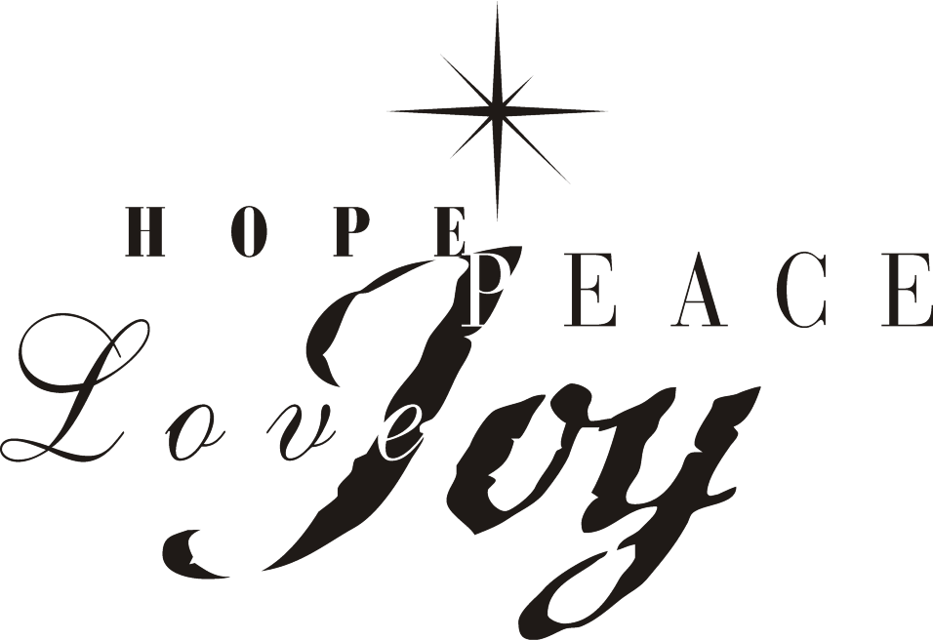SENDING FORTH: “Let There Be Peace On Earth”
Let there be peace on earth and let it begin with me. Let there be peace on earth, the peace that was meant to be. With God as our Father, fam’ly all are we. Let us walk with each other in perfect harmony. Let peace begin with me; let this be the moment now. With ev’ry step I take, let this be my solemn vow; to take each moment and live each moment in peace eternally! Let there be peace on earth, and let it begin with me.
Text and tune by Sy Miller, 1908-1941, Jill Jackson. Copyright 1955, 1983, Jan-Lee Music. All rights reserved.

