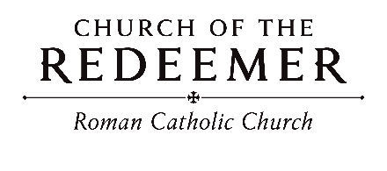
Feast of the Holy Family of Jesus, Mary and Joseph December 27/28, 2025

GATHERING SONG: “Awake, Awake, and Greet the New Morn”
1. Awake! Awake, and greet the new morn, for angels herald its dawning, Sing out your joy, for now he is born, Behold! The Child of our longing. Come as a baby weak and poor, to bring all hearts together, he opens wide the heav’nly door and lives now inside us forever.

2. Rejoice, rejoice, take heart in the night, though dark the winter and cheerless, the rising sun shall crown you with light, be strong and loving and fearless; love be our song and love our prayer, and love, our endless story, may God fill ev’ry day we share, and bring us at last into glory.
By Marty Haugen. Copyright 1983 by GIA Publications, Inc. All rights reserved. OneLicense.net License #A-701559

GREETING
GLORIA: “Mass of Renewal”
Glory to God in the highest, and on earth peace to people of good will.

1. We praise you, we bless you, we adore you, we glorify you, we give you thanks for your great glory, Lord God, heavenly King, O God, almighty Father.

2. Lord, Jesus Christ, Only Begotten Son, Lord God, Lamb of God, Son of the Father, you take away the sins of the world, have mercy on us; you take away the sins of the world, receive our prayer; you are seated at the right hand of the Father, have mercy, have mercy on us.
3. For you alone are the Holy One, you alone are the Lord, you alone are the Most High, Jesus Christ, with the Holy Spirit, in the glory of God the Father. Amen. Amen.
Text Copyright 2010, ICEL. Music Mass of Renewal by Curtis Stephan. Published by OCP. All rights reserved under OneLicense.net.
FIRST READING: Sirach 3:2-6, 12-14
PSALM 128: “Blest Are Those Who Love You”
Please repeat refrain after cantor the first time:

Blest are those who love you, happy those who follow you, blest are those who seek you, O God.
By Marty Haugen. Copyright 1987 by G.I.A. Publications, Inc. All rights reservedOneLicense.net License _A-701559.

SECOND READING: Colossians 3:12-21

GOSPEL ACCLAMATION: “Mass of Renewal”
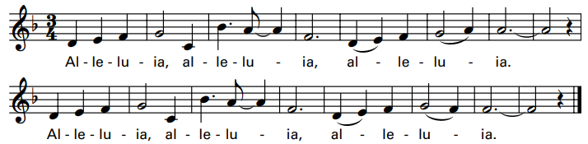
Verses text copyright 1969, 1981, 1997. Copyright 2009 by Curtis Stephan. Published by OCP Publications. All rights reserved. Used with permission.

GOSPEL: Matthew 2:13-15, 19-23
HOMILY

CREED
I believe in one God, the Father Almighty, maker of heaven and earth, of all things visible and invisible.
I believe in one Lord, Jesus Christ, the only Begotten Son of God, born of the Father before all ages. God from God, Light from Light, true God from true God, begotten, not made, consubstantial with the Father; through him all things were made. For us men and for our salvation he came down from heaven: (bow) And by the Holy Spirit was incarnate of the Virgin Mary, and became man. For our sake he was crucified under Pontius Pilate; he suffered death and was buried, and rose again on the third day in accordance with the Scriptures. He ascended into heaven and is seated at the right hand of the Father. He will come again in glory to judge the living and the dead and his kingdom will have no end.
I believe in the Holy Spirit, the Lord, the giver of life, who proceeds from the Father and the Son, who with the Father and the Son is adored and glorified, who has spoken through the prophets. I believe in one holy catholic and apostolic Church. I confess one Baptism for the forgiveness of sins and I look forward to the resurrection of the dead and the life of the world to come. Amen.

LITURGY OF THE EUCHARIST: “What Child Is This?”
1. What child is this, who laid to rest, on Mary's lap is sleeping? Whom angels greet with anthems sweet, while shepherds watch are keeping?

Refrain: This, this, is Christ the King, whom shepherds guard and angels sing, haste, haste, to bring Him laud, the Babe, the Son of Mary.

2. Why lies he in such mean estate where ox and ass are feeding? Good Christian fear; for sinners here the silent Word is pleading.

3. So bring him incense, gold and myrrh, come peasant, king to own him; the King of kings salvation brings, let loving hearts enthrone him.
Text: William C. Dix, 1827-1898. Tune: Greensleeves.

Invitation to Prayer
Priest: Pray, brothers and sisters, that my sacrifice and yours may be acceptable to God, the almighty Father.
People: May the Lord accept the sacrifice at your hands for the praise and glory of his name, for our good and the good of all his holy church.

Preface Dialogue
Priest: The Lord be with you. People: And with your spirit.
Priest: Lift up your hearts. People: We lift them up to the Lord.
Priest: Let us give thanks to the Lord our God. People: It is right and just.

Holy, Holy
Holy, holy, holy Lord God of hosts. Heaven and earth are full of your glory. Hosanna in the highest. Blessed is he who comes in the name of the Lord. Hosanna in the highest. Hosanna in the highest.

Memorial Acclamation
When we eat this bread and drink this Cup, we proclaim your Death, O Lord, until you come again.

Amen

A-men, a-men, a-men! A-men, a-men, a-men!
Revised Mass of Creation. Setting by Marty Haugen. Copyright 1984, 2010 by G.I.A. Publications, Inc. All rights reserved. OneLicense.net License #A-701559

The Lord’s Prayer

Sign of Peace

Lamb of God

Lamb of God: you take away the sins of the world: have mercy on us.
Lamb of God: you take away the sins of the world: have mercy on us.
Lamb of God: you take away the sins of the world: grant us peace, grant us peace.
By Marty Haugen. Copyright 1987 by G.I.A. Publications, Inc. All rights reserved. OneLicense.net License #A-701559

Priest: Behold the Lamb of God, behold him who takes away the sins of the world. Blessed are those called to the supper of the Lamb.
People: Lord, I am not worthy that you should enter under my roof, but only say the word and my soul shall be healed.

COMMUNION: “Ubi Caritas”
Ubi caritas est vera, est vera; Deus ibi est, Deus ibi est.

1. The love of Christ joins us together. Let us rejoice in him, and in our love and care for all now love God in return.

2. In true communion let us gather. May all divisions cease and in their place be Christ the Lord, our risen Prince of Peace.

3. May we who gather at this table to share the bread of life become a sacrament of love, your healing touch, O Christ.

4. For those in need make us your mercy, for those oppressed, your might. Make us, your Church, a holy sign of justice and new life.

5. May we one day behold your glory and see you face to face, rejoicing with the saints of God to sing eternal praise.
Verses 1, 2 and 5 based on Ubi Caritas, 9th cent., verses 3 & 4 by Bob Hurd. Tune by Bob Hurd, arranged by Craig S. Kingsbury. Published by spiritand song.com. All rights reserved. Reproduced with permission under License #U2739, OneLicense.net.

COMMUNION: “Song of Simeon”
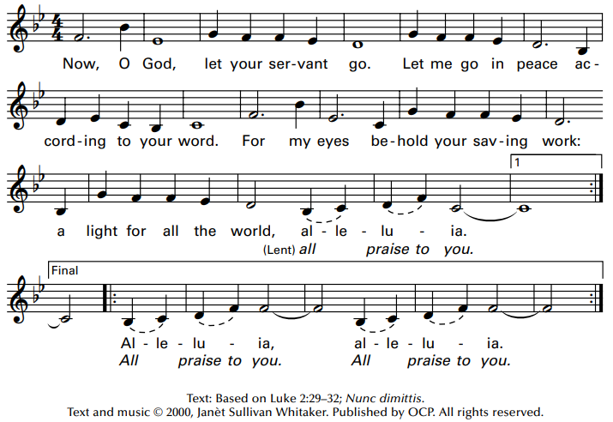

SENDING FORTH: “Hark! The Herald Angels Sing”
1. Hark! the herald angels sing, "Glory to the newborn King; Peace on earth and mercy mild, God and sinners reconciled!" Joyful, all ye nations rise, join the triumph of the skies; with angelic hosts proclaim: "Christ is born in Bethlehem!" Hark! the herald angels sing, "Glory to the newborn King!"

2. Christ, by highest heaven adored, Christ the everlasting Lord: Late in time behold him come, offspring of the Virgin’s womb. Veiled in flesh the Godhead see: hail the incarnate Deity, pleased as man with us to dwell, Jesus, our Emmanuel. Hark! the herald angels sing, "Glory to the newborn King!"

