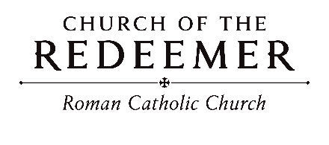
Solemnity of the Epiphany of the Lord January 3/4, 2026

GATHERING SONG: “Rise Up in Splendor”
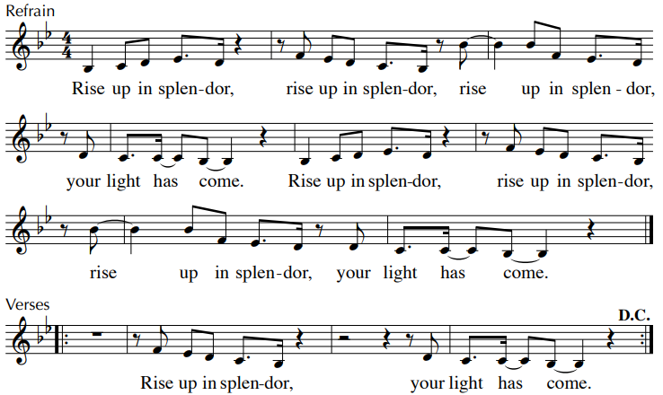

GREETING
GLORIA: “Mass of Renewal”
Glory to God in the highest, and on earth peace to people of good will.

1. We praise you, we bless you, we adore you, we glorify you, we give you thanks for your great glory, Lord God, heavenly King, O God, almighty Father.

2. Lord, Jesus Christ, Only Begotten Son, Lord God, Lamb of God, Son of the Father, you take away the sins of the world, have mercy on us; you take away the sins of the world, receive our prayer; you are seated at the right hand of the Father, have mercy, have mercy on us.
3. For you alone are the Holy One, you alone are the Lord, you alone are the Most High, Jesus Christ, with the Holy Spirit, in the glory of God the Father. Amen. Amen.
Text Copyright 2010, ICEL. Music Mass of Renewal by Curtis Stephan. Published by OCP. All rights reserved under OneLicense.net.
Children’s Liturgy (10:00) “Open My Eyes”
Open my ears, Lord. Help me to hear your voice. Open my ears, Lord, help me to hear. By Jesse Manibusan. Copyright 1988, 1998, 1999, by Jesse Manibusan. Published by OCP Publications. All rights reserved.
FIRST READING: Isaiah 60:1-6
PSALM 72: “Lord, Every Nation”
Please repeat after the cantor the first time and after the verses:

Lord, ev’ry nation on earth will adore you, O God. Lord, ev’ry nation on earth will adore you.
By Jesse Manibusan. Copyright 1998, 1999 Jesse Manibusan. Published by OCP Publications. All rights reserved. All rights reserved. Reproduced with permission under License #A-701559, OneLicense.net.

SECOND READING: Ephesians 3:2-3a, 5-6
GOSPEL ACCLAMATION: “Mass of Renewal”
Alleluia, alleluia, alleluia. Alleluia, alleluia, alleluia.
Verses text copyright 1969, 1981, 1997. Copyright 2009 by Curtis Stephan. Published by OCP Publications. All rights reserved. Used with permission.

GOSPEL: Matthew 2:1-12
HOMILY

CREED

I believe in one God, the Father Almighty, maker of heaven and earth, of all things visible and invisible.
I believe in one Lord, Jesus Christ, the only Begotten Son of God, born of the Father before all ages. God from God, Light from Light, true God from true God, begotten, not made, consubstantial with the Father; through him all things were made. For us men and for our salvation he came down from heaven: (bow) And by the Holy Spirit was incarnate of the Virgin Mary, and became man. For our sake he was crucified under Pontius Pilate; he suffered death and was buried, and rose again on the third day in accordance with the Scriptures. He ascended into heaven and is seated at the right hand of the Father. He will come again in glory to judge the living and the dead and his kingdom will have no end.
I believe in the Holy Spirit, the Lord, the giver of life, who proceeds from the Father and the Son, who with the Father and the Son is adored and glorified, who has spoken through the prophets. I believe in one holy catholic and apostolic Church. I confess one Baptism for the forgiveness of sins and I look forward to the resurrection of the dead and the life of the world to come. Amen.

LITURGY OF THE EUCHARIST: “Epiphany Carol”
1. Ev’ry nation sees the glory of a star that pierced the night. As we tell the wondrous story we are bathed in radiant light. Star sent forth from highest heaven, dancing light of God’s design, shine upon the gift that’s given: Word made flesh now born in time.

2. Ev’ry tongue shall sing the praises of his birth in deepest night. He is healing for the ages; He is Christ, our God’s delight. He proclaims within his being all our hopes, our great desires. He shall die to rise, redeeming all who follow with their lives.

3. Once again may we discover Word made flesh sent from above. In our neighbor, sister, brother, in the lonely and unloved. May we touch him, may we hold him, may we cradle him with care as we learn to love each other, bringing hope from out despair.

4. Gather, God, the word together in the brightness of your day. Fill our hearts with
joy forever; help us walk the holy way. May your justice rule the nations; may all
people live as one. Now we see our true salvation in the glory of your Son.
Text: Francis Patrick O’Brien. Tune: BEACH SPRING...Copyright 2002, GIA Publications, Inc. All rights reserved. OneLicense.net License #A-701559

Invitation to Prayer
Priest: Pray, brothers and sisters, that my sacrifice and yours may be acceptable to God, the almighty Father.
People: May the Lord accept the sacrifice at your hands for the praise and glory of his name, for our good and the good of all his holy church.

Holy, Holy
Holy, holy, holy Lord God of hosts. Heaven and earth are full of your glory. Hosanna in the highest. Blessed is he who comes in the name of the Lord. Hosanna in the highest. Hosanna in the highest.

Memorial Acclamation
When we eat this bread and drink this Cup, we proclaim your Death, O Lord, until you come again.

Amen

A-men, a-men, a-men! A-men, a-men, a-men!
Revised Mass of Creation. Setting by Marty Haugen. Copyright 1984, 2010 by G.I.A. Publications, Inc. All rights reserved. OneLicense.net License #A-701559

The Lord’s Prayer

Sign of Peace

Lamb of God
Lamb of God: you take away the sins of the world: have mercy on us.
Lamb of God: you take away the sins of the world: have mercy on us.
Lamb of God: you take away the sins of the world: grant us peace, grant us peace.
By Marty Haugen. Copyright 1987 by G.I.A. Publications, Inc. All rights reserved. OneLicense.net License #A-701559
COMMUNION: “The First Noel”
1. They looked up and saw a star shining in the east beyond them far, and to the
earth it gave great light and so it continued both day and night.

Noel, Noel, Noel, Noel, born is the King of Israel!
2. And by the light of that same star three wise men came from country far; to seek for a king was their intent, and to follow the star wherever it went.

3. This star drew nigh to the northwest, O'er Bethlehem it took its rest. And there it did both stop and stay, right over the place where Jesus lay.

4. Then entered in those wise men three, full rev’rently upon their knee, and offered there, in His presence, their gold and myrrh and frankincense.

5. Then let us all with one accord sing praises to our heav’nly Lord; who made the heav’ns and earth of naught, and with his blood our life has bought.
English traditional carol, 17th century.

COMMUNION: “As With Gladness”
1. As with gladness men of old did the guiding star behold; as with joy they hailed its light, leading onward, beaming bright; so, most gracious Lord, may we ever more your splendor see.

2. As with joyful steps they sped to that lowly manger bed, there to bend the knee before Him whom heaven and earth adore; so may we with hurried pace run to seek your throne of grace.

3. As they offered gifts most rare at that manger crude and bare; so may we this holy day, drawn to you without delay, all our costliest treasures bring, Christ, to you, our heavenly King.

4. Holy Jesus, ev’ry day, keep us in the narrow way; and when earthly things are past, bring our ransomed souls at last there they need no star to guide, where no clouds your glory hide.
Text by William C. Dix, 1837-1898. Tune DIX, arr. from Conrad Kocher, 1786-1872, by William H. Monk, 1823-1889.

SENDING FORTH: “We Three Kings of Orient Are”
1. We three kings of Orient are; bearing gifts we traverse afar. Field and fountain, moor and mountain, following yonder star.

Refrain: O star of wonder, star of night, star with royal beauty bright, westward leading, still proceeding, guide us to the perfect Light.

2. Glorious now behold him arise, King and God and Sacrifice; “Alleluia, Alleluia!” Sounds through the earth and skies. Text: Matthew 2:1-11. Text and tune: John H. Hopkins, Jr.,

