
The Solemnity of Our Lord Jesus Christ,
King of the Universe
November 22/23, 2025

GATHERING SONG: “To Jesus Christ, Our Sovereign King”
1. To Jesus Christ, our sov’reign King, who is the world’s salvation, all praise and homage do we bring and thanks and adoration. Christ Jesus, Victor! Christ Jesus, Ruler! Christ Jesus, Lord and Redeemer!

2. Your reign extend, O King benign, to ev’ry land and nation; for in your Kingdom, Lord divine, alone we find salvation. Christ Jesus, Victor! Christ Jesus, Ruler! Christ Jesus, Lord and Redeemer! Text: Martin B. Hellrigel, 1891-1981, alt. Copyright 1941, Irene C. Mueller. Tune: ICH GLAUB AN GOTT, 8 7 8 7 with refrain; Mainz Gesangbuch, 1870; harm. By Richard Proulx, b. 1937. Copyright 1986 GIA Publications, Inc.

GLORIA
Glory to God in the highest, and on earth peace to people of good will.
1. We praise you, we bless you, we adore you, we glorify you, we give you thanks for your great glory, Lord God, heavenly King, O God, almighty Father.

2. Lord, Jesus Christ, Only Begotten Son, Lord God, Lamb of God, Son of the Father, you take away the sins of the world, have mercy on us; you take away the sins of the world, receive our prayer; you are seated at the right hand of the Father, have mercy on us.

3. For you alone are the Holy One, you alone are the Lord, you alone are the Most High, Jesus Christ, with the Holy Spirit, in the glory of God the Father. Amen.
Excerpts from the English translation of The Roman Missal, copyright 2010, International Commission on English in the Liturgy Corporation. Music: Mass of Renewal, by William Gokelman & David Kauffman. Copyright 2010 GFTSMusic Publishing Company, Inc. Administered by International Liturgy Publications. All rights reserved.

FIRST READING: 2 Samuel 5:1-3

PSALM 122: “Let Us Go Rejoicing”
Please repeat refrain after the cantor and sing after each verse:

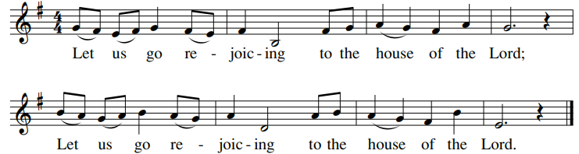

SECOND READING: Colossians 1:12-20

GOSPEL ACCLAMATION: “Alleluia! Give the Glory”

Alleluia! Alleluia! Allelu-ia! Give the glory and the honor to the Lord! Alleluia! Alleluia! Allelu-ia! Give the glory and the honor to the Lord!

GOSPEL: Luke 23:35-43
HOMILY

CREED
I believe in one God, the Father Almighty, maker of heaven and earth, of all things visible and invisible.

I believe in one Lord, Jesus Christ, the only Begotten Son of God, born of the Father before all ages. God from God, Light from Light, true God from true God, begotten, not made, consubstantial with the Father; through him all things were made. For us men and for our salvation he came down from heaven: (bow) And by the Holy Spirit was incarnate of the Virgin Mary, and became man. For our sake he was crucified under Pontius Pilate; he suffered death and was buried, and rose again on the third day in accordance with the Scriptures. He ascended into heaven and is seated at the right hand of the Father. He will come again in glory to judge the living and the dead and his kingdom will have no end.

I believe in the Holy Spirit, the Lord, the giver of life, who proceeds from the Father and the Son, who with the Father and the Son is adored and glorified, who has spoken through the prophets. I believe in one holy catholic and apostolic Church. I confess one Baptism for the forgiveness of sins and I look forward to the resurrection of the dead and the life of the world to come. Amen

LITURGY OF THE EUCHARIST: “King of My Heart”
1. Fill me, I’m an empty vessel; make me whole, king of my heart, king of my heart. Fill me, I’m an empty vessel; make me whole, king of my heart, king of my heart. You are Lord, Lord. You are Lord and king of my heart.

2. Bread of life, blessed and broken; make us whole, king of our hearts, king of our hearts. Bread of life, blessed and broken; make us whole, king of our hearts, king of our hearts. You are Lord, Lord. You are Lord and king of our hearts.

3. Sacred cup of our salvation; make us whole, king of our hearts, king of our hearts. Sacred cup of our salvation; make us whole, king of our hearts, king of our hearts. You are Lord, Lord. You are Lord and king of our hearts. You are Lord, Lord. You are Lord and king of our hearts.
By Greg Walton. Copyright 1997, 2004, Greg Walton. Published by spiritandsong.com. All rights reserved. Reproduced with permission under License #A-701559, OneLicense.net.

INVITATION TO PRAYER
Priest: Pray, brothers and sisters, that my sacrifice and yours may be acceptable to God, the almighty Father.
People: May the Lord accept the sacrifice at your hands for the praise and glory of his name, for our good and the good of all his holy church.

Preface Dialogue
Priest: The Lord be with you. People: And with your spirit.
Priest: Lift up your hearts. People: We lift them up to the Lord.
Priest: Let us give thanks to the Lord our God. People: It is right and just.

Holy, Holy: “Mass of Glory”

Holy, Holy, Holy Lord God of hosts. Heaven and earth are full of your glory. Hosanna, hosanna, hosanna in the highest. Blessed is he who comes in the name of the Lord. Hosanna, hosanna, hosanna in the highest.

Memorial Acclamation

When we eat this Bread and drink this Cup, we proclaim your Death, O Lord, until you come again, until you come again.

Amen

Amen. Amen. Alleluia, amen.

The Lord’s Prayer

Sign of Peace

Lamb of God

Cantor: Lamb of God, All: you take away the sins of the world, have mercy on us.
Cantor: Lamb of God, All: you take away the sins of the world, have mercy on us.
Cantor: Lamb of God, All: you take away the sins of the world, grant us, grant us peace.
Excerpts from the English translation of The Roman Missal, copyright 2010, International Commission on English in the Liturgy Corporation. Music: Mass of Glory; by Bob Hurd. Copyright 1991, 1993, 2010. Published by OCP. All rights reserved under OneLicense License #A-701559.

Priest: Behold the Lamb of God, behold him who takes away the sins of the world. Blessed are those called to the supper of the Lamb.
People: Lord, I am not worthy that you should enter under my roof, but only say the word and my soul shall be healed.

COMMUNION: “Jesus, the Lord”
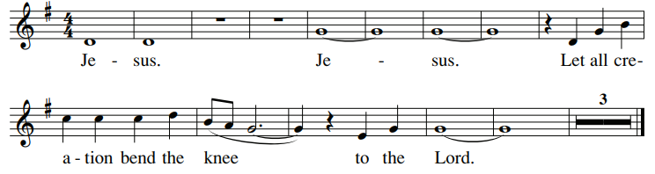
1. In Him we live, we move and have our being; in Him the Christ, in Him the King! Jesus, the Lord.

2. Though Son, He did not cling to godliness; but emptied Himself, became a slave! Jesus, the Lord.

3. He lived obediently His Father's will accepting His death, death on a tree! Jesus, the Lord.
By Roc O'Connor, S.J. Copyright 1981 by Robert F. O'Connor, S.J. and New Dawn Music. All rights reserved. Reproduced with permission under License #A-701559, OneLicense.net.

COMMUNION: “The Jesus Song”
1. Lord Jesus Christ, Son of God, have mercy on me, have mercy on me. Lord Jesus Christ, Son of God, have mercy on me, have mercy on me. Amen. (Repeat)

2. Jesus, I trust in you. Jesus, I trust in you. You are the Son of the Living God. Jesus, I trust in you. Jesus, I trust in you. (Repeat)

Final time: Jesus, I trust in you. Lord Jesus Christ, Son of God, have mercy on me, have mercy on me. Amen.
Text based on the Jesus Prayer and the Chaplet of Divine Mercy. Text and Music by Tom Booth. Copyright 2014 Published by Spirit & Song a division of OCP Publications. All rights reserved. Used with permission. Reproduced with permission under OneLicense.net.

SENDING FORTH: “The King of Glory”
The King of glory comes, the nation rejoices, Open the gates before him, lift up your voices.

1. Who is the king of glory; how shall we call him? He is Emmanuel, the promised of ages.

2. He conquered sin and death; he truly has risen. And he will share with us his heavenly vision.
By Willard F. Jabusch, b. 1930. Copyright 1966, 1982, Willard F. Jabusch. Administered by OCP. Tune: KING OF GLORY, 12 12 with refrain, Israeli harm. By Richard Proulx, 1937-2010. Copyright 1986 GIA Publications, Inc. OneLicense.net License #A-701559

