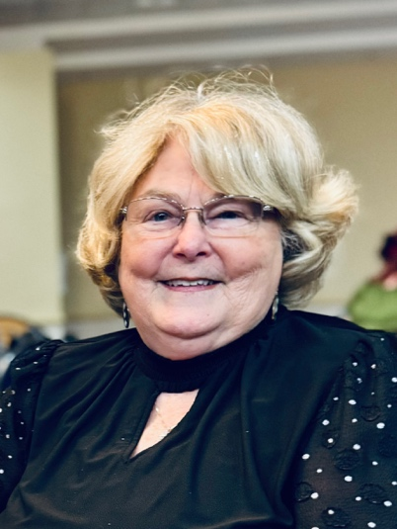
My name is Carolyn Brand. I grew up attending Saint Elizabeth Church in Highland Park and have lived my entire life within a seven-mile radius. I have been an active member of Redeemer since 1978, when we held liturgy at Mechanicsville Recreation Center. Prior to the appointment of a staff coordinator for Religious Education (RE), I served on the RE committee and taught sixth grade. I explored many opportunities at Redeemer that didn't quite fit for me—I spent a year in the Bell Choir but discovered I had no rhythm and participated briefly in the card ministry.

Currently, I serve as co-chair of the Haiti Ministry, which I've been involved with since its inception 30 years ago. I also chair the Prayer Shawl Ministry and have acted as a Eucharistic Minister since the 1990s. Additionally, I regularly help prepare meals for individuals experiencing homelessness and am an active member of the No Room at the Inn Committee, Money Counting team and the Linen Ministry. Previously, I was a member of the Pastoral Council.

I am retired from Woodfin and am a former EMT. I volunteered with the Henrico Volunteer Rescue Squad and continue to be actively involved with the Virginia Association of First Responders. I have one daughter, who grew up at Redeemer and currently resides in Boise, Idaho, with her husband and my granddog.

My ongoing involvement at Redeemer is driven by the deep connection I feel to this community. Here, I have made friendships that will last a lifetime. I value Redeemer’s diversity, which gives me a sense of belonging. On Pastoral Council, I offer a broad background in volunteer work, and listening ear, and genuine affection for our church.

