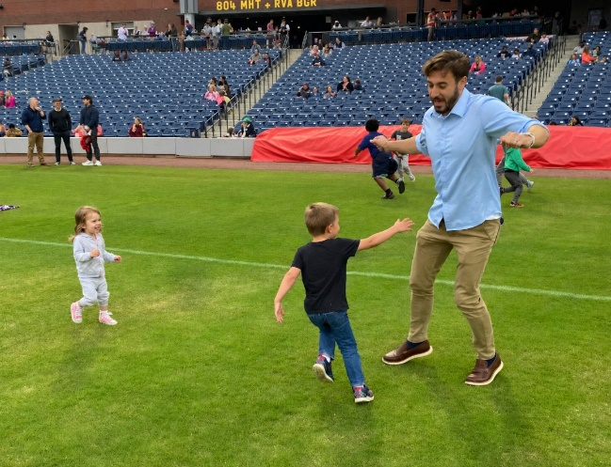
Aaron Winter Bio
Hi, my name is Aaron Winter, and I am interested in pursuing the Parish Council position. I am grateful for the opportunity to share a little about myself and what I hope to contribute to our parish community.
My Catholic journey began when I entered the Church through the RCIA program at the age of 18. I am deeply grateful for the life-altering gift of being a member of the Church, which has borne invaluable fruit in my life through friendships, the vocation of marriage, and a sense of purpose and meaning in both life’s joys and its struggles.
My wife, Darryn, and I live in Mechanicsville with our three children: Iva, Seth, and Elliot. Since leaving Michigan in 2019, our family’s journey has taken us to South Carolina for educational pursuits and then to the Richmond area, where we have begun putting down roots. We are grateful to be building our life here and becoming more connected to the community around us.
Professionally, I work as an engineer at Dominion Energy. As part of a family with two working parents and young children, I feel connected to both the blessings and challenges that come with this stage of life. If given the opportunity to serve on Parish Council, I would hope to bring that perspective in a thoughtful and constructive way — especially in considering how the parish can support young families, while also listening to and learning from the needs of parishioners in every season of life.
Outside of work, I enjoy world history, especially from late antiquity through modern times; I am a longtime Titanic enthusiast; and I love traveling with my family. I am also an avid runner. Running has become a real passion of mine, and I once heard it said that when we take part in something we truly love, we can “feel our Creator’s joy”. That idea has always resonated with me.
It would be an honor to be considered for Parish Council. I would be excited for the opportunity to contribute my energy, and perspectives in service to our parish as we seek to support one another and follow God’s will for our community.

