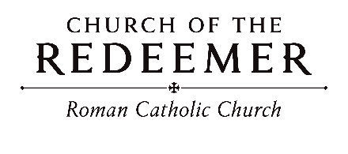
Sixth Sunday in Ordinary Time February 14/15, 2026

GATHERING SONG: “Lead Me, Lord”
- Blest are they who through their lifetimes sow the seeds of peace; all will call them children of the Lord. Blest are you though persecuted in your holy life, for in heaven, great is your reward

Refrain: Lead me, Lord, lead me, Lord, by the light of truth to seek and to find the narrow way. Be my way; be my truth; be my life, my Lord, and lead me, Lord, today. And lead me, Lord, today.
By John D. Becker. Copyright 1987, John D. Becker. Published by OCP Publications. All rights reserved under OneLicense.net.
GLORIA: “Mass of Renewal”
Glory to God in the highest, and on earth peace to people of good will.

1. We praise you, we bless you, we adore you, we glorify you, we give you thanks for your great glory, Lord God, heavenly King, O God, almighty Father.

2. Lord, Jesus Christ, Only Begotten Son, Lord God, Lamb of God, Son of the Father, you take away the sins of the world, have mercy on us; you take away the sins of the world, receive our prayer; you are seated at the right hand of the Father, have mercy, have mercy on us.

3. For you alone are the Holy One, you alone are the Lord, you alone are the Most High, Jesus Christ, with the Holy Spirit, in the glory of God the Father. Amen. Amen.
Text Copyright 2010, ICEL. Music Mass of Renewal by Curtis Stephan. Published by OCP. All rights reserved under OneLicense.net.

FIRST READING: Sirach 15:15-20
PSALM 119: “Blessed are They”
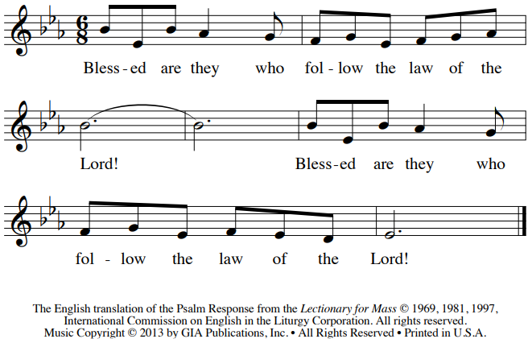

SECOND READING: 1 Corinthians 2:6-10
GOSPEL ACCLAMATION: “Mass of Renewal”
Alleluia, alleluia, alleluia. Alleluia, alleluia, alleluia.
Verses text copyright 1969, 1981, 1997. Copyright 2009 by Curtis Stephan. Published by OCP Publications. All rights reserved. Used with permission.
GOSPEL: Matthew 5:17-37
HOMILY

CREED
I believe in one God, the Father Almighty, maker of heaven and earth, of all things visible and invisible.
I believe in one Lord, Jesus Christ, the only Begotten Son of God, born of the Father before all ages. God from God, Light from Light, true God from true God, begotten, not made, consubstantial with the Father; through him all things were made. For us men and for our salvation he came down from heaven: (bow) And by the Holy Spirit was incarnate of the Virgin Mary, and became man. For our sake he was crucified under Pontius Pilate; he suffered death and was buried, and rose again on the third day in accordance with the Scriptures. He ascended into heaven and is seated at the right hand of the Father. He will come again in glory to judge the living and the dead and his kingdom will have no end.
I believe in the Holy Spirit, the Lord, the giver of life, who proceeds from the Father and the Son, who with the Father and the Son is adored and glorified, who has spoken through the prophets. I believe in one holy catholic and apostolic Church. I confess one Baptism for the forgiveness of sins and I look forward to the resurrection of the dead and the life of the world to come. Amen.

LITURGY OF THE EUCHARIST: “Wisdom, My Road” 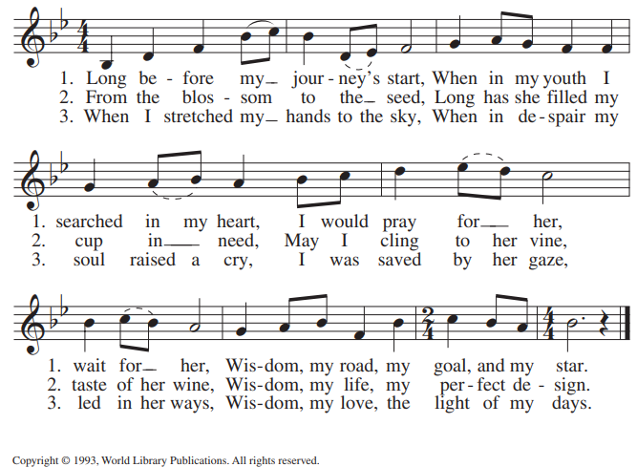
Invitation to Prayer
Priest: Pray, brothers and sisters, that my sacrifice and yours may be acceptable to God, the almighty Father.
People: May the Lord accept the sacrifice at your hands, for the praise and glory of his name, for our good, and the good of all his holy Church.

Preface Dialogue
Priest: The Lord be with you. People: And with your spirit.
Priest: Lift up your hearts. People: We lift them up to the Lord.
Priest: Let us give thanks to the Lord our God. People: It is right and just.

Holy, Holy
Holy, Holy, Ho-ly Lord God of hosts. Heaven and earth are full of your glory. Hosanna in the highest. Blessed is he who comes in the name of the Lord. Hosanna in the highest. Hosanna in the high-est.

Memorial Acclamation
We proclaim your death, O Lord, and profess your Resurrection until you come again.
Amen
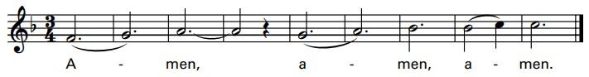
Excerpts from the English translation of The Roman Missal, copyright 2010, International Commission on English in the Liturgy Corporation. Music: Mass of Renewal, by Curtis Stephan. Copyright 2009. Published by OCP. All rights reserved.

The Lord’s Prayer

Sign of Peace

Lamb of God: “Mass of St. Timothy”
Please repeat each phrase after the cantor:

Cantor: Lamb of God, All: Lamb of God,
Cantor: you take away All: you take away
Cantor: the sins of All: the sins of
Cantor: the world: All: the world:
Cantor: Miserere nobis. All: Miserere nobis.
(Last time)
Cantor: Dona nobis pacem. All: Dona nobis pacem.
By Matt Maher. Copyright 2013. Published by OCP. All rights reserved.

Priest: Behold the Lamb of God, behold him who takes away the sins of the world. Blessed are those called to the supper of the Lamb.
People: Lord, I am not worthy that you should enter under my roof, but only say the word and my soul shall be healed.
COMMUNION: “Hold on to Love”
1. Cantor: All: Hold on to Love.
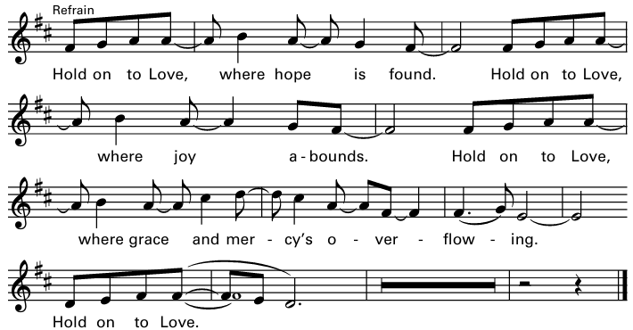
2. Cantor: All: Hold on to Love.

3. When hatred is used to divide us, hold on to Love. Wisdom and truth reunite us. Hold on to Love. When prejudice poses as freedom, hold on to Love. Dignity means “all are welcome!” Hold on to Love.
Text and tune by Jesse Manibusan. Copyright 2016. Spirit & Song, a division of OCP.OneLicense.net License #A-701559

COMMUNION: “Eye Has Not Seen”
Eye has not seen, ear has not heard what God has ready for those who love him; Spirit of love, come, give us the mind of Jesus, teach us the wisdom of God.

1. When pain and sorrow weigh us down, be near to us, O Lord, forgive the weakness of our faith, and bear us up within your peaceful word.

2. Our lives are but a single breath, we flower and we fade, yet all our days are in your hands, so we return in love what love has made.

3. To those who see with eyes of faith, the Lord is ever near, reflected in the faces of all the poor and lowly of the world.

4. We sing a myst’ry from the past in halls where saints have trod, yet ever new the music rings to Jesus, Living Song of God.
By Marty Haugen. Copyright 1982, GIA Publications, Inc. All rights reserved. OneLicense.net License#A-701559

SENDING FORTH: “Rain Down”
Rain down, rain down, rain down your love on your people. Rain down, rain down, rain down your love, God of life.

1. Faithful and true is the word of our God. All of God’s works are so worthy of trust. God’s mercy falls on the just and the right; full of God’s love is the earth.
By Jaime Cortez. Copyright 1991. Published by OCP Publications. All rights reserved. Reproduced with permission under License #A-701559, OneLicense.net.

