
Fourth Sunday of Advent
December 20/21, 2025
Church of the Redeemer
Simbang Gabi, 5:30pm
PRELUDE (5:30): “Ang Kulay ng Pasko” (The Color of Christmas)
GATHERING SONG: “Hope Will Not Fail”
Please repeat verse after the cantor:
1. Love will not fail, no, love will not fail. Though hatred and hopelessness seem to prevail, no, love will not fail; love, love will prevail.

2. Believe in the power, the power of love! Though hatred and hopelessness seem to prevail, no, love will not fail; love, love will prevail.
PENITENTIAL ACT
I confess to almighty God, and to you, my brothers and sisters,
that I have greatly sinned, in my thoughts and in my words,
in what I have done and in what I have failed to do,
(All strike their breast as they say:)
through my fault, through my fault, through my most grievous fault;
(Then they continue:)
Therefore, I ask blessed Mary ever-Virgin, all the Angels and Saints,
and you, my brothers and sisters, to pray for me to the Lord our God.

INVOCATIONS
Priest: Lord, have mercy. People: Lord, have mercy.
Priest: Christ, have mercy. People: Christ, have mercy.
Priest: Lord, have mercy. People: Lord, have mercy.

FIRST READING: Isaiah 7:10-14
PSALM 24: “Open Wide Your Gates”

Please repeat refrain after the cantor and sing after each verse:
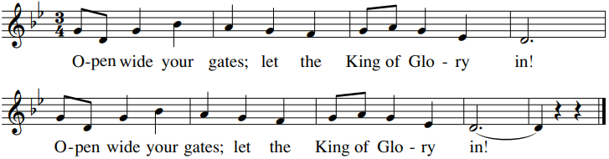
SECOND READING: Romans 1:1-7
GOSPEL ACCLAMATION: “Mass of Renewal”
Alleluia, alleluia, alleluia. Alleluia, alleluia, alleluia.
Verses text copyright 1969, 1981, 1997. Copyright 2009 by Curtis Stephan. Published by OCP Publications. All rights reserved. Used with permission.
GOSPEL: Matthew 1:18-24
HOMILY

CREED
I believe in one God, the Father Almighty, maker of heaven and earth, of all things visible and invisible.
I believe in one Lord, Jesus Christ, the only Begotten Son of God, born of the Father before all ages. God from God, Light from Light, true God from true God, begotten, not made, consubstantial with the Father; through him all things were made. For us men and for our salvation he came down from heaven: (bow) And by the Holy Spirit was incarnate of the Virgin Mary, and became man. For our sake he was crucified under Pontius Pilate; he suffered death and was buried, and rose again on the third day in accordance with the Scriptures. He ascended into heaven and is seated at the right hand of the Father. He will come again in glory to judge the living and the dead and his kingdom will have no end.
I believe in the Holy Spirit, the Lord, the giver of life, who proceeds from the Father and the Son, who with the Father and the Son is adored and glorified, who has spoken through the prophets. I believe in one holy catholic and apostolic Church. I confess one Baptism for the forgiveness of sins and I look forward to the resurrection of the dead and the life of the world to come. Amen.

LITURGY OF THE EUCHARIST: “Hail Mary, Gentle Woman”
Hail Mary, full of grace, the Lord is with you. Blessed are you among women, and blest is the fruit of your womb, Jesus. Holy Mary, Mother of God, pray for us sinners now and at the hour of death. A-men.

Refrain: Gentle woman, quiet light, morning star, so strong and bright, gentle Mother,
peaceful dove, teach us wisdom, teach us love.

1. You were chosen by the Father, you were chosen for the Son. You were chosen from all women and for woman, shining one.
2. Blessed are you among women, blest in turn all women too. Blessed they with peaceful spirits. Blessed they with gentle hearts.
Hail Mary based on Luke 1:28, music and additional words by Carey Landry. Copyright 1975 by Carey Landry and New Dawn Music. All rights reserved. Used with permission.

INVITATION TO PRAYER
Priest: Pray, brothers and sisters, that my sacrifice and yours may be acceptable to God, the almighty Father.
People: May the Lord accept the sacrifice at your hands for the praise and glory of his name, for our good and the good of all his holy church.

Holy, Holy
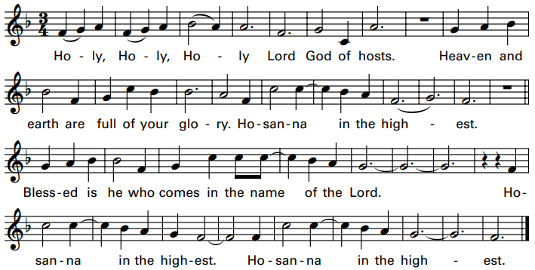

Memorial Acclamation
We proclaim your Death, O Lord, and profess your Resurrection until you come again.

Amen

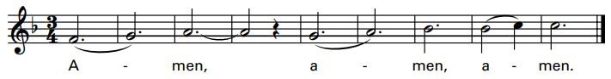
Excerpts from the English translation of The Roman Missal, copyright 2010, International Commission on English in the Liturgy Corporation.
Music: Mass of Renewal, by Curtis Stephan. Copyright 2009. Published by OCP. All rights reserved.

The Lord’s Prayer

Sign of Peace

Lamb of God: “Mass of St. Timothy”
Cantor: Lamb of God, All: Lamb of God,
Cantor: you take away All: you take away
Cantor: the sins of All: the sins of
Cantor: the world: All: the world:
Cantor: Miserere nobis. All: Miserere nobis.
(Last time) Cantor: Dona nobis pacem. All: Dona nobis pacem.

COMMUNION: “Holy Is His Name”
1. My soul proclaims the greatness of the Lord, and my spirit exalts in God my Savior. For he has looked with mercy on my lowliness and my name will be forever exalted. For the mighty God has done great things for me and his mercy will reach from age to age.
Refrain: And Ho-ly, Ho-ly, Ho-ly is His Name.
2. He has mercy in ev’ry generation. He has revealed His power and His glory. He has cast down the mighty in their arrogance, and has lifted up the meek and the lowly. He has come to help His servant Israel. He remembers His promise to our fathers. (Refrain twice)
By John Michael Talbot. Copyright 1980 Birdwing Music/Cherry Lane Music Publishing Co., Inc. All rights reserved.

COMMUNION: “Ready the Way”
Ready the way, ready the way, ready the way of the Lord.
Ready the way, ready the way, ready the way of the Lord. (Last time: Ready the way of the Lord.)

1. Make straight the road, raise the valleys, and mountains make low.
Turning from sin, let the broken be whole, and ready the way of the Lord.

2. As we wait for you, give us the strength to walk in your truth,
So we may love more like you and ready the way of the Lord.

3. Let us see your face; in our hearts we prepare a place. Come bring this world your mercy and grace, as we ready the way of the Lord.
Copyright 2004, Curtis Stephan. Published by spiritandsong.com. All rights reserved. Reproduced with permission under License #A-701559, OneLicense.net.

SENDING FORTH: “O Come, O Come Emmanuel”
1. O come, O come, Emmanuel, and ransom captive Israel, that mourns in lonely exile here until the Son of God appear.

Refrain: Rejoice! Rejoice! Emmanuel shall come to you, O Israel!

2. O come, Desire of nations, bind in one the hearts of all humankind; Bid thou our sad divisions cease, and be thyself our Prince of Peace.
Text: Latin, 9th century. Music: Chant, Mode 1, Veni, Veni Emmanuel, adapt. by T. Helmore, 1811-1890.

