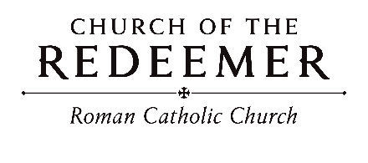
Third Sunday of Lent
March 7/8, 2026
First Scrutiny: 10:00 Mass

GATHERING SONG: “Lord, Who throughout These Forty Days”
- Lord, who throughout these forty days for us did fast and pray, teach us to overcome our sins, and close by you to stay.

- As you did hunger and did thirst, so teach us gracious Lord, to die to self, and only live by your most holy word.

- And through these days of penitence, and through your Passiontide, for evermore, in life and death, O Lord, with us abide.
Text: Claudia F. Hernaman. Tune: ST. FLAVIAN Published by GIA Publications. All rights reserved. Used with permission. Reproduced with permission under License #A-701559, OneLicense.net
KYRIE, ELEISON

Children’s Liturgy (10:00) “Open My Eyes”
Open my ears, Lord. Help me to hear your voice. Open my ears, Lord, help me to hear. By Jesse Manibusan. Copyright 1988, 1998, 1999, by Jesse Manibusan. Published by OCP Publications. All rights reserved.

FIRST READING: Exodus 17:3-7

PSALM 95: “If Today”
Please sing refrain WITH the cantor the first time and sing after each verse:
If today you hear the voice of God, if today you hear God’s own voice, harden not your heart, harden not your heart, harden not your heart today. (Last time: today.)
By Bob Hurd and Joe Bellamy. Copyright 1991 by Bob Hurd and Joe Bellamy. Published by OCP Publications. All rights reserved. Reproduced with permission under License #A-701559, OneLicense.net.

SECOND READING: Romans 5:1-2, 5-8
GOSPEL ACCLAMATION: “Mass of Joy and Peace”
Glory to you, Word of God, Lord Jesus Christ! Glory to you, Word of God, Lord Jesus Christ! Text: ICEL, copyright 2010. Music: Mass of Joy and Peace, Tony E. Alonso. Copyright 2010 GIA Publications, Inc.
GOSPEL: John 4:5-15, 19b-26, 39a, 40-42
HOMILY

CREED
I believe in one God, the Father Almighty, maker of heaven and earth, of all things visible and invisible.
I believe in one Lord, Jesus Christ, the only Begotten Son of God, born of the Father before all ages. God from God, Light from Light, true God from true God, begotten, not made, consubstantial with the Father; through him all things were made. For us men and for our salvation he came down from heaven: (bow) And by the Holy Spirit was incarnate of the Virgin Mary and became man. For our sake he was crucified under Pontius Pilate; he suffered death and was buried and rose again on the third day in accordance with the Scriptures. He ascended into heaven and is seated at the right hand of the Father. He will come again in glory to judge the living and the dead, and his kingdom will have no end.
I believe in the Holy Spirit, the Lord, the giver of life, who proceeds from the Father and the Son, who with the Father and the Son is adored and glorified, who has spoken through the prophets. I believe in one holy catholic and apostolic Church. I confess one Baptism for the forgiveness of sins, and I look forward to the resurrection of the dead and the life of the world to come. Amen.

LITURGY OF THE EUCHARIST: “God, Our Source and Life, Unite Us”
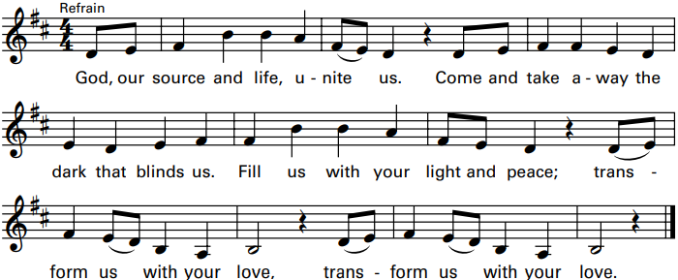
Verses: Cantor: All: Transform us with your love.
By Trevor Thomson. Copyright 2011, 2013 Published by Spirit & Song, a division of OCP. All rights reserved. Used with permission. Reproduced with permission under License #A-701559, OneLicense.net.

INVITATION TO PRAYER
Priest: Pray, brothers and sisters, that my sacrifice and yours may be acceptable to God, the almighty Father.
People: May the Lord accept the sacrifice at your hands for the praise and glory of his name, for our good and the good of all his holy church.

Preface Dialogue
Priest: The Lord be with you. People: And with your spirit.
Priest: Lift up your hearts. People: We lift them up to the Lord.
Priest: Let us give thanks to the Lord our God. People: It is right and just.

Holy, Holy: “Mass of Joy and Peace”

Holy, Holy, Holy Lord God of hosts. Heaven and earth are full of your glory. Hosanna in the highest, hosanna in the highest. Blessed is he, blessed is he who comes in the name of the Lord. Hosanna in the highest, hosanna in the highest. Hosanna in the highest, hosanna in the highest.

Memorial Acclamation: “Mass of Joy and Peace”

We proclaim your Death, O Lord, and profess your Resurrection until you come again.

Amen: “Mass of Joy and Peace”

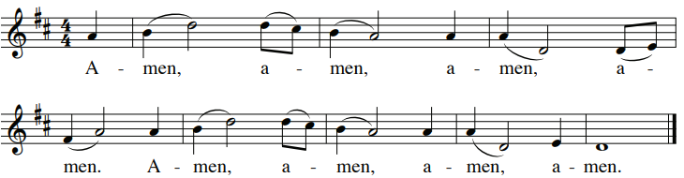

The Lord’s Prayer

Sign of Peace

Lamb of God: “Mass of Joy and Peace"
Lamb of God: you take away the sins of the world: have mercy on us.
Lamb of God: you take away the sins of the world: have mercy on us.
Lamb of God: you take away the sins of the world: grant us peace.
Text: ICEL, copyright 2010. Music: Mass of Joy and Peace, Tony E. Alonso. Copyright 2010 GIA Publications, Inc.

COMMUNION: “Come, All You Thirsty”
1. Come, all you thirsty, to the water, parched and lonely, starved for grace. Here the feast is spread for your famished soul. Come and take, come and eat, come and drink.

2. Come, all you weary, to the water, bound by mem’ry, crushed by fear. Lay your burdens down in this place of rest. Without cost, take your place at the feast.

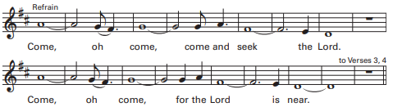

3. Come, all you wounded, to the water, you who suffer broken faith. You who fear
to trust in the love of God, without cost, take your place at the feast.

4. Come, all who stumble, to the water. In your weakness, know God’s strength.
Taste the mercy greater than all your sin. Come and take, come and eat, come
and drink. By Kathleen M. Basi. Copyright 2020, 2021 Published by OCP. All rights reserved. Used with permission. Reproduced with
permission under License #A-701559, OneLicense.net.

COMMUNION: “I Heard the Voice of Jesus Say”
1. I heard the voice of Jesus say, “Come unto me and rest; Lay down, O weary one, lay down your head upon my breast.” I came to Jesus as I was, so weary, worn, and sad; I found in him a resting place, and he has made me glad.
2. I heard the voice of Jesus say, “Behold, I freely give the living water, thirsty one, stoop down and drink and live.” I came to Jesus, and I drank of that life-giving stream; My thirst was quenched, my soul revived, and now I live in him.
3. I heard the voice of Jesus say, “I am this dark world’s light; look unto me, your morn shall rise, and all your day be bright.” I looked to Jesus, and I found in him my star, my sun; and in that light of life I’ll walk till trav’ling days are done.
Text: Horatius Bonar, 1808-1889. Tune: KINGSFOLD, CMD, English harm by Ralph Vaughan Williams, 1872-1958. Copyright Oxford University Press.

SENDING FORTH: “Change Our Hearts”
Change our hearts this time, Your word says it can be. Change our minds, this time, Your life could make us free. We are the people Your call set apart, Lord, this time, change our hearts.

- Show us the way that leads to Your side, over the mountains and sands of the soul. Be for us manna, water from stone, light which says we never walk alone.
By Rory Cooney. Copyright 1984 by New Dawn Music Reproduced with permission under License #A-701559, OneLicense.net.

