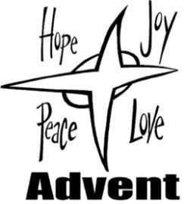
Third Sunday of Advent
December 13/14, 2025
Church of the Redeemer

GATHERING SONG: “Hope Will Not Fail”
Please repeat verse after the cantor:
1. Joy will not fail, no, joy will not fail. Though mourning and misery seem to prevail, no, joy will not fail; joy, joy will prevail.
PENITENTIAL ACT
I confess to almighty God, and to you, my brothers and sisters,
that I have greatly sinned, in my thoughts and in my words,
in what I have done and in what I have failed to do,
(All strike their breast as they say:)
through my fault, through my fault, through my most grievous fault;
(Then they continue:)
Therefore, I ask blessed Mary ever-Virgin, all the Angels and Saints,
and you, my brothers and sisters, to pray for me to the Lord our God.

INVOCATIONS
Priest: Lord, have mercy. People: Lord, have mercy.
Priest: Christ, have mercy. People: Christ, have mercy.
Priest: Lord, have mercy. People: Lord, have mercy.

FIRST READING: Isaiah 35:1-6a, 10
PSALM 146: “Lord, Come and Save Us”

Please repeat refrain after the cantor and sing after each verse:
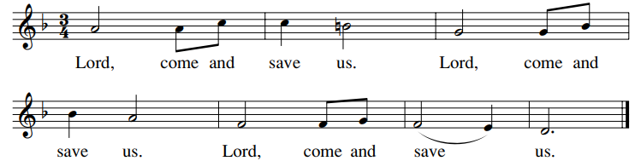

SECOND READING: James 5:7-10
GOSPEL ACCLAMATION: “Mass of Renewal”
Alleluia, alleluia, alleluia. Alleluia, alleluia, alleluia.
Verses text copyright 1969, 1981, 1997. Copyright 2009 by Curtis Stephan. Published by OCP Publications. All rights reserved. Used with permission.
GOSPEL: Matthew 11:2-11
HOMILY

CREED
I believe in one God, the Father Almighty, maker of heaven and earth, of all things visible and invisible.
I believe in one Lord, Jesus Christ, the only Begotten Son of God, born of the Father before all ages. God from God, Light from Light, true God from true God, begotten, not made, consubstantial with the Father; through him all things were made. For us men and for our salvation he came down from heaven: (bow) And by the Holy Spirit was incarnate of the Virgin Mary, and became man. For our sake he was crucified under Pontius Pilate; he suffered death and was buried, and rose again on the third day in accordance with the Scriptures. He ascended into heaven and is seated at the right hand of the Father. He will come again in glory to judge the living and the dead and his kingdom will have no end.
I believe in the Holy Spirit, the Lord, the giver of life, who proceeds from the Father and the Son, who with the Father and the Son is adored and glorified, who has spoken through the prophets. I believe in one holy catholic and apostolic Church. I confess one Baptism for the forgiveness of sins and I look forward to the resurrection of the dead and the life of the world to come. Amen.

LITURGY OF THE EUCHARIST: “Ready the Way”
Ready the way, ready the way, ready the way of the Lord.
Ready the way, ready the way, ready the way of the Lord. (Last time: Ready the way of the Lord.)

1. Make straight the road, raise the valleys, and mountains make low.
Turning from sin, let the broken be whole, and ready the way of the Lord.

2. As we wait for you, give us the strength to walk in your truth,
So we may love more like you and ready the way of the Lord.

3. Let us see your face; in our hearts we prepare a place. Come bring this world your mercy and grace, as we ready the way of the Lord.
Copyright 2004, Curtis Stephan. Published by spiritandsong.com. All rights reserved. Reproduced with permission under License #U2739, OneLicense.net.

INVITATION TO PRAYER
Priest: Pray, brothers and sisters, that my sacrifice and yours may be acceptable to God, the almighty Father.
People: May the Lord accept the sacrifice at your hands for the praise and glory of his name, for our good and the good of all his holy church.
Preface Dialogue
Priest: The Lord be with you. People: And with your spirit.
Priest: Lift up your hearts. People: We lift them up to the Lord.
Priest: Let us give thanks to the Lord our God. People: It is right and just.

Holy, Holy
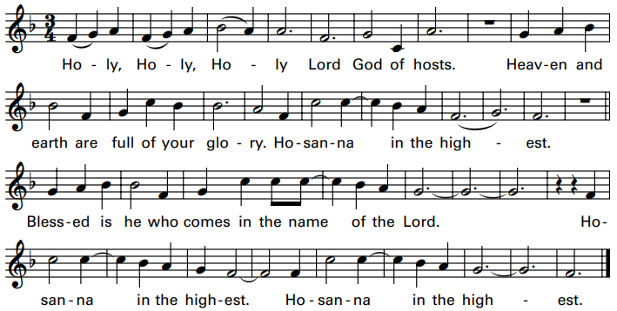

Memorial Acclamation
We proclaim your Death, O Lord, and profess your Resurrection until you come again.

Amen

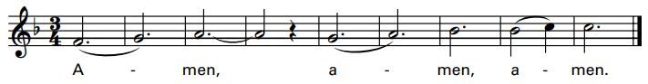
Excerpts from the English translation of The Roman Missal, copyright 2010, International Commission on English in the Liturgy Corporation.
Music: Mass of Renewal, by Curtis Stephan. Copyright 2009. Published by OCP. All rights reserved.

The Lord’s Prayer

Sign of Peace

Lamb of God: “Mass of St. Timothy”
Cantor: Lamb of God, All: Lamb of God,
Cantor: you take away All: you take away
Cantor: the sins of All: the sins of
Cantor: the world: All: the world:
Cantor: Miserere nobis. All: Miserere nobis.
(Last time) Cantor: Dona nobis pacem. All: Dona nobis pacem.

COMMUNION: “We Shall Prepare”
We shall prepare our hearts for new love. We shall prepare our eyes for the blinding light. We shall prepare our faith to break the dark of night. We shall prepare the way of the Lord!

1. A voice strong and clear cries out in the night: “Make straight the way of our God.” The mountains bend low, the plains will rise up to the glory, the glory of God!

2. There shall be one who is to come, mightier than you or I. We shall be changed, baptized with fire of the spirit, the spirit of God!

3. Children of God, come change your hearts. Come to the water of life. Offer your hand, offer your heart to the people, the people of God!
Text copyright 1998 by Janet Vogt and Mark Friedman. Music copyright 1998 by Janet Vogt. Published by OCP Publications. All rights reserved.
Reproduced with permission under License #A-701559, OneLicense.net.

COMMUNION: “Sing Out Earth & Skies”
1. Come, O God of all the earth, come to us, O Righteous One: Come, and bring our love to birth: in the glory of your Son.

Refrain: Sing out, earth and skies! Sing of the God who loves you! Raise your joyful cries! Dance to the life around you!

2. Come, O God of wind and flame: fill the earth with righteousness; Teach us all to
sing your name: may our lives your love confess.

3. Come, O God of flashing light: twinkling star and burning sun; God of day and
God of night: in your light we all are one.

4. Come, O God of snow and rain: shower down upon the earth; come, O God of
Joy and pain: God of sorrow, God of mirth.

5. Come, O Justice, come, O Peace: come and shape our hearts anew; come and
make oppression cease: bring us all to life in you.
By Marty Haugen. Copyright 1985 by G.I.A. Publications, Inc. All rights reserved. Used with permission. OneLicense.net License #A-701559

SENDING FORTH: “O Come, O Come Emmanuel”
1. O come, O come, Emmanuel, and ransom captive Israel, that mourns in lonely exile here until the Son of God appear.

Refrain: Rejoice! Rejoice! Emmanuel shall come to you, O Israel!

2. O come, Desire of nations, bind in one the hearts of all humankind; Bid thou our sad divisions cease, and be thyself our Prince of Peace.
Text: Latin, 9th century. Music: Chant, Mode 1, Veni, Veni Emmanuel, adapt. by T. Helmore, 1811-1890.

