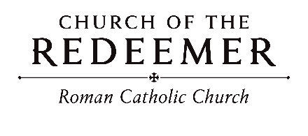
Third Sunday in Ordinary Time January 24/25, 2026

GATHERING SONG: “Praise To You, O Christ, Our Savior”
Praise to you, O Christ, our Savior, Word of the Father, calling us to life; Son of God who leads us to freedom: glory to you, Lord Jesus Christ!

1. You are the Word who calls us out of darkness; you are the Word who leads us into light; you are the Word who brings us through the desert: glory to you, Lord Jesus Christ!
Bernadette Farrell. Copyright 1986 by B. Farrell of St. Thomas More Center. Published by New Dawn Music. All rights reserved. Reproduced with permission under OneLicense.net.

GLORIA: “Mass of Renewal”
Glory to God in the highest, and on earth peace to people of good will.

1. We praise you, we bless you, we adore you, we glorify you, we give you thanks for your great glory, Lord God, heavenly King, O God, almighty Father.

2. Lord, Jesus Christ, Only Begotten Son, Lord God, Lamb of God, Son of the Father, you take away the sins of the world, have mercy on us; you take away the sins of the world, receive our prayer; you are seated at the right hand of the Father, have mercy, have mercy on us.

3. For you alone are the Holy One, you alone are the Lord, you alone are the Most High, Jesus Christ, with the Holy Spirit, in the glory of God the Father. Amen. Amen.
Text Copyright 2010, ICEL. Music Mass of Renewal by Curtis Stephan. Published by OCP. All rights reserved under OneLicense.net.

Children’s Liturgy (10:00) “Open My Eyes”
Open my ears, Lord. Help me to hear your voice. Open my ears, Lord, help me to hear. By Jesse Manibusan. Copyright 1988, 1998, 1999, by Jesse Manibusan. Published by OCP Publications. All rights reserved.

FIRST READING: Isaiah 8:23-9:3
PSALM 27: “The Lord is My Light”
Please repeat refrain after the cantor the first time and sing after each verse:
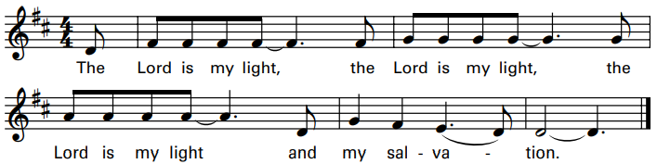
By Scot Crandal. Copyright 2012, 2013 Published by OCP. All rights reserved. OneLicense.net License #A-701559.
SECOND READING: 1 Corinthians 1:10-13, 17
GOSPEL ACCLAMATION: “Mass of Renewal”
Alleluia, alleluia, alleluia. Alleluia, alleluia, alleluia.
Verses text copyright 1969, 1981, 1997. Copyright 2009 by Curtis Stephan. Published by OCP Publications. All rights reserved. Used with permission.
GOSPEL: Matthew 4:12-23
HOMILY

CREED
I believe in one God, the Father Almighty, maker of heaven and earth, of all things visible and invisible.
I believe in one Lord, Jesus Christ, the only Begotten Son of God, born of the Father before all ages. God from God, Light from Light, true God from true God, begotten, not made, consubstantial with the Father; through him all things were made. For us men and for our salvation he came down from heaven: (bow) And by the Holy Spirit was incarnate of the Virgin Mary, and became man. For our sake he was crucified under Pontius Pilate; he suffered death and was buried, and rose again on the third day in accordance with the Scriptures. He ascended into heaven and is seated at the right hand of the Father. He will come again in glory to judge the living and the dead and his kingdom will have no end.
I believe in the Holy Spirit, the Lord, the giver of life, who proceeds from the Father and the Son, who with the Father and the Son is adored and glorified, who has spoken through the prophets. I believe in one holy catholic and apostolic Church. I confess one Baptism for the forgiveness of sins and I look forward to the resurrection of the dead and the life of the world to come. Amen.

LITURGY OF THE EUCHARIST: “The Summons”
1. Will you come and follow me if I but call your name? Will you go where you don’t know and never be the same? Will you let my love be shown, will you let my name be known, will you let my life be grown in you and you in me?

2. Will you leave yourself behind if I but call your name? Will you care for cruel and kind and never be the same? Will you risk the hostile stare should your life attract or scare? Will you let me answer pray’r in you and you in me?

3. Will you let the blinded see if I but call your name? Will you set the pris’ners free and never be the same? Will you kiss the leper clean, and do such as this unseen, and admit to what I mean in you and you in me?

4. Will you love the ‘you’ you hide if I but call your name? Will you quell the fear inside and never be the same? Will you use the faith you’ve found to reshape the world around, through my sight and touch and sound in you and you in me?

5. Lord, your summons echoes true when you but call my name. Let me turn and follow you and never be the same. In your company I’ll go where your love and footsteps show. Thus I’ll move and live and grow in you and you in me.
Text by John L. Bell. Copyright 1987 Iona Community, GIA Publications, Inc., agent. Tune: KELVINGROVE, Scottish traditional, arranged by John L. Bell. Copyright 1987 Iona Community, GIA Publications, Inc., agent. All rights reserved. One License.net License #A-701559

INVITATION TO PRAYER
Priest: Pray, brothers and sisters, that my sacrifice and yours may be acceptable to God, the almighty Father.
People: May the Lord accept the sacrifice at your hands for the praise and glory of his name, for our good and the good of all his holy church.

Preface Dialogue
Priest: The Lord be with you. People: And with your spirit.
Priest: Lift up your hearts. People: We lift them up to the Lord.
Priest: Let us give thanks to the Lord our God. People: It is right and just.

Holy, Holy
Holy, Holy, Ho-ly Lord God of hosts. Heaven and earth are full of your glory. Hosanna in the highest. Blessed is he who comes in the name of the Lord. Hosanna in the highest. Hosanna in the high-est.

Memorial Acclamation
We proclaim your death, O Lord, and profess your Resurrection until you come again.
Amen

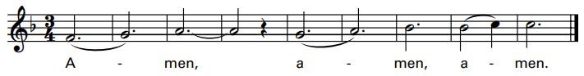
Excerpts from the English translation of The Roman Missal, copyright 2010, International Commission on English in the Liturgy Corporation. Music: Mass of Renewal, by Curtis Stephan. Copyright 2009. Published by OCP. All rights reserved.

The Lord’s Prayer

Sign of Peace

Lamb of God: “Mass of St. Timothy”
Please repeat each phrase after the cantor:

Cantor: Lamb of God, All: Lamb of God,
Cantor: you take away All: you take away
Cantor: the sins of All: the sins of
Cantor: the world: All: the world:
Cantor: Miserere nobis. All: Miserere nobis.
(Last time)
Cantor: Dona nobis pacem. All: Dona nobis pacem.
By Matt Maher. Copyright 2013. Published by OCP. All rights reserved.
COMMUNION: “Pescador de Hombres/Lord, You Have Come”
1. Lord, you have come to the seashore, neither searching for the rich nor the wise, Desiring only that I should follow.

Refrain: O Lord, with your eyes set upon me, gently smiling, you have spoken my name; all I long for I have found by the water, at your side, I will seek other shores.

2. Lord, see my goods my possessions; In my boat you find no power, no wealth. Will you accept, then, my nets and labor?

3. Lord, take my hands and direct them. Help me spend myself in seeking the lost, returning love for the love you gave me.

4. Lord, as I drift on the waters, be the resting place of my restless heart, my life’s companion, my friend and refuge.
English text:Robert C. Trupia. Copyright 1987 Cesareo Gabarain. Published by OCP Publications. All rights reserved

COMMUNION: “Christ, Be Our Light”
1. Longing for light, we wait in darkness, longing for truth, we turn to you. Make us your own, your holy people, light for the world to see.

Refrain: Christ, be our light! Shine in our hearts. Shine through the darkness. Christ, be our light! Shine in your church gathered today.

2. Longing for peace, our world is troubled. Longing for hope, many despair. Your word alone has pow’r to save us. Make us your living voice.

3. Longing for food, many are hungry. Longing for wa-ter, many still thirst. Make us your bread, broken for others, shared until all are fed.

4. Longing for shelter, many are homeless. Longing for warmth, many are cold. Make us your building, sheltering others, walls made of living stone.

5. Many the gifts, many the people, many the hearts that yearn to belong. Let us be servants to one another, making your kingdom come.
By Bernadette Farrell. Copyright 1993 by Bernadette Farrell. Published by OCP Publications. All rights reserved. Used with permission. Reproduced with permission under OneLicense.net. License #A-701559

SENDING FORTH: “Shine, Jesus, Shine”
Shine, Jesus, shine; fill this land with the Father’s glory. Blaze, Spirit, blaze; set our hearts on fire. Flow, river, flow; flood the nations with grace and mercy. Send forth your Word, Lord, and let there be light.

1. Lord, the light of your love is shining, in the midst of the darkness, shining. Jesus, Light of the world, shine upon us. Set us free by the truth you now bring us. Shine on me, shine on me.
By Graham Kendrick. Copyright by Integrity’s Hosanna! Music (ASCAP). 1999. Published by spiritandsong.com/OCP Publications. All rights reserved. Reproduced with permission under License #A-701559,OneLicense.net.

