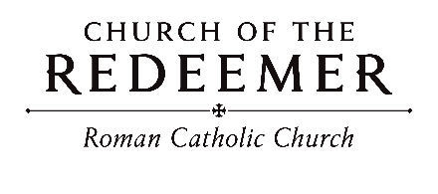
Twenty-Eighth Sunday in Ordinary Time
October 10/11, 2026

GATHERING SONG: “Table of Plenty”
Come to the feast of heaven and earth! Come to the table of plenty! God will provide for all that we need, here at the table of plenty.

1. O, come and sit at my table where saints and sinners are friends. I wait to welcome the lost and lonely to share the cup of my love. Refrain.
Copyright 1992 by Daniel L. Schutte. Published by OCP Publications. All rights reserved. Reproduced with permission under License #A-701559 OneLicense.net.

GLORIA
Glory to God in the highest, and on earth peace to people of good will.

1. We praise you, we bless you, we adore you, we glorify you, we give you thanks for your great glory, Lord God, heavenly King, O God, almighty Father.

2. Lord, Jesus Christ, Only Begotten Son, Lord God, Lamb of God, Son of the Father, you take away the sins of the world, have mercy on us; you take away the sins of the world, receive our prayer; you are seated at the right hand of the Father, have mercy on us.

3. For you alone are the Holy One, you alone are the Lord, you alone are the Most High, Jesus Christ, with the Holy Spirit, in the glory of God the Father. Amen.
Excerpts from the English translation of The Roman Missal, copyright 2010, International Commission on English in the Liturgy Corporation. Music: Mass of Renewal, by William Gokelman & David Kauffman. Copyright 2010 GFTSMusic Publishing Company, Inc. Administered by International Liturgy Publications. All rights reserved.

(10:00) Children’s Liturgy of the Word
Cantor: Go and listen to the Word of God. All: Go and listen to the Word of God.
Cantor: God has the words of everlasting life. All: God has the words of everlasting life.
By Robert J. Batastini. Copyright 2004 by G.I.A. Publications, Inc. All rights reserved. OneLicense.net License #A-701559

FIRST READING: Isaiah 25:6-10a

PSALM 23: “Shepherd Me, O God”

Please repeat refrain after the cantor the first time and sing after each verse:

Shepherd me, O God, beyond my wants, beyond my fears, from death into life.
By Marty Haugen. Copyright 1987 by G.I.A. Publications, Inc. All rights reserved. OneLicense.net License #A-701559.

SECOND READING: Philippians 4:12-14, 19-20
GOSPEL ACCLAMATION: “Alleluia! Give the Glory”
Alleluia! Alleluia! Allelu-ia! Give the glory and the honor to the Lord! Alleluia! Alleluia! Allelu-ia! Give the glory and the honor to the Lord!
Copyright 1991 by Ken Canedo and Bob Hurd. Published by OCP Publications. All rights reserved. Used with permission

GOSPEL: Matthew 22:1-14
HOMILY

CREED
I believe in one God, the Father Almighty, maker of heaven and earth, of all things visible and invisible.
I believe in one Lord, Jesus Christ, the only Begotten Son of God, born of the Father before all ages. God from God, Light from Light, true God from true God, begotten, not made, consubstantial with the Father; through him all things were made. For us men and for our salvation he came down from heaven: (bow) And by the Holy Spirit was incarnate of the Virgin Mary, and became man. For our sake he was crucified under Pontius Pilate; he suffered death and was buried, and rose again on the third day in accordance with the Scriptures. He ascended into heaven and is seated at the right hand of the Father. He will come again in glory to judge the living and the dead and his kingdom will have no end.
I believe in the Holy Spirit, the Lord, the giver of life, who proceeds from the Father and the Son, who with the Father and the Son is adored and glorified, who has spoken through the prophets. I believe in one holy catholic and apostolic Church. I confess one Baptism for the forgiveness of sins and I look forward to the resurrection of the dead and the life of the world to come. Amen

LITURGY OF THE EUCHARIST: “On That Holy Mountain”
Please sing after Cantor each time during verse: On that holy mountain…

Last time: On that holy mountain of the Lord.
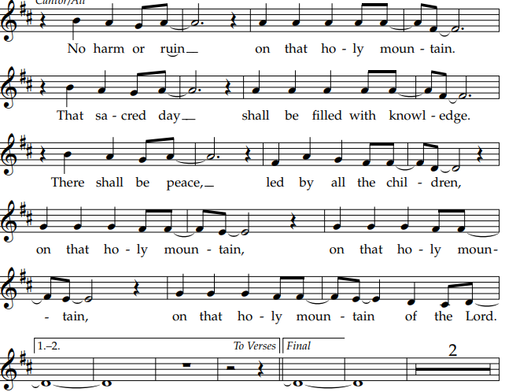 Copyright 1990 by WLP. By Joe Mattingly.
Priest: Pray, brothers and sisters, that my sacrifice and yours may be acceptable to God, the almighty Father.
People: May the Lord accept the sacrifice at your hands, for the praise and glory of his name, for our good, and the good of all his holy Church.

Preface Dialogue
Priest: The Lord be with you. People: And with your spirit.
Priest: Lift up your hearts. People: We lift them up to the Lord.
Priest: Let us give thanks to the Lord our God. People: It is right and just.

Holy, Holy: “Mass of Glory”

Holy, Holy, Holy Lord God of hosts. Heaven and earth are full of your glory. Hosanna, hosanna, hosanna in the highest. Blessed is he who comes in the name of the Lord. Hosanna, hosanna, hosanna in the highest.

Memorial Acclamation

When we eat this Bread and drink this Cup, we proclaim your Death, O Lord, until you come again, until you come again.

Amen
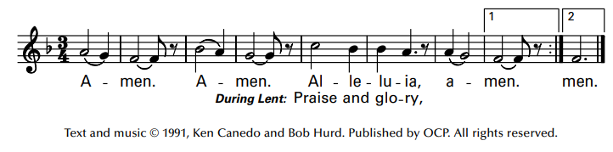

The Lord’s Prayer

Sign of Peace

Lamb of God

Cantor: Lamb of God, All: you take away the sins of the world, have mercy on us.
Cantor: Lamb of God, All: you take away the sins of the world, have mercy on us.
Cantor: Lamb of God, All: you take away the sins of the world, grant us, grant us peace.
Excerpts from the English translation of The Roman Missal, copyright 2010, International Commission on English in the Liturgy Corporation. Music: Mass of Glory; by Bob Hurd. Copyright 1991, 1993, 2010. Published by OCP. All rights reserved under OneLicense License #A-701559.

Priest: Behold the Lamb of God, behold him who takes away the sins of the world. Blessed are those called to the supper of the Lamb.
People: Lord, I am not worthy that you should enter under my roof, but only say the word and my soul shall be healed.
COMMUNION: “Here At This Table”
Come and be filled here at this table. Food for all who hunger and drink for all who thirst. Drink of his love, wine of salvation. You shall live forever in Jesus Christ the Lord. (Last time: you shall live forever in Jesus Christ the Lord.)

1. You who labor for justice, you who labor for peace, you who steady the plow in the field of the Lord.

2. You with lives full of pain, you who sorrow and weep, you, beloved of Christ, come to him, come to him!

3. Children of ev’ry color in ev’ry land, you are his own, he gathers you gently. Don’t you grow weary, for when you run, you run with the Lord!

4. You, the aged among us, holy, faithful and wise, may the wisdom you share form our lives and our world!

5. Let each woman and man learn from the stranger; we’re not so different and so much unites us. For we are one, blest with the Spirit and the power of love!
Copyright 1996, 1999 by Janet Sullivan Whitaker and James Maxwell Whitaker. Published by OCP Publications. All rights reserved. Reproduced with permission under License #A-701559, OneLicense.net.

COMMUNION: “Bread of Life”
1. Bread of life and cup of hope, we come as gift to you. Change our hearts; fill us with peace. Transform our lives anew. Open our eyes so that we might see your presence in one another. Your life, outpoured in love today, unites us all in you.
2. Loving Lord, Creator God, open our eyes to see the good that lives in each of us, that called the world to be. And when we fail to see the good, when friendships falter and crumble, give us the courage to forgive that we may live in peace.
3. Living Word, O Son of God, your love shows us the way that we may live in harmony, and from you never stray. Wipe all oppression from our midst; give us a love for all people. Your song of justice sing in us, to live for peace today.
Copyright 1994 by Bobby Fisher. Published by OCP Publications. All rights reserved. Reproduced with permission under License #A-701559 OneLicense.net.
SENDING FORTH: “Now Thank We All Our God”

1. Now thank we all our God with hearts and hands and voices, who wondrous things has done, in whom his world rejoices; who from our mothers’ arms has blessed us on our way with countless gifts of love, and still is ours today.

2. O may this bounteous God through all our life be near us, with ever joyful hearts and blessed peace to cheer us; preserve us in his grace, and guide us in distress, and free us from all harm, till heaven we possess.
Text by Martin Rinkart, 1586-1649, translated by Catherine Winkworth, 1827-1878. Tune: NUN DANKET, Johann Cruger, 1598-1662. Harm. By A. Gregory Murray, OXB, 1905-1992.

