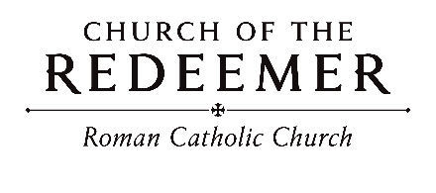
Twenty-Sixth Sunday in Ordinary Time September 26/27, 2026

5:30 Baptism: Thiago Sanchez
10:00 Baptisms: Marco Bulic, Kyler Avery Call
_____________________________________________________________________________________________________________
GATHERING SONG: “Send Down the Fire”
Send down the fire of your justice, send down the rains of your love; come send down
the Spirit, breathe life in your people, and we shall be people of God.

1. Call us to learn of your mercy, teach us the way of your peace; give us hearts that feel, give us hands that heal, make us walk in the way of your peace.
By Marty Haugen. Copyright 1989 by GIA Publications, Inc. All rights reserved. OneLicense.net License #A-701559

GLORIA
Glory to God in the highest, and on earth peace to people of good will.

1. We praise you, we bless you, we adore you, we glorify you, we give you thanks for your great glory, Lord God, heavenly King, O God, almighty Father.

2. Lord, Jesus Christ, Only Begotten Son, Lord God, Lamb of God, Son of the Father, you take away the sins of the world, have mercy on us; you take away the sins of the world, receive our prayer; you are seated at the right hand of the Father, have mercy on us.

3. For you alone are the Holy One, you alone are the Lord, you alone are the Most High, Jesus Christ, with the Holy Spirit, in the glory of God the Father. Amen.
Excerpts from the English translation of The Roman Missal, copyright 2010, International Commission on English in the Liturgy Corporation. Music: Mass of Renewal, by William Gokelman & David Kauffman. Copyright 2010 GFTSMusic Publishing Company, Inc. Administered by International Liturgy Publications. All rights reserved.

(10:00) Children’s Liturgy of the Word

Cantor: Go and listen to the Word of God. All: Go and listen to the Word of God.
Cantor: God has the words of everlasting life. All: God has the words of everlasting life. By Robert J. Batastini. Copyright 2004 by G.I.A. Publications, Inc. All rights reserved. OneLicense.net License #A-701559

FIRST READING: Ezekiel 18:25-28
PSALM 25: “To You, O Lord”
Please repeat after the cantor the first time and after the verses:
To You, O Lord, I lift my soul, to You, I lift my soul.
By Marty Haugen. Copyright 1982 by G.I.A. Publications, Inc. All rights reserved. OneLicense.net License #A-701559

SECOND READING: Philippians 2:1-11
GOSPEL ACCLAMATION: “Alleluia! Give the Glory”
Alleluia! Alleluia! Allelu-ia! Give the glory and the honor to the Lord! Alleluia! Alleluia! Allelu-ia! Give the glory and the honor to the Lord!
Copyright 1991 by Ken Canedo and Bob Hurd. Published by OCP Publications. All rights reserved. Used with permission

GOSPEL: Matthew 21:28-32
HOMILY

(5:30/10:00) Baptismal Acclamation: “Halle, Halle, Halle”
Halle, halle, halle-lu-jah! Halle, halle, halle-lu-jah! Halle, halle, halle-lu-jah! Halle-lu-jah! Halle-lu-jah!
Music: Traditional Carribean, arr. By John Bell. Copyright 1990, Iona Community, GIA Publications, Inc., agent, verses and acc. By Marty Haugen. Copyright 1993, GIA Publications, Inc. All rights reserved. OneLicense.net License #A-701559
(10:00) “Wade in the Water”
Refrain: Wade in the water, wade in the water, children, wade in the water, God’s gonna trouble the water.
Response during verse: God’s gonna trouble the water.
Copyright 2013, World Library Puiblications. Arr. Robert Noble. All rights reserved under OneLicense License #A-701559.
(8:00) CREED
I believe in one God, the Father Almighty, maker of heaven and earth, of all things visible and invisible.
I believe in one Lord, Jesus Christ, the only Begotten Son of God, born of the Father before all ages. God from God, Light from Light, true God from true God, begotten, not made, consubstantial with the Father; through him all things were made. For us men and for our salvation he came down from heaven: (bow) And by the Holy Spirit was incarnate of the Virgin Mary, and became man. For our sake he was crucified under Pontius Pilate; he suffered death and was buried, and rose again on the third day in accordance with the Scriptures. He ascended into heaven and is seated at the right hand of the Father. He will come again in glory to judge the living and the dead and his kingdom will have no end.
I believe in the Holy Spirit, the Lord, the giver of life, who proceeds from the Father and the Son, who with the Father and the Son is adored and glorified, who has spoken through the prophets. I believe in one holy catholic and apostolic Church. I confess one Baptism for the forgiveness of sins and I look forward to the resurrection of the dead and the life of the world to come. Amen.

LITURGY OF THE EUCHARIST: “Jesus Christ is Lord”
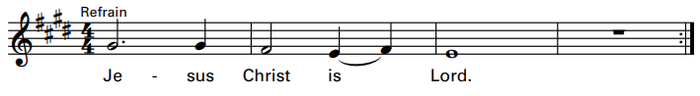
1. He did not hold to his equality with God, for he did empty himself to be as one of us, to be as one of us.

2. He chose the will of God through death upon a cross, and God did raise him up, exalting him on high, exalting him on high.

3. And so God gave to him a name above all names. May all in heaven and earth proclaim him now as Lord, proclaim him now as Lord.
Invitation to Prayer
Priest: Pray, brothers and sisters, that my sacrifice and yours may be acceptable to God, the almighty Father.
People: May the Lord accept the sacrifice at your hands for the praise and glory of his name, for our good and the good of all his holy church.

Preface Dialogue

Priest: The Lord be with you. People: And with your spirit.
Priest: Lift up your hearts. People: We lift them up to the Lord.
Priest: Let us give thanks to the Lord our God. People: It is right and just.

“Mass of Glory”

Ho-ly, Ho-ly, Ho-ly Lord God of hosts. Heaven and earth are full of your glory. Hosanna, hosanna, hosanna in the highest. Blessed is he who comes in the name of the Lord. Hosanna, hosanna, hosanna in the highest.

Memorial Acclamation

When we eat this Bread and drink this Cup, we proclaim your Death, O Lord, until you come again, until you come again.

Amen

A – men. A – men. Alleluia, A – men.

The Lord’s Prayer

Sign of Peace

Lamb of God
Lamb of God: you take away the sins of the world: have mercy on us.
Lamb of God: you take away the sins of the world: have mercy on us.
Lamb of God: you take away the sins of the world: grant us peace, grant us peace.
Excerpts from the English translation of The Roman Missal, copyright 2010, International Commission on English in the Liturgy Corporation. Music: Mass of Glory; by Bob Hurd. Copyright 1991, 1993, 2010. Published by OCP. All rights reserved under OneLicense License #A-701559.
COMMUNION: “Turn My Heart, O God”
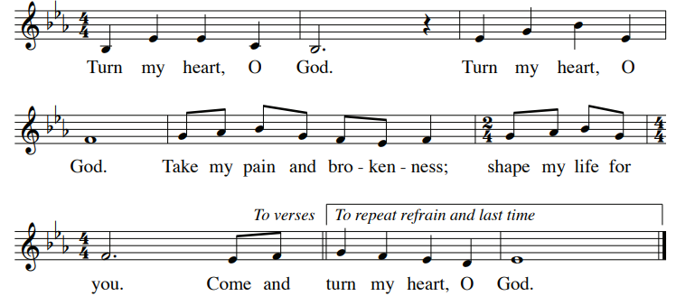
By Marty Haugen. Copyright 2002 GIA Publications, Inc. All Rights Reserved. OneLicense.net License #A-701559.

COMMUNION: “The Servant Song”
1, 6. Will you let me be your servant, let me be as Christ to you; pray that I may have the grace to let you be my servant, too.

2. We are pilgrims on a journey, we are trav'lers on the road; we are here to help each other walk the mile and bear the load.

3. I will hold the Christ-light for you in the nighttime of your fear; I will hold my hand out to you, speak the peace you long to hear.

4. I will weep when you are weeping; when you laugh, I’ll laugh with you. I will share your joy and sorrow 'til we've seen this journey through.

5. When we sing to God in heaven, we shall find such harmony, born of all we've known together of Christ's love and agony.
By Richard Gillard. Copyright 1977, Scripture in Song. All rights reserved.

SENDING FORTH: “God Has Chosen Me”
1. God has chosen me, God has chosen me to set alight a new fire. God has chosen me, God has chosen me to bring to birth a new kingdom on earth: God has chosen me, chosen me:
Refrain: And to tell the world that God’s kingdom is near, to remove oppression and break down fear, yes God’s time is near, God’s time is near, God’s time is near, God’s time is near.
2. God is calling me, God is calling me in all whose cry is unheard. God is calling me, God is calling me to raise up the voice with no power or choice: God is calling me, calling me.
By Bernadette Farrell. Copyright 1990 by Bernadette Farrell. Published by OCP Publications. All rights reserved. Used with permission. Reproduced with permission under OneLicense.net.

