**Twenty Fifth Sunday in Ordinary Time**

**September 20/21, 2025**

**Church of the Redeemer**

**10:00 Baptisms: Elise Lennox Goldman,**

**Macon Andrew McFadden, Sutton Reed Smith**

**GATHERING SONG: “All are Welcome (All Belong)”**

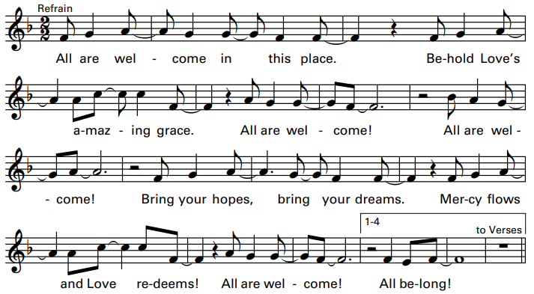

*Cantor: Welcome all who work for justice, bringing hope, charity, and peace!*

**All:** You are not alone, for you are God’s own! Together, we sing and we proclaim!



**GLORIA**

Glory to God in the highest, and on earth peace to people of good will.

1. We praise you, we bless you, we adore you, we glorify you, we give you thanks for your great glory, Lord God, heavenly King, O God, almighty Father.

2. Lord, Jesus Christ, Only Begotten Son, Lord God, Lamb of God, Son of the Father, you take away the sins of the world, have mercy on us; you take away the sins of the world, receive our prayer; you are seated at the right hand of the Father, have mercy on us.

3. For you alone are the Holy One, you alone are the Lord, you alone are the Most High, Jesus Christ, with the Holy Spirit, in the glory of God the Father. Amen.

Excerpts from the English translation of *The Roman Missal*, copyright 2010, International Commission on English in the Liturgy Corporation. Music: *Mass of Renewal*, by William Gokelman & David Kauffman. Copyright 2010 GFTSMusic Publishing Company, Inc. Administered by International Liturgy Publications. All rights reserved.

**FIRST READING: Amos 8:4-7**

**PSALM 113: “Praise the Lord”**

Please repeat refrain after the cantor and sing after each verse:

Praise the Lord who lifts up the poor. Praise the Lord who lifts up the poor.

Refrain text copyright 1969, 1981, 1997, ICEL. All rights reserved. Used with permission. Verses text (adapted) copyright 1970, 1997, 1998 CCD. All rights reserved. Used with permission. Music copyright 2012 by Tony Alonso. Published by GIA Publications, Inc. All rights reserved. Reproduced with permission under License #A-7015599, OneLicense.net

**SECOND READING: 1 Timothy 2:1-8**

**GOSPEL ACCLAMATION: “Alleluia! Give the Glory”**

Alleluia! Alleluia! Allelu-ia! Give the glory and the honor to the Lord! Alleluia! Alleluia! Allelu-ia! Give the glory and the honor to the Lord!

Copyright 1991 by Ken Canedo and Bob Hurd. Published by OCP Publications. All rights reserved. Used with permission

**GOSPEL: Luke 16:1-13**

**HOMILY**

**10:00 Baptismal Acclamation: “Halle, Halle, Halle”**

Halle, halle, halle-lu-jah! Halle, halle, halle-lu-jah! Halle, halle, halle-lu-jah! Halle-lu-jah! Halle-lu-jah!

Music: Traditional Carribean, arr. By John Bell. Copyright 1990, Iona Community, GIA Publications, Inc., agent, verses and acc. By Marty Haugen. Copyright 1993, GIA Publications, Inc. All rights reserved. OneLicense.net License #A-701559

**CREED**

I believe in one God, the Father Almighty, maker of heaven and earth, of all things visible and invisible.

I believe in one Lord, Jesus Christ, the only Begotten Son of God, born of the Father before all ages. God from God, Light from Light, true God from true God, begotten, not made, consubstantial with the Father; through him all things were made. For us men and for our salvation he came down from heaven: (*bow) And by the Holy Spirit was incarnate of the Virgin Mary, and became man.*  For our sake he was crucified under Pontius Pilate; he suffered death and was buried, and rose again on the third day in accordance with the Scriptures. He ascended into heaven and is seated at the right hand of the Father. He will come again in glory to judge the living and the dead and his kingdom will have no end.

I believe in the Holy Spirit, the Lord, the giver of life, who proceeds from the Father and the Son, who with the Father and the Son is adored and glorified, who has spoken through the prophets. I believe in one holy catholic and apostolic Church. I confess one Baptism for the forgiveness of sins and I look forward to the resurrection of the dead and the life of the world to come. Amen.

**LITURGY OF THE EUCHARIST: “The Cry of the Poor”**

The Lord hears the cry of the poor. Blessed be the Lord.

1. I will bless the Lord at all times, with praise ever in my mouth. Let my soul glory in the Lord, who will hear the cry of the poor.

2. Let the lowly hear and be glad: the Lord listens to their pleas; and to hearts broken God is near, who will hear the cry of the poor.

The Lord hears the cry of the poor. Blessed be the Lord.

3. Ev'ry spirit crushed God will save; will be ransom for their lives; will be safe shelter for their fears, and will hear the cry of the poor.

4. We proclaim your greatness O God, your praise ever in our mouth; ev'ry face brightened in your light, for you hear the cry of the poor.

By John B. Foley, S.J. Copyright 1978 John B. Foley and New Dawn Music. All rights reserved. Reproduced with permission under License #A-701559 OneLicense.net.

**INVITATION TO PRAYER**

Priest: Pray, brothers and sisters, that my sacrifice and yours may be acceptable

to God, the almighty Father.

**People: May the Lord accept the sacrifice at your hands for the praise and**

**glory of his name, for our good and the good of all his holy church.**

**Holy, Holy**

Holy, holy, holy Lord God of hosts. Heaven and earth are full of your glory. Hosanna, Hosanna, Hosanna in the highest. Blessed is he who comes in the name of the Lord. Hosanna, Hosanna, Hosanna in the highest.

**Memorial Acclamation**

When we eat this Bread and drink this Cup, we proclaim your Death, O Lord, until you come again, until you come again.

**Amen**

A – men. A – men. Alleluia, A – men.

**The Lord’s Prayer**

**Sign of Peace**

**Lamb of God**

Cantor: Lamb of God, All: you take away the sins of the world, have mercy on us.

Cantor: Lamb of God, All: you take away the sins of the world, have mercy on us.

Cantor: Lamb of God, All: you take away the sins of the world, grant us, grant us peace. Excerpts from the English translation of *The Roman Missal*, copyright 2010, International Commission on English in the Liturgy Corporation. Music: *Mass of Glory;* by Bob Hurd. Copyright 1991, 1993, 2010. Published by OCP. All rights reserved under OneLicense License #A-701559

Priest**:** Behold the Lamb of God, behold him who takes away the sins of the world. Blessed are those called to the supper of the Lamb.

**People: Lord, I am not worthy that you should enter under my roof, but only say the word and my soul shall be healed.**

**COMMUNION: “Unwavering”**

1. Blessed are the poor, the kingdom is theirs, alive in the promise to be dead to the world. Blessed are the meek, in awe of You Father. The word at your right hand, Spirit of truth.

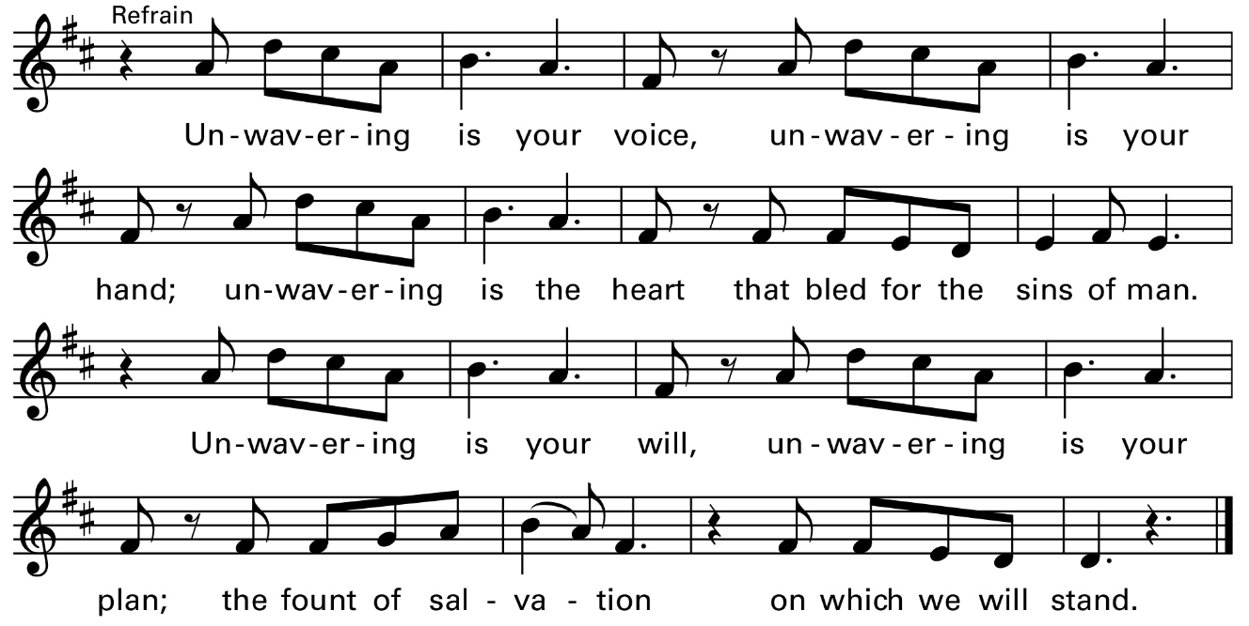

1. Blessed are the righteous, on bended knee, found in this freedom, committed to You. Blessed are those who seek the heights of glory, found in the valley and suff’ring for You. (Refrain twice)



**COMMUNION: “God of Day and God of Darkness”**

1. God of day and God of darkness, now we stand before the night; as the shadows stretch and deepen, come and make our darkness bright. All creation still is groaning for the dawning of your might, when the Sun of peace and justice fills the earth with radiant light.

2. Still the nations curse the darkness, still the rich oppress the poor; still the earth is bruised and broken by the ones who still want more. Come and wake us from our sleeping, so our hearts cannot ignore, all your people lost and broken, all your children at our door.

3. You shall be the path that guides us, you the light that in us burns; shining deep within all people, yours the love that we must learn, for our hearts shall wander restless 'til they safe to you return; finding you in one another, we shall all your Face discern.

Text by Marty Haugen. Tune: BEACH SPRING. Copyright 1985 by G.I.A. Publications, Inc. All rights reserved. OneLicense.net License #A-

**SENDING FORTH: “Let Justice Roll Like A River”**

Let justice roll like a river, and wash all oppression away; Come, O God, and take us, move and shake us, come now, and make us anew, that we might live justly like you.

1. You have been told the way of life, the way of justice and peace; to act justly, to

Love gently, and walk humbly with God.

By Marty Haugen. Copyright 1991 by G.I.A. Publications, Inc. All rights reserved. OneLicense.net License #A-701559