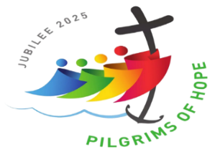**22nd Sunday in Ordinary Time**

**August 30/31, 2025**

**Church of the Redeemer**

**GATHERING SONG: “Gather Us In”**

1. Here in this place, new light is streaming, now is the darkness vanished away, see, in this space, our fears and our dreamings, brought here to you in the light of this day. Gather us in the lost and forsaken, gather us in the blind and the lame; call to us now, and we shall awaken, we shall arise at the sound of our name.

2. We are the young, our lives are a myst'ry, we are the old who yearn for your face, we have been sung throughout all of hist'ry, called to be light to the whole human race. Gather us in the rich and the haughty, gather us in the proud and the strong; give us a heart so meek and so lowly, give us the courage to enter the song. By Marty Haugen. Copyright 1982 by G.I.A. Publications, Inc. All rights reserved. OneLicense.net License #A-701559

**GLORIA**

Glory to God in the highest, and on earth peace to people of good will.

1. We praise you, we bless you, we adore you, we glorify you, we give you thanks for your great glory, Lord God, heavenly King, O God, almighty Father.

2. Lord, Jesus Christ, Only Begotten Son, Lord God, Lamb of God, Son of the Father, you take away the sins of the world, have mercy on us; you take away the sins of the world, receive our prayer; you are seated at the right hand of the Father, have mercy on us.

3. For you alone are the Holy One, you alone are the Lord, you alone are the Most High, Jesus Christ, with the Holy Spirit, in the glory of God the Father. Amen.

Excerpts from the English translation of *The Roman Missal*, copyright 2010, International Commission on English in the Liturgy Corporation. Music: *Mass of Renewal*, by William Gokelman & David Kauffman. Copyright 2010 GFTSMusic Publishing Company, Inc. Administered by International Liturgy Publications. All rights reserved.

**FIRST READING: Sirach 3:17-18, 20, 28-29**

**PSALM 68: “You Have Made a Home for the Poor”**

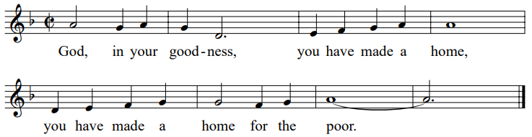

**SECOND READING: Hebrews 12:18-19, 22-24a**

**GOSPEL ACCLAMATION: “Mass of Renewal”**

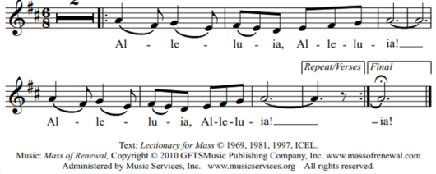

**GOSPEL: Luke 14:1, 7-14**

**HOMILY**

**CREED**

I believe in one God, the Father Almighty, maker of heaven and earth, of all things visible and invisible.

I believe in one Lord, Jesus Christ, the only Begotten Son of God, born of the Father before all ages. God from God, Light from Light, true God from true God, begotten, not made, consubstantial with the Father; through him all things were made. For us men and for our salvation he came down from heaven: (*bow) And by the Holy Spirit was incarnate of the Virgin Mary, and became man.*  For our sake he was crucified under Pontius Pilate; he suffered death and was buried, and rose again on the third day in accordance with the Scriptures. He ascended into heaven and is seated at the right hand of the Father. He will come again in glory to judge the living and the dead and his kingdom will have no end.

I believe in the Holy Spirit, the Lord, the giver of life, who proceeds from the Father and the Son, who with the Father and the Son is adored and glorified, who has spoken through the prophets. I believe in one holy catholic and apostolic Church. I confess one Baptism for the forgiveness of sins and I look forward to the resurrection of the dead and the life of the world to come. Amen.

**LITURGY OF THE EUCHARIST:** **“With All I Am”**

With all I am I come with humble heart, I come with soul rejoicing to do your will. With all I am, all I can be, all I offer I offer for you.

1. Teach me your ways, O Lord, and send me forth with your word on my lips and

my heart.

2. Let your compassion live within me, so that I may give to all as you give to me.

Text: Copyright 1997, Michael P. Nelson. Music: Copyright 1997, Michael P. Nelson and Michael Anthony Perna. Published by OCP. All

rights reserved under OneLicense.net #A-701559.

**INVITATION TO PRAYER**

Priest: Pray, brothers and sisters, that my sacrifice and yours may be acceptable to God, the almighty Father.

**People: May the Lord accept the sacrifice at your hands for the praise and glory of his name, for our good and the good of all his holy church.**

**Preface Dialogue**

Priest: The Lord be with you. **People: And with your spirit.**

Priest: Lift up your hearts. **People: We lift them up to the Lord.**

Priest: Let us give thanks to the Lord our God. **People: It is right and just**.

**Holy, Holy: Mass of Renewal**

Holy, Holy, Holy Lord God of host. Heaven and earth are full, full of your glo-ry. Hosanna, Hosanna in the highest. Blessed is he who comes in the name of the Lord. Hosan-na, Hosanna in the highest. Hosan-na, Hosanna in the highest.

**Memorial Acclamation**

Save us, Savior of the world, for by your Cross and Resurrection, you have set us free.

**Amen**

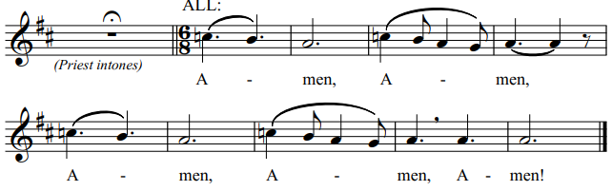

**The Lord’s Prayer**

**Sign of Peace**

**Lamb of God**

Cantor: Lamb of God, All: you take away the sins of the world, have mercy on us.

Cantor: Lamb of God, All: you take away the sins of the world, have mercy on us.

Cantor: Lamb of God, All: you take away the sins of the world, grant us, grant us peace. Excerpts from the English translation of *The Roman Missal*, copyright 2010, International Commission on English in the Liturgy Corporation.

Priest**:** Behold the Lamb of God, behold him who takes away the sins of the world. Blessed are those called to the supper of the Lamb.

**People: Lord, I am not worthy that you should enter under my roof, but only say the word and my soul shall be healed.**

**COMMUNION:**  “**A Place at the Table”**

1. For ev’ryone born, a place at the table, for ev’ryone born, clean water and bread, a shelter, a space, a safe place for growing, for ev’ryone born, a star overhead.

Refrain: And God will delight when we are creators of justice and joy, yes, God will delight when we are creators of justice, justice and joy!

2. For woman and man, a place at the table, revising the roles, deciding the share, with wisdom and grace, dividing the power, for woman and man, a system that’s fair. Refrain.

3. 3. For young and for old, a place at the table, a voice to be heard, a part in the

song, the hands of a child in hands that are wrinkled, for young and for old, the

right to belong. Refrain.

4. For just and unjust, a place at the table, abuser, abused, with need to forgive, in anger, in hurt, a mindset of mercy, for just and unjust, a new way to live. Refrain.

5. For ev’ryone born, a place at the table, to live without fear, and simply to be, to work, to speak out, to witness and worship, for ev’ryone born the right to be free.

Text by Shirley Erena Murray. Copyright 1998 by Hope Publishing Co. Tune by Lori True. Copyright 1998 by GIA Publications, Inc. All rights reserved. Onelicense.net License #A-701559

**COMMUNION: “Here At This Table”**

Come and be filled here at this table. Food for all who hunger and drink for all who thirst. Drink of his love, wine of salvation. You shall live forever in Jesus Christ the Lord. (Last time: you shall live forever in Jesus Christ the Lord.)

1. You who labor for justice, you who labor for peace, you who steady the plow in the field of the Lord.

2. You with lives full of pain, you who sorrow and weep, you, beloved of Christ, come to him, come to him!

3. Children of ev’ry color in ev’ry land, you are his own, he gathers you gently. Don’t you grow weary, for when you run, you run with the Lord!

Copyright 1996, 1999 by Janet Sullivan Whitaker and James Maxwell Whitaker. Published by OCP Publications. All rights reserved. Reproduced with permission under License #A-701559, OneLicense.net.

**SENDING FORTH: “We Belong To You”**

We belong to you, O Lord of our longing, we belong to you. In our daily living, dying and rising we belong to you.

1. When we share the bread you’ve broken with the many and the few, we are

blessed and we are broken; We belong to you.

Text Copyright 2006, Victoria Thomson. Music Copyright 2006, Trevor Thomson. Text/music published by Spirit and Song, division of OCP. All rights

Reserved.