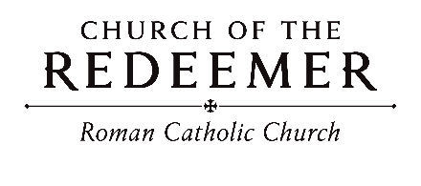
Twentieth Sunday in Ordinary Time
August 8/9, 2026

GATHERING SONG: “All are Welcome (All Belong)”
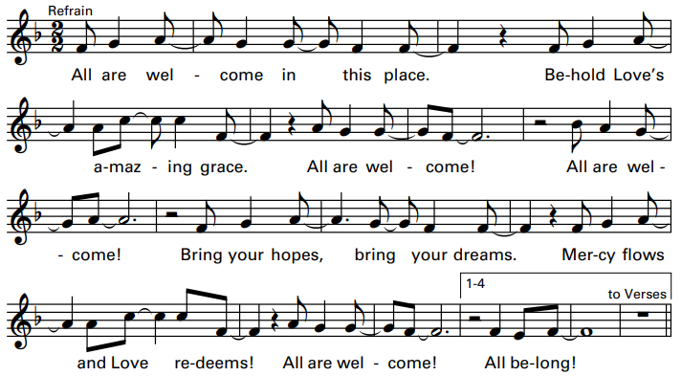
Cantor: Welcome all who work for justice, bringing hope, charity, and peace!
All: You are not alone, for you are God’s own! Together, we sing and we proclaim!
GLORIA
Glory to God in the highest, and on earth peace to people of good will.

1. We praise you, we bless you, we adore you, we glorify you, we give you thanks for your great glory, Lord God, heavenly King, O God, almighty Father.

2. Lord, Jesus Christ, Only Begotten Son, Lord God, Lamb of God, Son of the Father, you take away the sins of the world, have mercy on us; you take away the sins of the world, receive our prayer; you are seated at the right hand of the Father, have mercy on us.

3. For you alone are the Holy One, you alone are the Lord, you alone are the Most High, Jesus Christ, with the Holy Spirit, in the glory of God the Father. Amen.
Excerpts from the English translation of The Roman Missal, copyright 2010, International Commission on English in the Liturgy Corporation. Music: Mass of Renewal, by William Gokelman & David Kauffman. Copyright 2010 GFTSMusic Publishing Company, Inc. All rights reserved.

FIRST READING: Isaiah 56:1, 6-7

PSALM 67: “O God, Let All the Nations”
Please sing refrain after the cantor the first time and sing after the verses:
O God, let all the nations praise your name, let all the nations praise your name.
Refrain text copyright 1969, 1981, ICEL. Verses text copyright 1995, ICEL. All rights reserved. Used with permission. Music copyright 1996, Timothy R. Smith.
SECOND READING: Romans 11:13-15, 29-32
GOSPEL ACCLAMATION: “Mass of Renewal”
Please sing Refrain with Cantor: Al-le-lu-ia, Alleluia! Al-le-lu-ia, Alleluia!
GOSPEL: Matthew 15:21-28

HOMILY

CREED

I believe in one God, the Father Almighty, maker of heaven and earth, of all things visible and invisible.
I believe in one Lord, Jesus Christ, the only Begotten Son of God, born of the Father before all ages. God from God, Light from Light, true God from true God, begotten, not made, consubstantial with the Father; through him all things were made. For us men and for our salvation he came down from heaven: (bow) And by the Holy Spirit was incarnate of the Virgin Mary, and became man. For our sake he was crucified under Pontius Pilate; he suffered death and was buried, and rose again on the third day in accordance with the Scriptures. He ascended into heaven and is seated at the right hand of the Father. He will come again in glory to judge the living and the dead and his kingdom will have no end.

I believe in the Holy Spirit, the Lord, the giver of life, who proceeds from the Father and the Son, who with the Father and the Son is adored and glorified, who has spoken through the prophets. I believe in one holy catholic and apostolic Church. I confess one Baptism for the forgiveness of sins and I look forward to the resurrection of the dead and the life of the world to come. Amen

LITURGY OF THE EUCHARIST: “Mercy, O God”
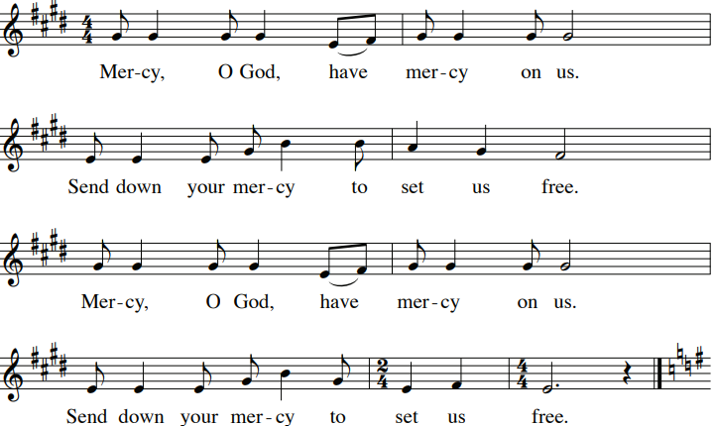
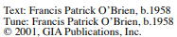
PREFACE DIALOGUE
Priest: The Lord be with you. People: And with your spirit.
Priest: Lift up your hearts. People: We lift them up to the Lord.
Priest: Let us give thanks to the Lord our God. People: It is right and just.

HOLY, HOLY: Mass of Renewal

Holy, Holy, Holy Lord God of host. Heaven and earth are full, full of your glo-ry. Hosanna, Hosanna in the highest. Blessed is he who comes in the name of the Lord. Hosan-na, Hosanna in the highest. Hosan-na, Hosanna in the highest.

MEMORIAL ACCLAMATION

Save us, Savior of the world, for by your Cross and Resurrection, you have set us free.

AMEN

A - men, A - men, A - men, A - men, Amen!

THE LORD’S PRAYER

SIGN OF PEACE
Priest: Lord Jesus Christ, who said to your Apostles: Peace I leave you, my peace I give you, look not on our sins, but on the faith of your Church, and graciously grant her peace and unity in accordance with your will. Who live and reign for ever and ever.
People: Amen.
Priest: The peace of the Lord be with you always.
People: And with your spirit.
Priest/Deacon: Let us offer each other the sign of peace.

LAMB OF GOD

Cantor: Lamb of God, All: you take away the sins of the world, have mercy on us.
Cantor: Lamb of God, All: you take away the sins of the world, have mercy on us.
Cantor: Lamb of God, All: you take away the sins of the world, grant us, grant us peace.
Excerpts from the English translation of The Roman Missal, copyright 2010, International Commission on English in the Liturgy Corporation. Music: Mass of Renewal, by William Gokelman & David Kauffman. Copyright 2010 GFTS Music Publishing Company, Inc. Administered by International Liturgy Publications. All rights reserved.

Priest: Behold the Lamb of God, behold him who takes away the sins of the world. Blessed are those called to the supper of the Lamb.
People: Lord, I am not worthy that you should enter under my roof, but only say the word and my soul shall be healed.
COMMUNION: “You Are All We Have”
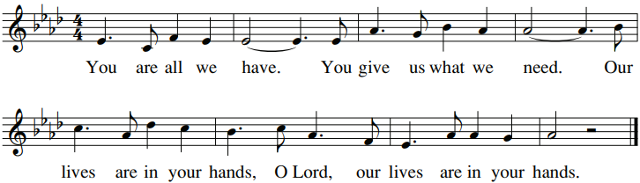

1. Protect me, Lord, I come to you for safety. I say, “You are my God.” All good things, Lord, all good things that I have come from you, the God of my salvation.

2. How wonderful are your gifts to me, how good they are! I praise the Lord who guides me and teaches me the way of truth and life.

3. You are near, the God I seek. Nothing can take me from your side. All my days I rest secure; you will show me the path that leads to life.
By Francis Patrick O'Brien. Copyright 1991 by G.I.A. Publications, Inc. All rights reserved. OneLicense.net License #A-701559.

COMMUNION: “Behold the Lamb”
1. Those who were in the dark are thankful for the sunlight; We who live, we who die are grateful for this gift, thankful for God’s love.
Refrain: Behold, behold the Lamb of God. All who eat, all who drink shall live; and all, all who dwell in God, shall come to know God’s glory!
2. Peaceful now, those whose hearts are blessed with understanding of the wheat, of the wine united with God’s word and the love we share.
3. Gentle one, Child of God, join with us at this table. Bless our lives, nourish all who hunger for this feast; shelter them with peace.
4. Lord of all, give us light. Deliver us from evil. Make us one; be our shield. Make still the winds that blow; cradle us with love.
By Martin Willett, b. 1960. Tune: Martin Willett, b. 1960; arr. By Craig Kingsbury, b. 1952. Copyright 1984 OCP. All rights reserved. Reproduced with permission under License #A-701559. OneLicense.net.
SENDING FORTH: “Fresh as the Morning”
1. Those without status, those who are nothing, you have made royal, gifted with rights, chosen as partners, midwives of justice, birthing new systems, lighting new lights.

Refrain: Fresh as the morning, sure as the sunrise, God always faithful, you do not change. Fresh as the morning, sure as the sunrise, God always faithful, you do not change.
Text by Shirley Erena Murray. Copyright 1996 by Hope Publishing Co. All rights reserved. Tune by Tony Alonso. Copyright 2001 by GIA Publications, Inc. All rights reserved. OneLicense.net License #A-701559

