**19th Sunday in Ordinary Time**

**August 9/10, 2025**

**Church of the Redeemer**

**GATHERING SONG: “We Walk By Faith”**

1. We walk by faith, and not by sight: no gracious words we hear from him who spoke as none e'er spoke, but we believe him near.

2. Help then, O Lord, our unbelief, and may our faith abound; to call on you when you are near, and seek where you are found:

3. That when our life of faith is done in realms of clearer light we may behold you as you are in full and endless sight.

4. We walk by faith, and not by sight: no gracious words we hear of him who spoke as none e'er spoke, but we believe him near.

By Marty Haugen. Copyright 1984 by G.I.A. Publications, Inc. All rights reserved. OneLicense.net License #A-701559

**GLORIA**

Glory to God in the highest, and on earth peace to people of good will.

1. We praise you, we bless you, we adore you, we glorify you, we give you thanks for your great glory, Lord God, heavenly King, O God, almighty Father.

2. Lord, Jesus Christ, Only Begotten Son, Lord God, Lamb of God, Son of the Father, you take away the sins of the world, have mercy on us; you take away the sins of the world, receive our prayer; you are seated at the right hand of the Father, have mercy on us.

3. For you alone are the Holy One, you alone are the Lord, you alone are the Most High, Jesus Christ, with the Holy Spirit, in the glory of God the Father. Amen.

Excerpts from the English translation of *The Roman Missal*, copyright 2010, International Commission on English in the Liturgy Corporation. Music: *Mass of Renewal*, by William Gokelman & David Kauffman. Copyright 2010 GFTSMusic Publishing Company, Inc. Administered by International Liturgy Publications. All rights reserved.

**FIRST READING: Wisdom 18:6-9**

**PSALM 33: “Happy Are the People”**

Please repeat refrain after the cantor and sing after each verse:

Happy are the people the Lord has chosen, chosen to be God’s own.

By Marty Haugen. Copyright 1987 by G.I.A. Publications, Inc. All rights reserved. One License.netLicense#A-701559

**SECOND READING: Hebrews 11:1-2, 8-19**

**GOSPEL ACCLAMATION: “Mass of Renewal”**

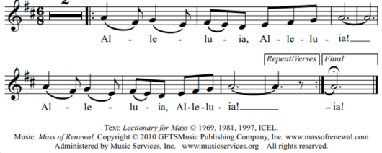

**GOSPEL: Luke 12:32-48**

**HOMILY**

**CREED**

I believe in one God, the Father Almighty, maker of heaven and earth, of all things visible and invisible.

I believe in one Lord, Jesus Christ, the only Begotten Son of God, born of the Father before all ages. God from God, Light from Light, true God from true God, begotten, not made, consubstantial with the Father; through him all things were made. For us men and for our salvation he came down from heaven: (*bow) And by the Holy Spirit was incarnate of the Virgin Mary, and became man.*  For our sake he was crucified under Pontius Pilate; he suffered death and was buried, and rose again on the third day in accordance with the Scriptures. He ascended into heaven and is seated at the right hand of the Father. He will come again in glory to judge the living and the dead and his kingdom will have no end.

I believe in the Holy Spirit, the Lord, the giver of life, who proceeds from the Father and the Son, who with the Father and the Son is adored and glorified, who has spoken through the prophets. I believe in one holy catholic and apostolic Church. I confess one Baptism for the forgiveness of sins and I look forward to the resurrection of the dead and the life of the world to come. Amen.

**LITURGY OF THE EUCHARIST: “In Every Age”**

1. Long before the mountains came to be and the land and sea and stars of the

night, through the endless seasons of all time, you have always been, you will

always be.

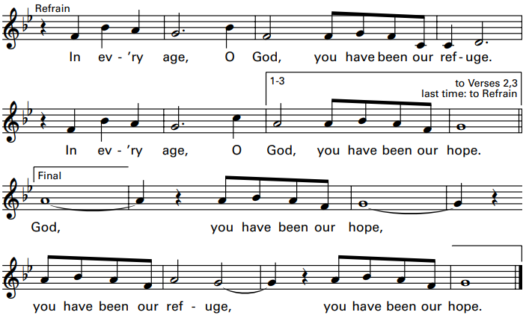

2. Destiny is cast and at your silent word we return to dust and scatter to the wind.

A thousand years are like a single moment gone, as the light that fades at the

end of day.

3. Teach us to make use of the time we have. Teach us to be patient even as we wait. Teach us to embrace our ev’ry joy and pain. To sleep peacefully, and to rise up strong. Text: Based on Psalm 90:1-4, 12. Text and Music copyright 1998, 2000, Janet Sullivan Whitaker. Published by OCP Publications, Inc. All rights reserved. OneLicense.net License #A-701559.

**Holy, Holy: Mass of Renewal**

Holy, Holy, Holy Lord God of host. Heaven and earth are full, full of your glo-ry. Hosanna, Hosanna in the highest. Blessed is he who comes in the name of the Lord. Hosan-na, Hosanna in the highest. Hosan-na, Hosanna in the highest.

**Memorial Acclamation**

Save us, Savior of the world, for by your Cross and Resurrection, you have set us free.

**Amen**

A-men, A—men, A-men, A—men, Amen!

**The Lord’s Prayer**

**Sign of Peace**

**Lamb of God**

Cantor: Lamb of God, All: you take away the sins of the world, have mercy on us.

Cantor: Lamb of God, All: you take away the sins of the world, have mercy on us.

Cantor: Lamb of God, All: you take away the sins of the world, grant us, grant us peace. Excerpts from the English translation of *The Roman Missal*, copyright 2010, International Commission on English in the Liturgy Corporation.

**COMMUNION: “All That Is Hidden”**

1. If you would follow me, follow where life will lead; do not look for me among the dead, for I am hidden in pain, risen in love; there is no harvest without sowing of grain.

Refrain: All that is hidden will be made clear. All that is dark now will be revealed. What you have heard in the dark, proclaim in the light; what you hear in whispers proclaim from the housetops.

2. If you would honor me, honor the least of these; you will not find me dressed in finery. My word cries out to be heard; breaks through the world: my Word is on your lips and lives in your heart.

3. If you would speak of me, live all your life in me: my ways are not the ways that you would choose; my thoughts are far beyond yours, as heaven from earth: if you believe in me my voice will be heard.

4. If you would rise with me, rise through your destiny: do not refuse the death which brings you life, for as the grain in the earth must die for rebirth, so I have planted your life deep within mine.

By Bernadette Farrell. Copyright 1986, 1988 Bernadette Farrell. Published by OCP Publications. All rights reserved. Reproduced with permission under License #A-701559, OneLicense.net

**COMMUNION:** **“Vine and Branches”**

I am the vine and you the branches. Remain in me as I remain in you; you will bear

great fruit in me.

1. A new commandment I give you: even as I have loved you, now love one another.

2. No greater love is there than this: than to lay down your life, your life for your friends.

3. I am the living bread from heaven; if you eat this bread, you will live forever.

4. All those who eat my flesh and drink my blood remain in me and I remain in them.

Copyright 2012, Trevor Thomson. Published by Two by Spirit & Song, a division of OCP. All rights reserved.

**SENDING FORTH: “A Rightful Place”**

Let us live our lives so that all might see that our hearts are restless till they rest in thee. Let us build your kingdom in truth and grace so that all might know they have a rightful place.

1. To gather in your presence we came to be one in spirit and truth and name; strengthened by the body of Christ, taking up the call now to share your light with all the world. Text and music by Steve Angrisano. Copyright 2012. Published by Spirit and Song, a division of OCP. All rights reserved.