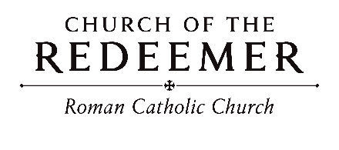
Seventeenth Sunday in Ordinary Time July 25/26, 2026

GATHERING SONG: “Praise to You, O Christ, Our Savior”
Praise to you, O Christ, our Savior, Word of the Father, calling us to life; Son of God who leads us to freedom: glory to you, Lord Jesus Christ!

1. You are the one whom prophets hoped and longed for; you are the one who speaks to us today; you are the one who leads us to our future: glory to you, Lord Jesus Christ!

2. You are the Word who calls us to be servants; you are the Word whose only law is love; you are the Word-made-flesh who lives among us: glory to you, Lord Jesus Christ!
Bernadette Farrell. Copyright 1986 by B. Farrell of St. Thomas More Center. Published by New Dawn Music. All rights reserved. Reproduced with permission under OneLicense.net.

GLORIA
Glory to God in the highest, and on earth peace to people of good will.

1. We praise you, we bless you, we adore you, we glorify you, we give you thanks for your great glory, Lord God, heavenly King, O God, almighty Father.

2. Lord, Jesus Christ, Only Begotten Son, Lord God, Lamb of God, Son of the Father, you take away the sins of the world, have mercy on us; you take away the sins of the world, receive our prayer; you are seated at the right hand of the Father, have mercy on us.

3. For you alone are the Holy One, you alone are the Lord, you alone are the Most High, Jesus Christ, with the Holy Spirit, in the glory of God the Father. Amen.
Excerpts from the English translation of The Roman Missal, copyright 2010, International Commission on English in the Liturgy Corporation. Music: Mass of Renewal, by William Gokelman & David Kauffman. Copyright 2010 GFTSMusic Publishing Company, Inc. Administered by International Liturgy Publications. All rights reserved.

FIRST READING: 1 Kings 3:5, 7-12

PSALM 119: “Lord, I Love Your Commands”
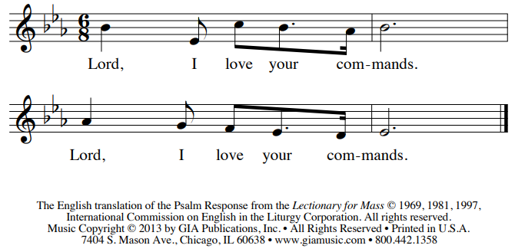
SECOND READING: Romans 8:28-30
GOSPEL ACCLAMATION: “Mass of Renewal”
Please sing Refrain with Cantor: Al-le-lu-ia, Alleluia! Al-le-lu-ia, Alleluia!
GOSPEL: Matthew 13:44-52

HOMILY

CREED
I believe in one God, the Father Almighty, maker of heaven and earth, of all things visible and invisible.
I believe in one Lord, Jesus Christ, the only Begotten Son of God, born of the Father before all ages. God from God, Light from Light, true God from true God, begotten, not made, consubstantial with the Father; through him all things were made. For us men and for our salvation he came down from heaven: (bow) And by the Holy Spirit was incarnate of the Virgin Mary, and became man. For our sake he was crucified under Pontius Pilate; he suffered death and was buried, and rose again on the third day in accordance with the Scriptures. He ascended into heaven and is seated at the right hand of the Father. He will come again in glory to judge the living and the dead and his kingdom will have no end.

I believe in the Holy Spirit, the Lord, the giver of life, who proceeds from the Father and the Son, who with the Father and the Son is adored and glorified, who has spoken through the prophets. I believe in one holy catholic and apostolic Church. I confess one Baptism for the forgiveness of sins and I look forward to the resurrection of the dead and the life of the world to come. Amen

LITURGY OF THE EUCHARIST: “Tend the Ground”
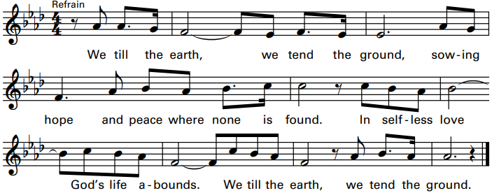
1. As God provides our every need, with grateful hearts, let us receive these gifts of love, and make return to bless the world, to bless the world.
2. With open hand our Lord has giv’n his life for all that we might live. No greater love is there than this, no greater love, no greater love.
3. Where hardened hearts have turned to greed, trampling upon the fledgling seed, help us to tend to others’ needs, open our eyes, open our eyes.
4. On rocky paths and trodden roads, Lord, clear the ground where thorns have grown. Give us the grace to follow you. Make straight the way, make straight the way.
5. Let plows be forged from swords that kill. Let tools of war be shaped to till and break the hard and stony ground. Lord, bring your peace, Lord, bring your peace.
6. Let mercy fall on us like rain to clear the air and heal the pain. Where sin has broken bonds of love let mercy reign, let mercy reign.

Invitation to Prayer
Priest: Pray, brothers and sisters, that my sacrifice and yours may be acceptable to God, the almighty Father.
People: May the Lord accept the sacrifice at your hands for the praise and glory of his name, for our good and the good of all his holy church.
Preface Dialogue
Priest: The Lord be with you. People: And with your spirit.
Priest: Lift up your hearts. People: We lift them up to the Lord.
Priest: Let us give thanks to the Lord our God. People: It is right and just.

Holy, Holy: Mass of Renewal
Holy, Holy, Holy Lord God of host. Heaven and earth are full, full of your glo-ry. Hosanna, Hosanna in the highest. Blessed is he who comes in the name of the Lord. Hosan-na, Hosanna in the highest. Hosan-na, Hosanna in the highest.

Memorial Acclamation
Save us, Savior of the world, for by your Cross and Resurrection, you have set us free.

Amen
A - men, A - men, A - men, A - men, Amen!

The Lord’s Prayer

Sign of Peace

Lamb of God
Cantor: Lamb of God, All: you take away the sins of the world, have mercy on us.
Cantor: Lamb of God, All: you take away the sins of the world, have mercy on us.
Cantor: Lamb of God, All: you take away the sins of the world, grant us, grant us peace. Excerpts from the English translation of The Roman Missal, copyright 2010, International Commission on English in the Liturgy Corporation. Music: Mass of Renewal, by William Gokelman & David Kauffman. Copyright 2010 GFTS Music Publishing Company, Inc. Administered by International Liturgy Publications. All rights reserved.
COMMUNION: “Lead Me, Lord”

- Blessed are the poor in spirit, longing for their Lord, for God’s coming kingdom shall be theirs. Blessed are the sorrowing, for they shall be consoled, and the meek shall come to rule the world.

Refrain: Lead me, Lord, lead me, Lord, by the light of truth to seek and to find the narrow way. Be my way; be my truth; be my life, my Lord, and lead me, Lord, today. And lead me, Lord, today.

2. Blessed are the merciful, for mercy shall be theirs, and the pure in heart shall see their God. Blest are they whose hunger only holiness can fill, for I say they shall be satisfied.

3. Blest are they who through their lifetimes sow the seeds of peace; all will call them children of the Lord. Blest are you though persecuted in your holy life, for in heaven, great is your reward.
By John D. Becker. Copyright 1987, John D. Becker. Published by OCP Publications. All rights reserved under OneLicense.net. #A-701559.

COMMUNION: “The Lord is Kind and Merciful”
The Lord is kind and merciful, the Lord is kind and merciful.
1. Bless the Lord, O my soul, and all my being bless God’s name; bless the Lord, and forget not God’s benefits.
2. God pardons all your iniquities, and comforts your sorrows, redeems your life from destruction and crowns you with kindness.
3. Merciful, merciful, and gracious is our God; slow to anger, abounding in kindness.
Tune by Marty Haugen. Copyright 1983 by G.I.A. Publications, Inc. All rights reserved. OneLicense.net License #A-701559.

SENDING FORTH: “A Rightful Place”
Let us live our lives so that all might see that our hearts are restless till they rest in thee. Let us build your kingdom in truth and grace so that all might know they have a rightful place.

1. To gather in your presence we came to be one in spirit and truth and name; strengthened by the body of Christ, taking up the call now to share your light with all the world.
Text and music by Steve Angrisano. Copyright 2012. Published by Spirit and Song, a division of OCP. All rights reserved.

