**16th Sunday in Ordinary Time**

**July 19/20, 2025**

**Church of the Redeemer**

**GATHERING SONG: “Gather Us In”**

1. Here in this place, new light is streaming, now is the darkness vanished away, see, in this space, our fears and our dreamings, brought here to you in the light of this day. Gather us in the lost and forsaken, gather us in the blind and the lame; call to us now, and we shall awaken, we shall arise at the sound of our name.

2. Here we will take the wine and the water, here we will take the bread of new birth, here you shall call your sons and your daughters, call us anew to be salt for the earth. Give us to drink the wine of compassion, give us to eat the bread that is you; nourish us well and teach us to fashion, lives that are holy and hearts that are true.

By Marty Haugen. Copyright 1982 by G.I.A. Publications, Inc. All rights reserved. OneLicense.net License #A-701559

**GLORIA**

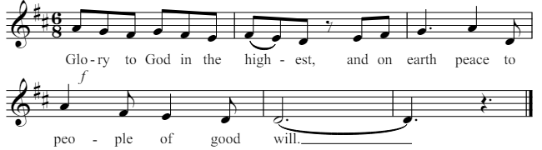

1. We praise you, we bless you, we adore you, we glorify you, we give you thanks for your great glory, Lord God, heavenly King, O God, almighty Father.

2. Lord, Jesus Christ, Only Begotten Son, Lord God, Lamb of God, Son of the Father, you take away the sins of the world, have mercy on us; you take away the sins of the world, receive our prayer; you are seated at the right hand of the Father, have mercy on us.

3. For you alone are the Holy One, you alone are the Lord, you alone are the Most High, Jesus Christ, with the Holy Spirit, in the glory of God the Father. Amen.

Excerpts from the English translation of *The Roman Missal*, copyright 2010, International Commission on English in the Liturgy Corporation. Music: *Mass of Renewal*, by William Gokelman & David Kauffman. Copyright 2010 GFTSMusic Publishing Company, Inc. Administered by International Liturgy Publications. All rights reserved.

**FIRST READING: Genesis 18:1-10a**

**PSALM 15: “He Who Does Justice”**

Please repeat refrain after the cantor the first time and sing after the verses:

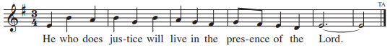

By Tony Alonso. Refrain text copyright 1969, 1981, 1997 from the *Lectionary for Mass*. ICEL. All rights reserved. Used with permission. Verses text copyright 2010, music copyright 2012, by GIA Publications, Inc. All rights reserved. Reproduced with permission under License #A-701559, OneLicense.net.

**SECOND READING: Colossians 1:24-28**

**GOSPEL ACCLAMATION: “Mass of Renewal”**

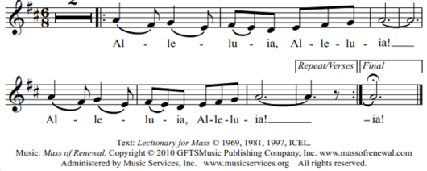

**GOSPEL: Luke 10:38-42**

**HOMILY**

**CREED**

I believe in one God, the Father Almighty, maker of heaven and earth, of all things visible and invisible.

I believe in one Lord, Jesus Christ, the only Begotten Son of God, born of the Father before all ages. God from God, Light from Light, true God from true God, begotten, not made, consubstantial with the Father; through him all things were made. For us men and for our salvation he came down from heaven: (*bow) And by the Holy Spirit was incarnate of the Virgin Mary, and became man.*  For our sake he was crucified under Pontius Pilate; he suffered death and was buried, and rose again on the third day in accordance with the Scriptures. He ascended into heaven and is seated at the right hand of the Father. He will come again in glory to judge the living and the dead and his kingdom will have no end.

I believe in the Holy Spirit, the Lord, the giver of life, who proceeds from the Father and the Son, who with the Father and the Son is adored and glorified, who has spoken through the prophets. I believe in one holy catholic and apostolic Church. I confess one Baptism for the forgiveness of sins and I look forward to the resurrection of the dead and the life of the world to come. Amen.

**LITURGY OF THE EUCHARIST: “Elegy” (Bundock Moore)**

**Holy, Holy: Mass of Renewal**

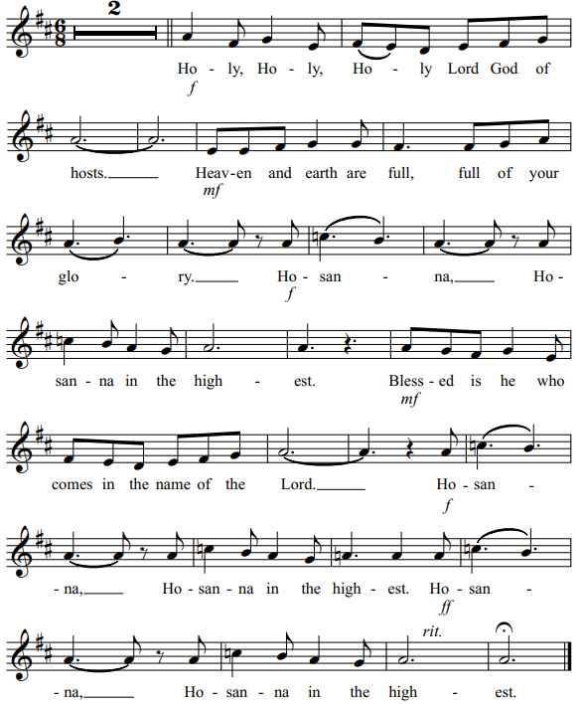

**Memorial Acclamation**

Save us, Savior of the world, for by your Cross and Resurrection, you have set us free.

**Amen**

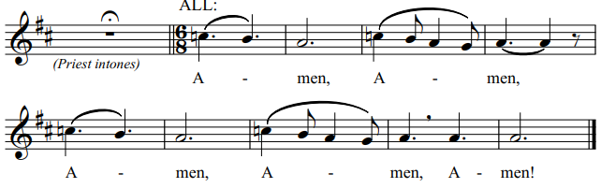

**Lamb of God**

Cantor: Lamb of God, All: you take away the sins of the world, have mercy on us.

Cantor: Lamb of God, All: you take away the sins of the world, have mercy on us.

Cantor: Lamb of God, All: you take away the sins of the world, grant us, grant us peace. Excerpts from the English translation of *The Roman Missal*, copyright 2010, International Commission on English in the Liturgy Corporation.

**COMMUNION:** **“The Servant Song”**

1. Will you let me be your servant, let me be as Christ to you; pray that I may have the grace to let you be my servant, too.

2. We are pilgrims on a journey, we are trav'lers on the road; we are here to help each other walk the mile and bear the load.

3. I will hold the Christ-light for you in the nighttime of your fear; I will hold my hand out to you, speak the peace you long to hear.

4. I will weep when you are weeping; when you laugh, I’ll laugh with you. I will share your joy and sorrow 'til we've seen this journey through.

5. When we sing to God in heaven, we shall find such harmony, born of all we've known together of Christ's love and agony.

6. Will you let me be your servant, let me be as Christ to you; pray that I may have the grace to let you be my servant, too.

By Richard Gillard. Copyright 1977, Scripture in Song. All rights reserved.

**COMMUNION:** **“Table of Plenty”**

Come to the feast of heaven and earth! Come to the table of plenty! God will provide for all that we need, here at the table of plenty.

1. O, come and sit at my table where saints and sinners are friends. I wait to

welcome the lost and lonely to share the cup of my love. Refrain.

2. O, come and eat without money; come to drink without price. My feast of

gladness will feed your spirit with faith and fullness of life. Refrain.

3. My bread will ever sustain you through days of sorrow and woe. My wine will

flow like a sea of gladness to flood the depths of your soul. Refrain.

Copyright 1992 by Daniel L. Schutte. Published by OCP Publications. All rights reserved. Reproduced with permission under License #A-701559,

OneLicense.net.

**SENDING FORTH: “I Heard the Voice of Jesus Say”**

1. I heard the voice of Jesus say, “Come unto me and rest; Lay down, O weary one, lay down your head upon my breast.” I came to Jesus as I was, so weary, worn, and sad; I found in him a resting place, and he has made me glad.

2. I heard the voice of Jesus say, “I am this dark world’s light; look unto me, your morn shall rise, and all your day be bright.” I looked to Jesus, and I found in him my star, my sun; and in that light of life I’ll walk till trav’ling days are done.

Text: Horatius Bonar, 1808-1889. Tune: KINGSFOLD, CMD, English harm by Ralph Vaughan Williams, 1872-1958. Copyright Oxford University Press.