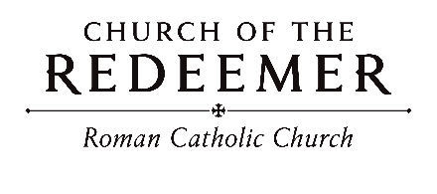
13th Sunday in Ordinary Time
June 27/28, 2026

GATHERING SONG:
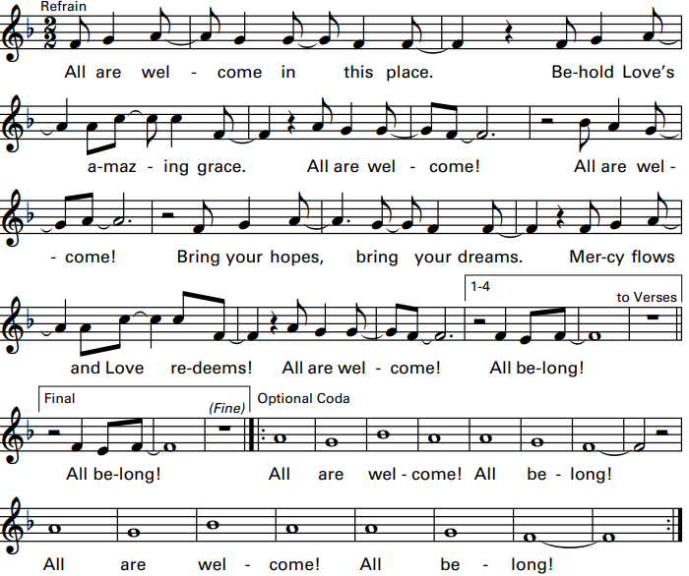

Cantor: Welcome, all who are forgotten, excluded and dignity denied!
People: You are not alone, for you are God’s own! Together we sing and we proclaim!
GLORIA
Glory to God in the highest, and on earth peace to people of good will.

1. We praise you, we bless you, we adore you, we glorify you, we give you thanks for your great glory, Lord God, heavenly King, O God, almighty Father.

2. Lord, Jesus Christ, Only Begotten Son, Lord God, Lamb of God, Son of the Father, you take away the sins of the world, have mercy on us; you take away the sins of the world, receive our prayer; you are seated at the right hand of the Father, have mercy on us.

3. For you alone are the Holy One, you alone are the Lord, you alone are the Most High, Jesus Christ, with the Holy Spirit, in the glory of God the Father. Amen.
Excerpts from the English translation of The Roman Missal, copyright 2010, International Commission on English in the Liturgy Corporation. Music: Mass of Renewal, by William Gokelman & David Kauffman. Copyright 2010 GFTSMusic Publishing Company, Inc. Administered by International Liturgy Publications. All rights reserved.
FIRST READING: 2 Kings 4:8-11, 14-16a

PSALM 89: “Forever I Will Sing”
Forever I will sing the goodness of the Lord.
By Tim Schoenbachler. Copyright 1979 by New Dawn Music. All rights reserved. Reproduced with permission under License #A-701559 OneLicense.net.

SECOND READING: Romans 6:3-4, 8-11
GOSPEL ACCLAMATION: “Mass of Renewal”
Refrain: Al-le-lu-ia, Alleluia! Al-le-lu-ia, Alleluia!
GOSPEL: Matthew 10:37-42

HOMILY

CREED
I believe in one God, the Father Almighty, maker of heaven and earth, of all things visible and invisible.
I believe in one Lord, Jesus Christ, the only Begotten Son of God, born of the Father before all ages. God from God, Light from Light, true God from true God, begotten, not made, consubstantial with the Father; through him all things were made. For us men and for our salvation he came down from heaven: (bow) And by the Holy Spirit was incarnate of the Virgin Mary, and became man. For our sake he was crucified under Pontius Pilate; he suffered death and was buried, and rose again on the third day in accordance with the Scriptures. He ascended into heaven and is seated at the right hand of the Father. He will come again in glory to judge the living and the dead and his kingdom will have no end.

I believe in the Holy Spirit, the Lord, the giver of life, who proceeds from the Father and the Son, who with the Father and the Son is adored and glorified, who has spoken through the prophets. I believe in one holy catholic and apostolic Church. I confess one Baptism for the forgiveness of sins and I look forward to the resurrection of the dead and the life of the world to come. Amen

LITURGY OF THE EUCHARIST: “I Will Choose Christ”

I will choose Christ, I will choose love, I choose to serve. I give my heart, I give my life, I give my all to you. (Last time: I give my all to you.)

1. How many times must he call my name and show to me that he is God? And as a servant he calls to me, “You must serve too.”

2. Christ, my teacher and healer, teach my heart and heal my soul. And as I walk this road with you, teach me to love.

3. As I look upon your cross, so too must I die with you. And with the death of my own desires I’ll rise with you. Copyright 1991, Tom Booth. Published by OCP Publications. All rights reserved. Used with permission. Reproduced with permission under License #A-701559, OneLicense.net.
Preface Dialogue
Priest: The Lord be with you. People: And with your spirit.
Priest: Lift up your hearts. People: We lift them up to the Lord.
Priest: Let us give thanks to the Lord our God. People: It is right and just.

Holy, Holy: Mass of Renewal

Holy, Holy, Holy Lord God of host. Heaven and earth are full, full of your glo-ry. Hosanna, Hosanna in the highest. Blessed is he who comes in the name of the Lord. Hosan-na, Hosanna in the highest. Hosan-na, Hosanna in the highest.

Memorial Acclamation

Save us, Savior of the world, for by your Cross and Resurrection, you have set us free.

Amen
A - men, A - men, A - men, A - men, Amen!

The Lord’s Prayer

Sign of Peace
Priest: Lord Jesus Christ, who said to your Apostles: Peace I leave you, my peace I give you, look not on our sins, but on the faith of your Church, and graciously grant her peace and unity in accordance with your will. Who live and reign for ever and ever.
People: Amen.
Priest: The peace of the Lord be with you always.
People: And with your spirit.
Priest/Deacon: Let us offer each other the sign of peace.

Lamb of God
Cantor: Lamb of God, All: you take away the sins of the world, have mercy on us.
Cantor: Lamb of God, All: you take away the sins of the world, have mercy on us.
Cantor: Lamb of God, All: you take away the sins of the world, grant us, grant us peace.
Excerpts from the English translation of The Roman Missal, copyright 2010, International Commission on English in the Liturgy Corporation. Music: Mass of Renewal, by William Gokelman & David Kauffman. Copyright 2010 GFTS Music Publishing Company, Inc. Administered by International Liturgy Publications. All rights reserved.

Priest: Behold the Lamb of God, behold him who takes away the sins of the world. Blessed are those called to the supper of the Lamb.
People: Lord, I am not worthy that you should enter under my roof, but only say the word and my soul shall be healed.
COMMUNION: “Here at This Table”
Come and be filled here at this table. Food for all who hunger and drink for all who thirst. Drink of his love, wine of salvation. You shall live forever in Jesus Christ the Lord. (Last time: you shall live forever in Jesus Christ the Lord.)
1. You who labor for justice, you who labor for peace, you who steady the plow in the field of the Lord.
2. You with lives full of pain, you who sorrow and weep, you, beloved of Christ, come to him, come to him!
3. Children of ev’ry color in ev’ry land, you are his own, he gathers you gently. Don’t you grow weary, for when you run, you run with the Lord!
4. You, the aged among us, holy, faithful and wise, may the wisdom you share form our lives and our world!
5. Let each woman and man learn from the stranger; we’re not so different and so much unites us. For we are one, blest with the Spirit and the power of love!
Copyright 1996, 1999 by Janet Sullivan Whitaker and James Maxwell Whitaker. Published by OCP Publications. All rights reserved. Reproduced with permission under License #A-701559, OneLicense.net.
COMMUNION: “The Summons”
1. Will you come and follow me if I but call your name? Will you go where you don’t know and never be the same? Will you let my love be shown, will you let my name be known, will you let my life be grown in you and you in me?
2. Will you leave yourself behind if I but call your name? Will you care for cruel and kind and never be the same? Will you risk the hostile stare should your life attract or scare? Will you let me answer pray’r in you and you in me?
3. Will you let the blinded see if I but call your name? Will you set the pris’ners free and never be the same? Will you kiss the leper clean, and do such as this unseen, and admit to what I mean in you and you in me?
4. Will you love the ‘you’ you hide if I but call your name? Will you quell the fear inside and never be the same? Will you use the faith you’ve found to reshape the world around, through my sight and touch and sound in you and you in me?
Text by John L. Bell. Copyright 1987 Iona Community, GIA Publications, Inc., agent. Tune: KELVINGROVE, Scottish traditional, arranged by John L. Bell. Copyright 1987 Iona Community, GIA Publications, Inc., agent. All rights reserved. One License.net License #A-701559

SENDING FORTH: “Blest Be the Lord”
Blest be the Lord, blest be the Lord, the God of mercy, the God who saves. I shall not fear the dark of night, nor the arrow that flies by day.
1. He will release me from the nets of all my foes. He will protect me from their wicked hands. Beneath the shadow of His wings I will rejoice to find a dwelling place secure.
By Dan Schutte. Copyright 1976 by New Dawn Music. All rights reserved. Used with permission.

