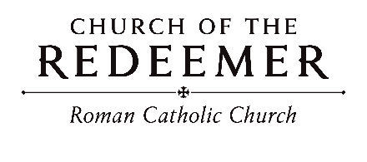
11th Sunday in Ordinary Time
June 13/14, 2026
Church of the Redeemer

GATHERING SONG: “God Has Chosen Me”
1. God has chosen me, God has chosen me to bring good news to the poor. God has chosen me, God has chosen me to bring new sight to those searching for light: God has chosen me, chosen me:
Refrain: And to tell the world that God’s kingdom is near, to remove oppression and break down fear, yes God’s time is near, God’s time is near, God’s time is near, God’s time is near.
2. God is calling me, God is calling me in all whose cry is unheard. God is calling me, God is calling me to raise up the voice with no power or choice: God is calling me, calling me.
By Bernadette Farrell. Copyright 1990 by Bernadette Farrell. Published by OCP Publications. All rights reserved. Used with permission. Reproduced with permission under OneLicense.net.

GLORIA
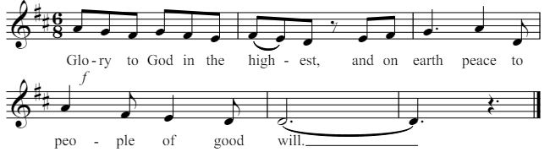

1. We praise you, we bless you, we adore you, we glorify you, we give you thanks for your great glory, Lord God, heavenly King, O God, almighty Father.

2. Lord, Jesus Christ, Only Begotten Son, Lord God, Lamb of God, Son of the Father, you take away the sins of the world, have mercy on us; you take away the sins of the world, receive our prayer; you are seated at the right hand of the Father, have mercy on us.

3. For you alone are the Holy One, you alone are the Lord, you alone are the Most High, Jesus Christ, with the Holy Spirit, in the glory of God the Father. Amen.
Excerpts from the English translation of The Roman Missal, copyright 2010, International Commission on English in the Liturgy Corporation. Music: Mass of Renewal, by William Gokelman & David Kauffman. Copyright 2010 GFTSMusic Publishing Company, Inc. Administered by International Liturgy Publications. All rights reserved.

FIRST READING: Exodus 19:2-6a

PSALM 100: “We are His People”
Please repeat refrain after the cantor the first time and sing after the verses:

We are his people, we are his people, we are his people; the sheep of his flock.
Refrain text copyright 1969, 1981, 1997, ICEL. All rights reserved. Used with permission. Verses text (adapted) copyright 1970, 1997, 1998 CCD. All rights reserved. Used with permission. Music copyright 2004 by Greg Walton. Published by OCP Publications, Inc. All rights reserved. Reproduced with permission under License #A-7015599, OneLicense.net

SECOND READING: Romans 5:6-11

GOSPEL ACCLAMATION: “Mass of Renewal”
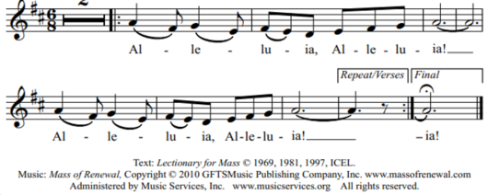

GOSPEL: Matthew 9:36-10:8

HOMILY

CREED
I believe in one God, the Father Almighty, maker of heaven and earth, of all things visible and invisible.
I believe in one Lord, Jesus Christ, the only Begotten Son of God, born of the Father before all ages. God from God, Light from Light, true God from true God, begotten, not made, consubstantial with the Father; through him all things were made. For us men and for our salvation he came down from heaven: (bow) And by the Holy Spirit was incarnate of the Virgin Mary, and became man. For our sake he was crucified under Pontius Pilate; he suffered death and was buried, and rose again on the third day in accordance with the Scriptures. He ascended into heaven and is seated at the right hand of the Father. He will come again in glory to judge the living and the dead and his kingdom will have no end.

I believe in the Holy Spirit, the Lord, the giver of life, who proceeds from the Father and the Son, who with the Father and the Son is adored and glorified, who has spoken through the prophets. I believe in one holy catholic and apostolic Church. I confess one Baptism for the forgiveness of sins and I look forward to the resurrection of the dead and the life of the world to come. Amen

LITURGY OF THE EUCHARIST: “The Summons”
1. Will you come and follow me if I but call your name? Will you go where you don’t know and never be the same? Will you let my love be shown, will you let my name be known, will you let my life be grown in you and you in me?
2. Will you leave yourself behind if I but call your name? Will you care for cruel and kind and never be the same? Will you risk the hostile stare should your life attract or scare? Will you let me answer pray’r in you and you in me?
3. Will you let the blinded see if I but call your name? Will you set the pris’ners free and never be the same? Will you kiss the leper clean, and do such as this unseen, and admit to what I mean in you and you in me?
4. Will you love the ‘you’ you hide if I but call your name? Will you quell the fear inside and never be the same? Will you use the faith you’ve found to reshape the world around, through my sight and touch and sound in you and you in me?
5. Lord, your summons echoes true when you but call my name. Let me turn and follow you and never be the same. In your company I’ll go where your love and footsteps show. Thus I’ll move and live and grow in you and you in me.
Text by John L. Bell. Copyright 1987 Iona Community, GIA Publications, Inc., agent. Tune: KELVINGROVE, Scottish traditional, arranged by John L. Bell. Copyright 1987 Iona Community, GIA Publications, Inc., agent. All rights reserved. One License.net License #A-701559
Holy, Holy: Mass of Renewal
Holy, Holy, Holy Lord God of host. Heaven and earth are full, full of your glo-ry. Hosanna, Hosanna in the highest. Blessed is he who comes in the name of the Lord. Hosan-na, Hosanna in the highest. Hosan-na, Hosanna in the highest.

Memorial Acclamation
Save us, Savior of the world, for by your Cross and Resurrection, you have set us free.

Amen
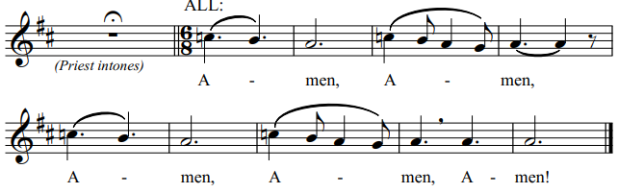
The Lord’s Prayer

Sign of Peace

Lamb of God
Cantor: Lamb of God, All: you take away the sins of the world, have mercy on us.
Cantor: Lamb of God, All: you take away the sins of the world, have mercy on us.
Cantor: Lamb of God, All: you take away the sins of the world, grant us, grant us peace. Excerpts from the English translation of The Roman Missal, copyright 2010, International Commission on English in the Liturgy Corporation.
COMMUNION: “What You Have Done for Me”
1. I am the hungry, I am the poor, I am the stranger outside your door. So when you feed the hungry, when you clothe the poor, I will no longer be just a stranger at your door.
Refrain: What you have done for the least of my children, you have done for me. What you have given, with nothing left to give, you have given me. (Last time: you have given - me.)
2. Come all you blessed, come and rejoice. Inherit the kingdom prepared for you. For you are my children, called to serve as keepers of the vision and speakers of the word.
3. I will look to you when life on earth has ended. Those who give will receive, those who seek will find; so seek my face in ev’ry face and see the eyes of God!
By Tony Alonso. Copyright 2001 by GIA Publications, Inc. All rights reserved. OneLicense.net License #A-701559.
COMMUNION: “Ubi Caritas”
Ubi caritas est vera, est vera; Deus ibi est, Deus ibi est.
(Translation: “Where there is true charity, God is present.”)
1. The love of Christ joins us together. Let us rejoice in him, and in our love and care for all now love God in return.
2. In true communion let us gather. May all divisions cease and in their place be Christ the Lord, our risen Prince of Peace.
3. May we who gather at this table to share the bread of life become a sacrament of love, your healing touch, O Christ.
4. For those in need make us your mercy, for those oppressed, your might. Make us, your Church, a holy sign of justice and new life.
5. May we one day behold your glory and see you face to face, rejoicing with the saints of God to sing eternal praise.
Verses 1, 2 and 5 based on Ubi Caritas, 9th cent., verses 3 & 4 by Bob Hurd. Tune by Bob Hurd, arranged by Craig S. Kingsbury. Published by spiritandsong.com. All rights reserved. Reproduced with permission under License #A-701559, OneLicense.net.
SENDING FORTH: “I Send You Out”
1. I baptize you in the name of the Father. I baptize you in the name of the Son. I baptize you with the Holy Spirit. Go out and spread Good News!
Refrain: I send you out on a mission of love. I send you out on a mission of love. I send you out on a mission of love, and know that I am with you always until the end of the world.
Copyright 2000, World Library Publications. Text and tune by John Angotti. Published by GIA Publications, Inc. All rights reserved. Used with permission under OneLicense.net License #A-701559.

