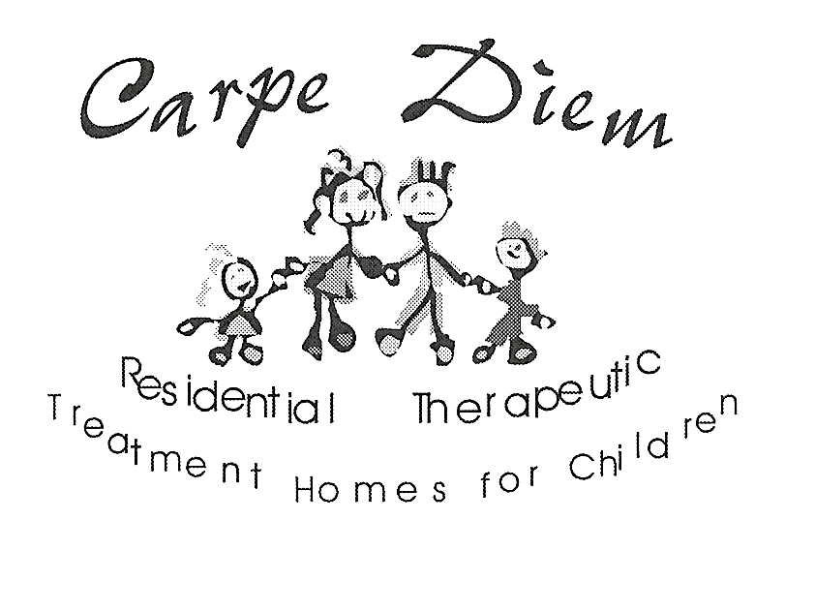

Definition Outline

FOSTER PARENT REPORT & PLAN OF CARE

CHILD: SEX:

D.O.B.: D.O.P.:

WORKER’S NAME: STATUS:

CARPE DIEM HOME:

FOR THE PERIOD COVERING:

FOSTER PARENT REPORT

STRENGTHS, APTITUDES AND ABILITIES:
- Organized, trustworthy, outgoing, athletic
- Enjoys playing/listening to music
- Good sense of humour, sociable
- Enjoys his/her own time
- Good with children / good with pets

FOR BABIES AND TODDLERS:
- Responsive to loud noises
- Meeting developmental milestones (i.e. starting to hold neck up, starting to roll over, etc.)
- Able to play independently for short periods of time (toddler)
- Starting to say a few words (toddler)
- Able to drink from a sippy cup (toddler)
- Learning to share
- Moves to music (dancing)

SUMMARY OF SIGNIFICANT EVENTS since last reporting period (i.e. court):
- Court dates and outcome
- Starting school / graduating from school
- Camp / trip
- Major change to visitation schedule
- Getting a job

LIST OF RESOURCES (include who provides which services):
- Relief and frequency - please list dates (provided by Carpe Diem)
- Drives (provided by Carpe Diem)
- FSW (Family Support Worker) – please list dates and purpose of their involvement
- Therapy (please name Therapist, type of therapy and dates)
- Any lessons or extra-curricular activities (i.e. swimming lessons, skating lessons, music lessons, day/overnight camp)

HEALTH (overall health, medical or dental appointments, specialist appointments, milestones, assessments, medication dosages and/or changes):

List all medical appointments within the reporting period including the name of the physician(s)
Are there any themes or concerns that have been identified because of appointments?
Are there any unfinished appointments or concerns?
Is there any variation in child’s behaviour or presentation due to medical interventions or appointments?
Please list dental appointments and note what specific work was done and with whom. How is the child’s oral hygiene?
Any health issues that are concerning, such as allergies or congenital issues?

Medication; who prescribed and is the medication helping. Please leave the previous medication information in the report with the specific date change. We need to compile an accurate list of meds and changes.
Are there any recent copies of the child’s checklists in the file?
Has medication affected the child and if so how has the treatment plan been altered?
Has menarche begun? If so when?
What is the child’s understanding about sexual development? What kind of information regarding health is shared with this child and by whom?
Is the child/teen developmentally older than he/she is emotionally or socially?

Medication: Prescription and over the counter drugs including vitamins

Medical: (MUST INCLUDE HEIGHT AND WEIGHT)
Dental:

Other: (i.e. Hearing test / Psychological Assessment / Therapy)

FOR BABIES AND TODDLERS:
Please add a daily routine (i.e. what time does the child wake up in the morning? Meal times? Nap times? Play time / tummy time for babies? Bath times? Bed time routines?)

For Babies: Name of formula / how much they consume and frequency within a 24 hour period / what solids do they consume and frequency / do they spit up or projectile vomit?

For older babies and toddlers: What foods do they consume and frequency / do they feed themselves with utensils or need to be fed / do they drink from a bottle and/or sippy cup / are they happy to be in a high chair/booster seat?

EDUCATION (number of school moves, adjustment to current or new school, need for/results of psychological testing, academic progress, information on learning disabilities or behavioural needs that affect school progress, school and extra-curricular activities, etc.

What school does the child go to?
What schools has the child attended?
What grade is the child in?
Is the child’s grade an age appropriate grade? Why not?
What are the child’s favourite and least favourite subjects?
How does the child see himself within his school community?
How does the school community view the child?
Does the child walk, get driven or get bussed to school?
Does this ever impact on how the child’s day progresses?
How does this child handle homework?
Does the child require one to one assistance or can the child work independently?
Does the child like to read? Are reading and literacy activities a part of this child’s daily routine? Do they need to be?
How does the bus driver view the child?
Does the school have any additional programs that they offer this child? Does the child participate in these or does the child refuse to participate in these?
What is the teacher’s style of classroom management? Is there extra staff in the classroom?
How does the child respond to staffing changes?
How does staff respond to the child when he/she is angry, sad, and anxious?
Does the child have any regular appointments that he/she misses school for?
How does this attendance affect his/her school performance?
Is the school experience positive for the child academically, socially, emotionally in regards to relationships within the school community?
Please list any school contacts.

RELIGIOUS AND CULTURAL NEEDS (involvement in religious and cultural activities, communication with cultural community / Band)

What are the child’s beliefs around a higher power / Spirituality?
Does the child attend a place of worship? If so, with who? Frequency?
Are there any specific religious practices? (i.e. Avoiding pork / fasting / smudging)
What is the child’s moral compass (i.e. do they believe in charity, helping others less fortunate, care for animals, etc.).
What cultural activities does the child engage in and with who / frequency? (i.e. Music / peer group / food / movies / books / shows / language / hair / holidays / education / room furnishings such as a Dream Catcher / events such as a Pow Wow / clothing)

IDENTITY (child’s feelings about biological family, child’s understanding of their past, child’s level of self-esteem, Lifebook information, etc.):

What is an overall description of this child emotionally, behaviourally and socially?
Does this child present consistently no matter where he or she is (i.e. is the child’s behaviour the same at home? At school? In the community, etc.?)
How does this child handle stress? What coping strategies does he/she have or practice? (i.e. How do you know if the child is stressed and what do they do to feel better / less stressed?)
How resilient is this individual? (i.e. How well do they handle negative situations such as a time out or receiving news that may upset them such as a cancelled visit)?
How insightful is this individual? (i.e. Does the child understand that they are in care? Why they are in care and what the next few months may hold for them?)
How does the child feel that others view him/her? (i.e. How would the child say that others such as friends, teachers, other adults, etc. would describe him/her?)
What is this child’s self image or view of self? (i.e. How would the child describe themself? happy/sad/friendly/shy, etc.)
Where does this child experience a sense of belonging? (This can also be noted in the next section.) i.e. Where does the child feel most safe and accepted?
Does the child utilize transitional objects to create feelings of safety? (i.e. Does the child have a favourite blanket or stuffed animal for example that makes them feel safe and must accompany them?)
Does the child have a life book? Does he /she look at this book? Can it be viewed to gain insight into this child’s world and experience?
What does the child do for fun?
Does the child have any collections?
Can he/she entertain himself/herself or does the child need to have time structured for him/her.

FOR BABIES AND TODDLERS:
Do they enjoy listening to music?
Do they like to watch/listen to a mobile or others in the room?
Do they follow others?
Do they enjoy being outdoors (i.e. for a walk in the stroller)?
How do they handle being bundled up in snowsuits, etc. during the winter months?
Do they enjoy splashing in the bath / pool?
Do they use a soother?
When upset, what helps to settle the baby/toddler (i.e. being held/rocked/soother)?

FAMILY AND SOCIAL RELATIONSHIPS (contact with biological family, effect of access on the child, quality of foster parent relationships, relationships with other adults, relationships with peers):

Who does this child connect with?
How does this child connect with adults?
How many adults has this child had a connection with?
Does the child connect with strangers or new adults more quickly than direct care providers?
Who does this child interact with; younger children, age appropriate children or older children?
What age group of peers is this child most likely to become friends with?
Does this child have friends?
Does this child have playmates?
Who initiates the play? What are standard activities occur with friends?
Has this child had the opportunity to form friendships or have multiple placements interfered with friendship development?
What do peers say about this child?
Does he/she get invited to birthday parties?
What do caregivers do to foster and support peer interaction?
Does the child have any special friends?
What type of contact does the child have with family if he/she is in care?
What is the history of contact?
Who is the contact with?
Who does the child want to or not want to have contact with?
Do any themes surface?
How does the child respond to contact prior to and after contact?
How is the child during family contact?
Are there any upcoming court dates or progress to be reported?

FOR BABIES AND TODDLERS:
Are they comfortable to go with anyone or do they make strange?
Do they seem to respond to foster parents and accept comforting?
Do they recognize foster parent’s voice?
Do they enjoy being around other children?
Does noise or too much stimulation upset them?
Do they enjoy being in the car?

SOCIAL PRESENTATION (child’s physical description and any changes, hygiene and physical presentation, ability to communicate effectively, ability to behave appropriately, etc.)

Please provide a physical description of child. Please note the child/teen’s height, weight, and note where information came from. Has height or weight changed in the last little while or since admission to current placement? Any concerns about the height or weight or children’s presentation; hair colour and style, eye color. Does the child wear certain types of clothes? Are they clean, in good repair, do they match, are they age appropriate, socially appropriate?
Does he/she have a persona that they are invested in presenting to the outside world or only family? For example, does child wear the long sleeve shirt with holes for thumbs that kids who often “cut” wear, or sports style or “goth” style?
Personal Care and Hygiene - please include the child’s dental hygiene and physical hygiene.
How does the child take care of his/her things or not take care of his/her things. Look at the child’s bedroom - is it representative of the child and his/her personality? Does the child take care of his/her space?
How is this child involved in the community? Does he/she take any lessons?
What activities is the child participating in with custodial parents, foster parents, birth parents or family support workers?
How does the child function in the community? What type of support does she/he need in order to feel successful and be successful?
Is the child safe in the community? Does he/she understand and practice ‘stranger safety’ or is he /he at high risk to go with anyone?
Has there been any complaints or concerns expressed about how this child functions in the community by neighbours or others?

Has the child had any interaction with the police or security officers?
Does the child verbalize wanting to participate in community activities? Does the child volunteer? Why? If so, what needs get attended to by their experience in the above opportunities?
Does the child attend a faith community with his foster parent or independently?

FOR BABIES AND TODDLERS:
Where does the baby/toddler sleep? Do they share a room? Is there a night light left on or is the room dark? Is the door closed or left open a little? Is there a baby monitor in the room? Are they content in their bed / room? Do they go to sleep without difficulty?
What is the baby/toddler’s bath routine? Do they enjoy their bath time or is it a process to get through? Do they have any skin conditions that require lotions (prescription or over the counter)?
What is the diaper change routine? Is this a task that the child is happy with or is it a struggle every time? Is there a problem with frequent diaper rash?
Has toilet training begun and provide details.

EMOTIONAL AND BEHAVIOURAL DEVELOPMENT (summary of Incident Reports or Serious Occurrences, improvements or regressions in behaviour, professional involvement, child’s coping strategies, positive events in the child’s life, turning points, etc.)

List any incident reports filed.
Are these incidents a new pattern for this child?
Were there lots of incidents experienced by this child prior to admission? And currently this child is not experiencing any incidents?
Have there been any serious occurrences since the child’s admission? Provide appropriate details.
Is there a specific approach that sets this child up for success?
If the child has a specific diagnosis, are there known intervention, strategies and management techniques that can be used with this child?
What isn’t effective when working with this child?

FOR BABIES AND TODDLERS:
When the baby cries, what would they generally be crying about? Are they easily soothed? How are they comforted? What is their energy level (i.e. calm and quiet or busy and active)?

SELF-CARE SKILLS (motor skills, speech development, life skills, social development, preparation for independence, etc.)
Are any developmental concerns stated by foster parents?
Do people outside of your family understand your child’s communication?
Does your child have age appropriate balance, gait and coordination?
Can he or she ride a bike, skateboard?
Does the child demonstrate age appropriate skills in the areas of gross and fine motor skills?
(Gross: Can they throw and catch a ball? Can they ride a bike? Can they kick a ball?)

(Fine: Can the child cut out shapes? Can they colour between lines? Can/do they play with Lego?)
Are there any sensory concerns or issues (i.e. Do seams on socks or tags on clothing bother the child? Does the sound of chairs being moved on the floor bother the child? Does the child react to rain; the feel of the rain or the sound of the rain?)
What are the child’s chores and responsibilities at home?
Does the child see their chores as work? Does the child take pride in their jobs?
Does the child take on new tasks without being asked?
Does the child talk about future plans such as college, part time jobs, trades, having their own space?
Is your child comfortable asking sexuality questions? How does the child get and process age appropriate information?
If your child is an adolescent, how sexually aware are they including safe sex practices, sexually transmitted diseases and pregnancy?
Allowance – Is the child a spender or a safer? Do they have a savings account? How much have they saved? What do they spend their allowance on? Are they saving for something in particular?

FOR BABIES AND TODDLERS:
Does your baby roll over, reach for items, pull themselves up to a standing position, sit on their own, etc.?
For toddlers, do they look at books, play with blocks, etc.?

_____________________
FOSTER PARENT

_____________________
CASE MANAGER,
OR DESIGNATE.

