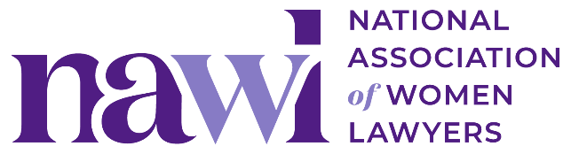
2026 Annual Meeting
“Case for Attendance” Template Email

Copy and paste the message below to share with your manager (and/or women’s initiative group).

----

Subject: Request to Attend NAWL 2026 Annual Meeting

Dear [Name],

I’d like approval to attend the National Association of Women Lawyers (NAWL) 2026 Annual Meeting on July 22–23 in Chicago. It’s NAWL’s largest event of the year, and attending would allow me to connect with [clients/outside counsel], learn from industry thought leaders, and represent [Firm/Company Name] within a prominent national network.

This conference convenes influential leaders from across the profession—including general counsel from Fortune 500 companies, managing partners at major firms, judges, and other key decision-makers. Many organizations we currently work with—or hope to engage with—regularly attend. A sample list of organizations that have participated in recent in-person meetings is available here.

The agenda includes expert-led sessions, candid peer discussions, and recognition of NAWL’s 2026 Award Recipients, who will share insights from their leadership experiences. The substantive programming is designed to offer real-world perspectives and practical takeaways that I can apply directly in my role, in my approach to [client/external] relationships, and in my professional growth.

Key Attendance Benefits:
- Build relationships with [insert: current clients / in-house counsel / potential partners] in a setting designed for open, strategic conversations
- Hear how other legal teams are approaching [insert: team structure, growth, outside counsel management, etc.]
- Bring back ideas and contacts to support [insert: a specific client, matter, or initiative]
- Strengthen personal and professional development in [insert: leadership, client engagement, subject-matter expertise, etc.]

Estimated Costs (Based on the early registration discount (Ends June 21) and NAWL’s discounted hotel rate):
- Registration: $X
- Travel: $X
- Hotel: $X ($259/night at Hilton Chicago)
- Total: $X

In addition, I hope to use my time in Chicago to also [insert: meet in-person with [client], build relationships with our Chicago office, develop new business with [potential client], etc.].

Please let me know if you have any questions or would like more details. If approved, I’ll share a summary afterward with key takeaways, new contacts, and ideas that may be useful to the broader team.

Thank you for your consideration.

Best,
[Your Name]

Post-Event Follow-Up Template Email

Subject: Follow-Up: NAWL 2026 Annual Meeting Insights and Next Steps
Dear [Name],
As promised, I wanted to provide a summary of my experience at the National Association of Women Lawyers (NAWL) 2026 Annual Meeting held on July 22–23 in Chicago.
Key Takeaways:
- Insightful Sessions: The sessions on [insert: specific topics] were particularly enlightening. I gained valuable insights into [insert: specific learnings].
- New Contacts: I had the chance to connect with industry leaders and peers, which I'm optimistic will lead to future collaborations and partnerships.
- Innovative Solutions: The expert speakers and my fellow attendees shared several innovative solutions that could be beneficial for our projects, especially [insert: any relevant solutions/projects].
Action Items:
- Implementing Learnings: I plan to integrate some strategies discussed in the sessions into our current projects. This includes [insert: specific actions].
- Follow-Up Meetings: I have scheduled follow-up meetings with [insert: names of contacts] to explore collaboration opportunities.
- Sharing Knowledge: I will organize a meeting to share the key insights and actionable items with the team.

Attending the NAWL 2026 Annual Meeting was a valuable experience that will positively impact our work. I appreciate your support in making this possible and look forward to discussing these insights further.
Thank you once again for approving my attendance. Please let me know if you have any questions or want to connect to chat in person about my takeaways.
Best,
[Your Name]

