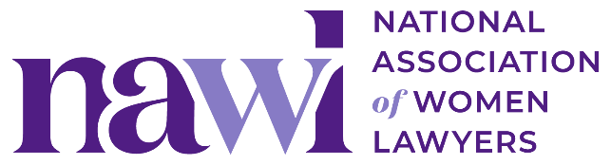
2026 General Counsel Institute
“Case for Attendance” Template Email

Copy and paste the message below to share with your manager (and/or women’s initiative group).

----

Subject: Request to Attend the NAWL 2026 General Counsel Institute

Hi [Name],

I’m writing to request approval to attend the National Association of Women Lawyers (NAWL) 2026 General Counsel Institute on October 14-16, 2026, in New York, NY.

The General Counsel Institute (GCI) is a 2.5-day program of networking, education, and inspiration intentionally designed for senior in-house counsel. Attending would allow me to refine my leadership skills, learn from the general counsel of major corporations and other industry thought leaders, and connect [Firm/Company Name] to a prominent national in-house network.

With in-house counsel comprising over 70% of the audience, GCI creates a unique and intimate environment for me to deepen relationships with other counsel, candidly share experiences, and gain valuable insights from other legal departments. A sample list of organizations that have participated in recent in-person GCIs is available here.

Key Attendance Benefits:
- Build relationships with [insert: potential partners/etc.] in a setting designed for open, strategic conversations
- Hear how other legal teams are approaching [insert: team structure, growth, outside counsel management, etc.]
- Bring back ideas and contacts to support [insert: a specific relationship, matter, or initiative]
- Strengthen personal and professional development in [insert: leadership, client engagement, subject-matter expertise, etc.]

Estimated Costs (based on the early registration discount and NAWL’s discounted hotel rate):
- Registration fee $X
- Travel $X
- Hotel $X ($449++/night (depending on room type) at the InterContinental New York Barclay)
- TOTAL: $X

In addition, I hope to use my time in New York to also [insert: meet in-person with [client], build relationships with our New York office, develop new business with [potential client], etc.].

Please let me know if you have any questions or would like more details. If approved, I’ll share a summary afterward with key takeaways, new contacts, and ideas that may be useful to the broader team.

Thank you for your consideration.

Thank you,
[Your Name]

Post-Event Follow-Up Template Email

Subject: Follow-Up: NAWL 2026 General Counsel Institute Insights and Next Steps
Dear [Name],
As promised, I wanted to provide a summary of my experience at the National Association of Women Lawyers (NAWL) 2026 General Counsel Institute held on October 14-16, 2026, in New York, NY.
Key Takeaways:
- Insightful Sessions: The sessions on [insert: specific topics] were particularly enlightening. I gained valuable insights into [insert: specific learnings].
- New Contacts: I had the chance to connect with industry leaders and peers, which I'm optimistic will lead to future collaborations and partnerships.
- Innovative Solutions: The expert speakers and my fellow attendees shared several innovative solutions that could be beneficial for our projects, especially [insert: any relevant solutions/projects].
Action Items:
- Implementing Learnings: I plan to integrate some strategies discussed in the sessions into our current projects. This includes [insert: specific actions].
- Follow-Up Meetings: I have scheduled follow-up meetings with [insert: names of contacts] to explore collaboration opportunities.
- Sharing Knowledge: I will organize a meeting to share the key insights and actionable items with the team.
Attending the NAWL 2026 General Counsel Institute was a valuable experience that will positively impact our work. I appreciate your support in making this possible and look forward to discussing these insights further.
Thank you once again for approving my attendance. Please let me know if you have any questions or want to connect to chat in person about my takeaways.
Best,
[Your Name]

