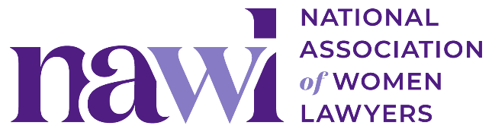

**2026 (un)conference**

**“Case for Attendance” Template Email**

Copy and paste the message below to share with your manager (and/or women’s initiative group).

----

**Subject Line:**

Request to attend the National Association of Women Lawyers 2026 (un)conference

Dear [NAME],

I’m writing to request approval to attend the [National Association of Women Lawyers](http://www.nawl.org) (NAWL) [(un)conference](https://www.nawl.org/2026-unconference) on March 4 through 6, 2026, in San Diego, California.

The (un)conference is an immersive, participant-driven experience for leaders in the legal profession seeking growth, clarity, and real community. From the peer-to-peer roundtable discussions to activity-based networking, every element is designed to encourage active engagement, not passive listening. Attendees leave with deep, trusting connections and fresh insight from a network of accomplished peers.

Here are a few key reasons why attending this conference would be beneficial for me and for [company name]:

* **Strategic Business Development:** The small-group format fosters long-lasting, trust-based relationships that can lead to new client opportunities and strengthen our industry presence. The relationships and skills gained will better position me to bring in the right resources to support [company name]’s growth.
* **Discussion-Based Programming:** Most sessions take the form of roundtable discussions led by senior in-house and firm leaders who will give actionable strategies to address attorneys’ challenges, benefiting our leadership pipeline and client strategies. This format encourages honest conversation and peer-to-peer relationship-building outside of traditional “networking” activities.
* **Personalized Approach:** The (un)conference is built for deeper engagement, with an intimate setting that allows for more meaningful and productive conversations. I’ll have the chance to connect directly with experienced, thoughtful professionals and bring their insights and ideas back to benefit our team.

Below is a breakdown of the approximate cost for me to attend NAWL’s (un)conference:

* Registration fee (which includes meals) $2,500
* Airfare/travel $X
* Hotel $X *(note the discounted room rate of $269/night at the Rancho Bernardo Inn through NAWL’s room block, the rate outside of the block is currently $368+/night)*
* **TOTAL: $X**

In addition, the (un)conference is designed to allow for flexibility, making it possible to arrange client meetings while in San Diego. Since programming does not begin until noon on Wednesday, March 4, I plan to schedule meetings with X on Tuesday afternoon and Wednesday morning.

I am confident that the insights and relationships I gain at the (un)conference will translate to actionable strategies that will benefit [company name]. Thank you for considering this request. I look forward to discussing this opportunity with you.

Thank you,

[NAME]

**SHORT VERSION:**

**Subject:** Request to Attend NAWL 2026 (un)conference

Dear [NAME],

I’m requesting approval to attend the [National Association of Women Lawyers](http://www.nawl.org) (NAWL) [(un)conference](https://www.nawl.org/2026-unconference) from March 4-6, 2026, in San Diego.

The event is a participant-driven experience focused on active discussion and meaningful networking with legal leaders. It offers opportunities to build trust-based relationships and gain practical strategies directly from peers and senior experts.

Key benefits for me and [company name] include:

* **Business development:** Small groups foster connections that can lead to new clients and stronger industry ties.
* **Discussion-based sessions:** Roundtables provide actionable insights for leadership and client strategies.
* **Personalized engagement:** The intimate setting encourages meaningful conversations with experienced professionals, allowing me to bring back valuable insights for our team.

**Estimated costs:**

* Registration (includes meals): $2,500
* Airfare/travel: $X
* Hotel (discounted rate): $X
* **Total:** **$X**

I also plan to schedule client meetings around the event, as programming starts midday on March 4.

I believe attending will provide valuable insights and relationships to support [company name]. Thank you for considering this request, and I’m happy to discuss further.

Best,

[NAME]