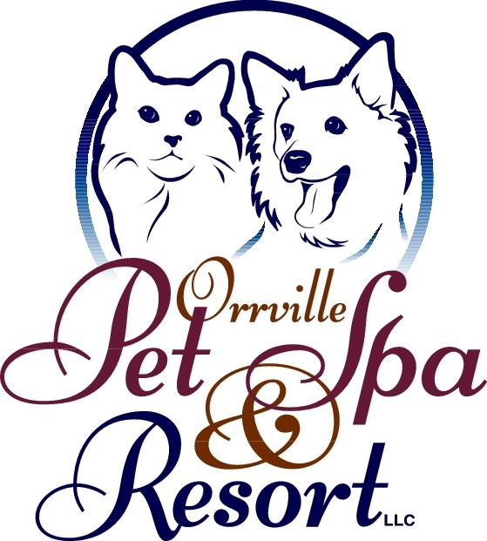
Exciting Updates to Our Daycare Experience at Orrville Pet Spa & Resort!
We’re thrilled to share a fresh new approach to our Daycare Center — one that prioritizes personalized care, enrichment, and fun for every guest. At Orrville Pet Spa & Resort, we are moving beyond the limitations of traditional group play and embracing an all-inclusive, activity-focused model tailored to meet the unique needs of each dog.
Our dedicated daycare attendants will now focus on giving your pet individualized attention and engaging them in activities best suited to their personality and play style. To ensure every dog receives personalized attention, our daycare attendants rotate through small groups or individuals throughout the day. While time with each individual pet is limited, this approach allows us to engage with every dog in a meaningful and enriching way. Our goal is to make sure it's focused, fun, and tailored to their personality. Whether it’s a lively game of fetch, splashing in the pool, solving puzzle games, chasing bubbles, or relaxing into a good massage with a side of belly rubs, your dog’s day will be filled with stimulating and joyful experiences. We have an extensive menu of activities to create a customized enrichment plan for each guest. This will also allow for adequate time for rest which, as always, we believe is just as important as play.
While we are shifting away from structured group play, small group sessions will still be part of our routine—especially for pups who thrive with their regular buddies. Social time will continue in a safe, thoughtful, and supervised environment.
Our commitment to being an inclusive facility means we welcome dogs of all temperaments. Whether your pet is or isn’t spayed or neutered, overly friendly, shy, excitable, reactive, or prefers solitude, our experienced team is ready to meet them where they are. We no longer require transitions to our Day Resort program—we're equipped and excited to care for every dog in the capacity they need.
We are deeply grateful for the trust our clients place in us. Although some things may look a little different, our core values remain unchanged: providing a safe, nurturing, and enriching space where all dogs feel loved and cared for.
Our hours and staff remain the same, so you’ll continue to see the friendly faces you know and trust. Your dog will enjoy time outside, frequent relief breaks, access to fresh water, and loving companionship. At the end of the day, you’ll be greeted by a happy, enriched, and wonderfully tired pup—just as you’ve come to expect from us.
You might have noticed our new doorbell. We added it to help us stay focused on giving your dog the best care and attention while they're with us. This allows our entire team to stay focused on attending to your dog’s experience throughout the day. Our regular desk hours will continue for routine 7am-9am drop-off and 4pm-6pm pick up. Other times will be welcomed and monitored by the doorbell. An attendant is always nearby and listening for the bell, and someone will be with you as soon as possible.
Thank you for being part of the Orrville Pet Spa & Resort family. We look forward to making every visit special for you and your furry friend!

