Oklahoma Mobility Management Program
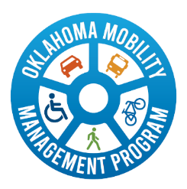
Mobility Management is a Federal Transit Administration (FTA)-funded program that focuses on meeting community transportation needs through the coordinated use of a wide range of transportation providers and services. The program works to improve access to transportation for people who may face mobility challenges.

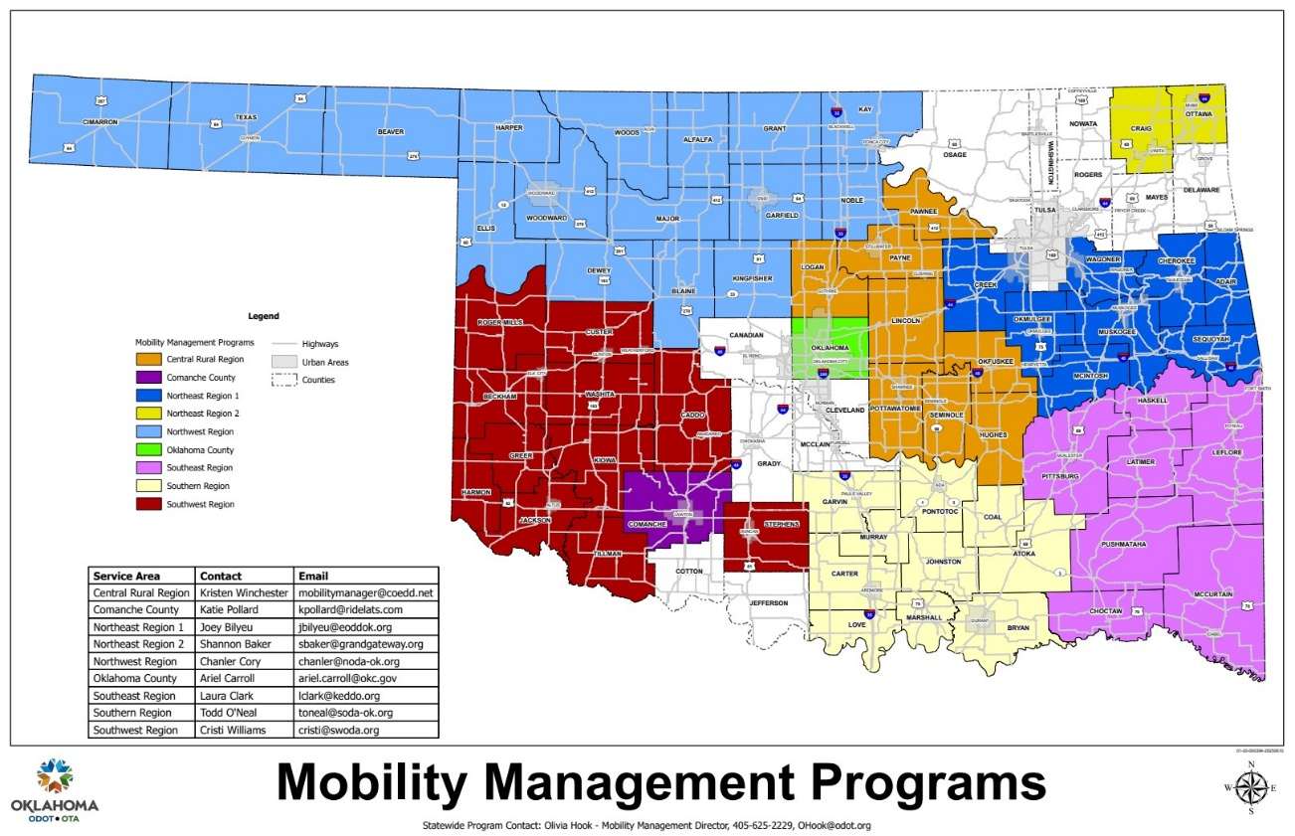
How to benefit from the mobility management program in your area:
INDIVIDUALS- Connect with your local Mobility Manager or Navigator for personalized assistance in identifying transportation options and overcoming mobility challenges.
AGENCIES/ORGANIZATIONS- Engage with the Mobility Management program by sharing unmet transportation needs, participating in regional coordination meetings, and inviting a Mobility Manager or Navigator to learn more about your services. Collaboration across partners helps develop effective, community-based transportation solutions.
Mobility management networks are designed to improve the overall mobility for individuals, regardless of the rider characteristics, mode, or geography.
Visit the Oklahoma’s Mobility Management Program Website to Learn More
https://okmm.multiscreensite.com/
or click the QR code



Mobility Management Program Contact Information
Region | Service Area (Counties) | Full Name | Phone | Email
Central | Oklahoma | Ariel Carroll | 405-230-7316 | ariel.carroll@okc.gov
Central | Pottawatomie, Seminole, Hughes, Okfuskee, Lincoln, Payne, Logan, and Pawnee | Kristi Winchester | 405-208-3596 | Mobilitymanager@coedd.net
Southwest | Roger Mills, Beckham, Greer, Harmon | TBD | 580-562-5038 | navigatornw@swoda.org
Southwest | Comanche | Katie Pollard | 580-450-1930 | kpollard@ridelats.com
Southwest | Caddo, Cotton, Grady, Jefferson, McClain and Stephens | Kendra Dilbeck | 580-562-5036 | navigatorsc@swoda.org
Southwest | Greer, Harmon, Jackson, Kiowa, Tillman and rural areas of Comanche | Delaney Berfield | 580-562-5033 | navigatorw@swoda.org
Northwest | Kay, Noble, Garfield, Grant, Kingfisher, Blaine, Major, Dewey, Alfalfa, Woods, Woodward, Ellis, Harper, Beaver, Texas & Cimarron | Chanler Cory | 580-599-0951 | chanler@noda-ok.org
Southeast | Coal, Atoka, Johnston, Bryan, Marshall, Love, Carter, Murray, Garvin, and Pontotoc | Todd O’Neal | 580-853-4248 | toneal@soda-ok.org
Southeast | Pittsburg, Latimer, Leflore, Haskell, Pushmataha, McCurtain, and Choctaw | Laura Clark | 918-506-9285 | lclark@keddo.org
Northeast | Adair, Cherokee, Wagoner, Muskogee, Okmulgee, McIntosh and Sequoyah | TBD | N/A | N/A
Northeast | Craig & Ottawa | Shannon Baker | 918-937-3707 | sbaker@grandgateway.org

Mobility Management ODOT Grant Program Contact:
Olivia Hook, Mobility Management Director
ohook@odot.org



https://oklahoma.gov/odot.html
The Oklahoma Department of Transportation (ODOT) ensures that no person or groups of persons shall, on the grounds of race, color, sex, religion, national origin, age, disability, retaliation or genetic information, be excluded from participation in, be denied the benefits of, or be otherwise subjected to discrimination under any and all programs, services, or activities administered by ODOT, its recipients, sub-recipients, and contractors. To request accommodation please contact the ADA Coordinator at 405-521-4140 or the Oklahoma Relay Service at 1-800-722-0353. If you have any ADA or Title VI questions email ODOT-ada-titlevi@odot.org.
Mobility management is a program recognized by the Federal Transit Administration. Learn more by visiting the FTA website https://www.transit.dot.gov/ccam/mobility-management Updated: 4/14/2026

