Dishes and their allergen content
Week 2
Dishes | 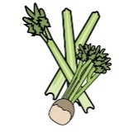 | 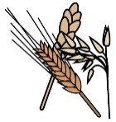 | 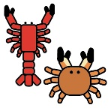 | 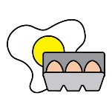 | 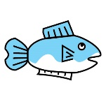 | 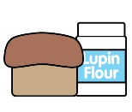 |  |  | 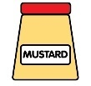 | 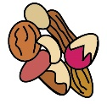 | 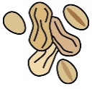 | 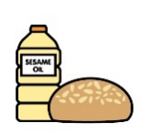 |  | 
Monday | Celery | Cereals containing gluten* | Crustaceans | Eggs | Fish | Lupin | Milk | Mollusc | Mustard | Nuts† | Peanuts | Sesame seeds | Soya | Sulphur Dioxide
Pork sausage roll |  | ✓ |  |  |  |  | ✓ |  |  |  |  |  | ✓ | ✓
Veg sausage roll |  | ✓ |  |  |  |  | ✓ |  |  |  |  |  | ✓
Jam doughnut |  | ✓ |  | ✓ |  |  | ✓ |  |  |  |  | ✓ | ✓
Yoghurt |  |  |  |  |  |  | ✓
Fruit
GF/DF:Sausage roll |  |  |  |  |  |  |  |  |  |  |  |  |  | ✓
GF/DF:Chocolate pot |  |  |  |  |  |  |  |  |  |  |  |  | ✓
Vegan:Veg sausage roll |  | ✓ |  |  |  |  | ✓ |  |  |  |  |  | ✓
Vegan:Chocolate pot |  |  |  |  |  |  |  |  |  |  |  |  | ✓
Jacket and cheese |  |  |  |  |  |  | ✓
Potatoes
Vegetables
Cheese for jackets |  |  |  |  |  |  | ✓
Bread |  | ✓
Packed lunches |  | ✓ |  |  |  |  | ✓ |  |  |  |  | ✓

Dishes
Tuesday | Celery | Cereals containing gluten* | Crustaceans | Eggs | Fish | Lupin | Milk | Mollusc | Mustard | Nuts† | Peanuts | Sesame seeds | Soya | Sulphur Dioxide
Chicken parmigiana |  | ✓ |  |  |  |  | ✓
Tomato pasta melt |  | ✓ |  |  |  |  | ✓
Chocolate pudding choc custard |  | ✓ |  | ✓ |  |  | ✓ |  |  |  |  |  | ✓
Yoghurt |  |  |  |  |  |  | ✓
Fruit
GF/DF:Chicken pasta
GF/DF:Chocolate brownie
Vegan:Butter bean tomato pasta |  |  |  |  |  |  |  |  |  |  |  |  |  | ✓
Vegan:Chocolate brownie
Jacket and beans
Garlic bread |  | ✓ |  |  |  |  | ✓ |  |  |  |  |  | ✓
Salad | ✓
Vegetables
Beans for jackets
Custard for pudding |  | ✓ |  | ✓ |  |  | ✓ |  |  |  |  |  | ✓
Bread |  | ✓
Packed lunches |  | ✓ |  |  |  |  | ✓ |  |  |  |  | ✓

Dishes
Wednesday | Celery | Cereals containing gluten* | Crustaceans | Eggs | Fish | Lupin | Milk | Mollusc | Mustard | Nuts† | Peanuts | Sesame seeds | Soya | Sulphur Dioxide
Roast pork
Quorn sausage |  | ✓
Toffee apple cake |  | ✓ |  | ✓ |  |  | ✓ |  |  |  |  |  | ✓
Yoghurt |  |  |  |  |  |  | ✓
Fruit
GF/DF:Roast pork
GF/DF:Iced apple cake
Vegan:Sausage roast |  | ✓
Vegan:Iced apple cake
Jacket tuna mayo sweetcorn |  |  |  | ✓ | ✓ |  |  |  | ✓
Roast potatoes
Vegetables
Tuna mayo for jackets |  |  |  | ✓ | ✓ |  |  |  | ✓
Yorkshire |  | ✓ |  | ✓ |  |  | ✓
Gravy
Gluten free Yorkshire |  |  |  | ✓ |  |  |  |  |  |  |  |  | ✓
Bread |  | ✓
Packed lunches |  | ✓ |  |  |  |  | ✓ |  |  |  |  | ✓

Dishes
Thursday | Celery | Cereals containing gluten* | Crustaceans | Eggs | Fish | Lupin | Milk | Mollusc | Mustard | Nuts† | Peanuts | Sesame seeds | Soya | Sulphur Dioxide
Cowboy beef taco |  |  |  |  |  |  |  |  |  |  |  |  |  | ✓
Pizza bread finger |  | ✓ |  |  |  |  | ✓
Fruity flapjack |  | ✓ |  |  |  |  | ✓ |  |  |  |  |  |  | ✓
Yoghurt |  |  |  |  |  |  | ✓
Fruit
GF/DF:Cowboy beef taco |  |  |  |  |  |  |  |  |  |  |  |  |  | ✓
GF/DF:Fruit cookie |  |  |  |  |  |  |  |  |  |  |  |  |  | ✓
Vegan:Cowboy veg taco |  | ✓ |  |  |  |  |  |  |  |  |  |  |  | ✓
Vegan:Fruit cookie |  |  |  |  |  |  |  |  |  |  |  |  |  | ✓
Jacket and cheese |  |  |  |  |  |  | ✓
Rice
Salad | ✓
Vegetables
Tacos
Bread |  | ✓
Packed lunches |  | ✓ |  |  |  |  | ✓ |  |  |  |  | ✓

Dishes
Friday | Celery | Cereals containing gluten* | Crustaceans | Eggs | Fish | Lupin | Milk | Mollusc | Mustard | Nuts† | Peanuts | Sesame seeds | Soya | Sulphur Dioxide
Fish fingers |  | ✓ |  |  | ✓
Salmon fishcake |  | ✓ |  |  | ✓
Cheese and tomato pizza |  | ✓ |  |  |  |  | ✓
Ice cream and fruit |  |  |  |  |  |  | ✓
Yoghurt |  |  |  |  |  |  | ✓
Fruit
GF/DF:Fish fingers |  |  |  |  | ✓
Gf/DF:Ice lolly
Vegan:Fishless fingers |  | ✓
Vegan:Ice lolly
Jacket and beans
Chips
Salad | ✓
Beans
Ketchup | ✓
Fruit for ice cream
Bread |  | ✓
Packed lunches |  | ✓ |  |  |  |  | ✓ |  |  |  |  | ✓

Review date: | 19.06.2025 | Reviewed by: | J Honess |  | 

